Electricals Home Activity: Design a new pylon!

Lesson Objective:

To design a new electrical transmission pylon

Science National Curriculum links:

KS1 Science: Electricity - Identify suitable materials for particular uses

KS2 Science: Electricity - Recognise which materials are conductors and insulators and associate metals with being good conductors

Optional: KS3 Science – Electricity - Electric fields and static electricity

Optional: KS4 Science – Electricity - How transformers are used in the National Grid

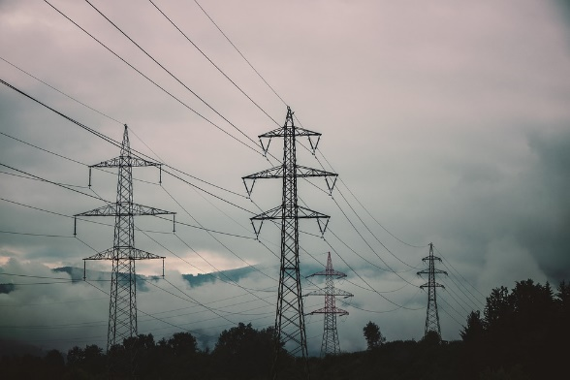
Resources:
Pylon picture from Pixabay: free to use.
- paper
- pencil
- ruler
- samples of different materials: wood, paper, metal, card, ceramic, plastic, rubber, cloth, glass.
Time required: 1 hour

Introduction to Activity:
All the electricity we use in our homes is brought to us through electrical transmission cables, held up by pylons. These massive structures march across our landscape, filling our countryside views with their presence.

Could you design a new pylon to transport electricity around the country?
What would it be made of? Could you make it beautiful yet practical?

Main Activity:
Look through the different materials and work out which are electrical conductors and which are insulators. How would this affect the use of them as pylons?

Design a new type of electrical transmission pylon. Look at the pictures on Page 3 for inspiration. Think about what features a pylon should have, i.e. strength, durability, able to hold the electrical cables high above the ground, insulating. Also consider what would happen to the pylon at the end of its useful life. How could it be recycled and what could it become next?
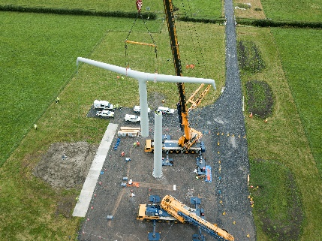
Picture of first T-pylon being constructed in Somerset in September 2021 (taken from National Grid website: https://www.nationalgrid.com/national-grid-build-worlds-first-t-pylon-somerset)
DID YOU KNOW?
A pylon competition run by the Royal Institute of British Architects and government (the then Department of Energy and Climate Change) in 2011 was won by a Danish firm called Bystrup with the T pylon design. This is the first new pylon design in the UK for over 100 years. They are currently being constructed and installed in Somerset, between the new Hinkley C nuclear power station at Bridgwater and Avonmouth dockyard.

Results:
Look through the designs and work out which would be the best suited for the job of carrying electricity.

Discussion:
Circular Economy (https://youtu.be/zCRKvDyyHmI) is a vital design feature that should be incorporated into all new products, whether it is a new toaster, car, sweatshirt or electricity pylon. Check your design materials can be recycled or reused at the end of their life.

Extension Activity:
KS3 - Find out about static electricity fields around cables. Are they a problem for people working with electricity?

KS4 -find out what part transformers play in the National Grid and how this affects the architecture of pylons. Have a look at this video which explains their role in power grids: https://youtu.be/yCSrxHXTA8k.

For further discussion at A Level and beyond consider this video which has caused some debate in the electrical engineering world: https://youtu.be/bHIhgxav9LY .

Extra Resources:
For further information about the competition see the details here: https://www.architecture.com/awards-and-competitions-landing-page/competitions-landing-page/pylon
There are more resources available at: https://inhabitat.com/pylon-of-the-future-6-design-worthy-possibilities-for-an-advanced-electrical-grid/
Share your pictures with us on Facebook, Twitter or Instagram by tagging @RecycleDevon #recycledevon

Make sure you have permission to share any photos first.

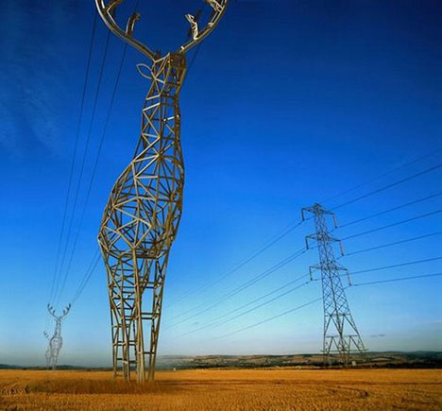

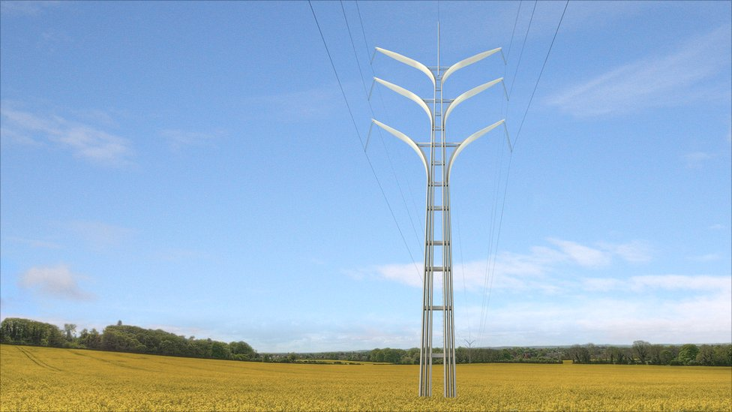

Concept design for Sochi Winter Olympics designed by
Russian design studio Design Depot.

Flower Tower by Gustafson Porter
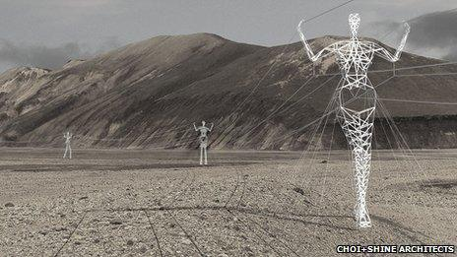

Land of the Giants by Choi and Shine architects

