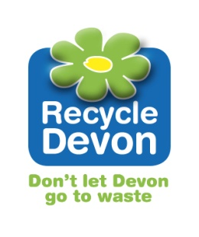
Packed Lunch Waste Audit

To help REDUCE the amount of rubbish children in your school produce, you are investigating what is thrown away from pupils’ packed lunches.

Instructions
- Label your sheets of paper with the criteria for sorting from the table below.
- Arrange your sorting sheets around the table, so that everybody in the group can reach them.
- Add a carrier bag to put in food waste.
- Put on a pair of gloves.
- Sort the packed lunch waste.
- Count the number of pieces in each pile and record your results in the table below.
- Weigh their carrier bag of food waste and record your result below.
- Make sure the area where you have been working is clean and tidy.
- Take off your gloves and wash your hands.
- Discuss your results with your group.

Results

material | number
plastic | mass of food (kg)
paper and card
metal
crisp and snack wrappers
drink cartons
other

Discuss your results with your group. Think of 3 actions to share with the rest of the school that will help you reduce your packed lunch waste.
1.
2.
3.

