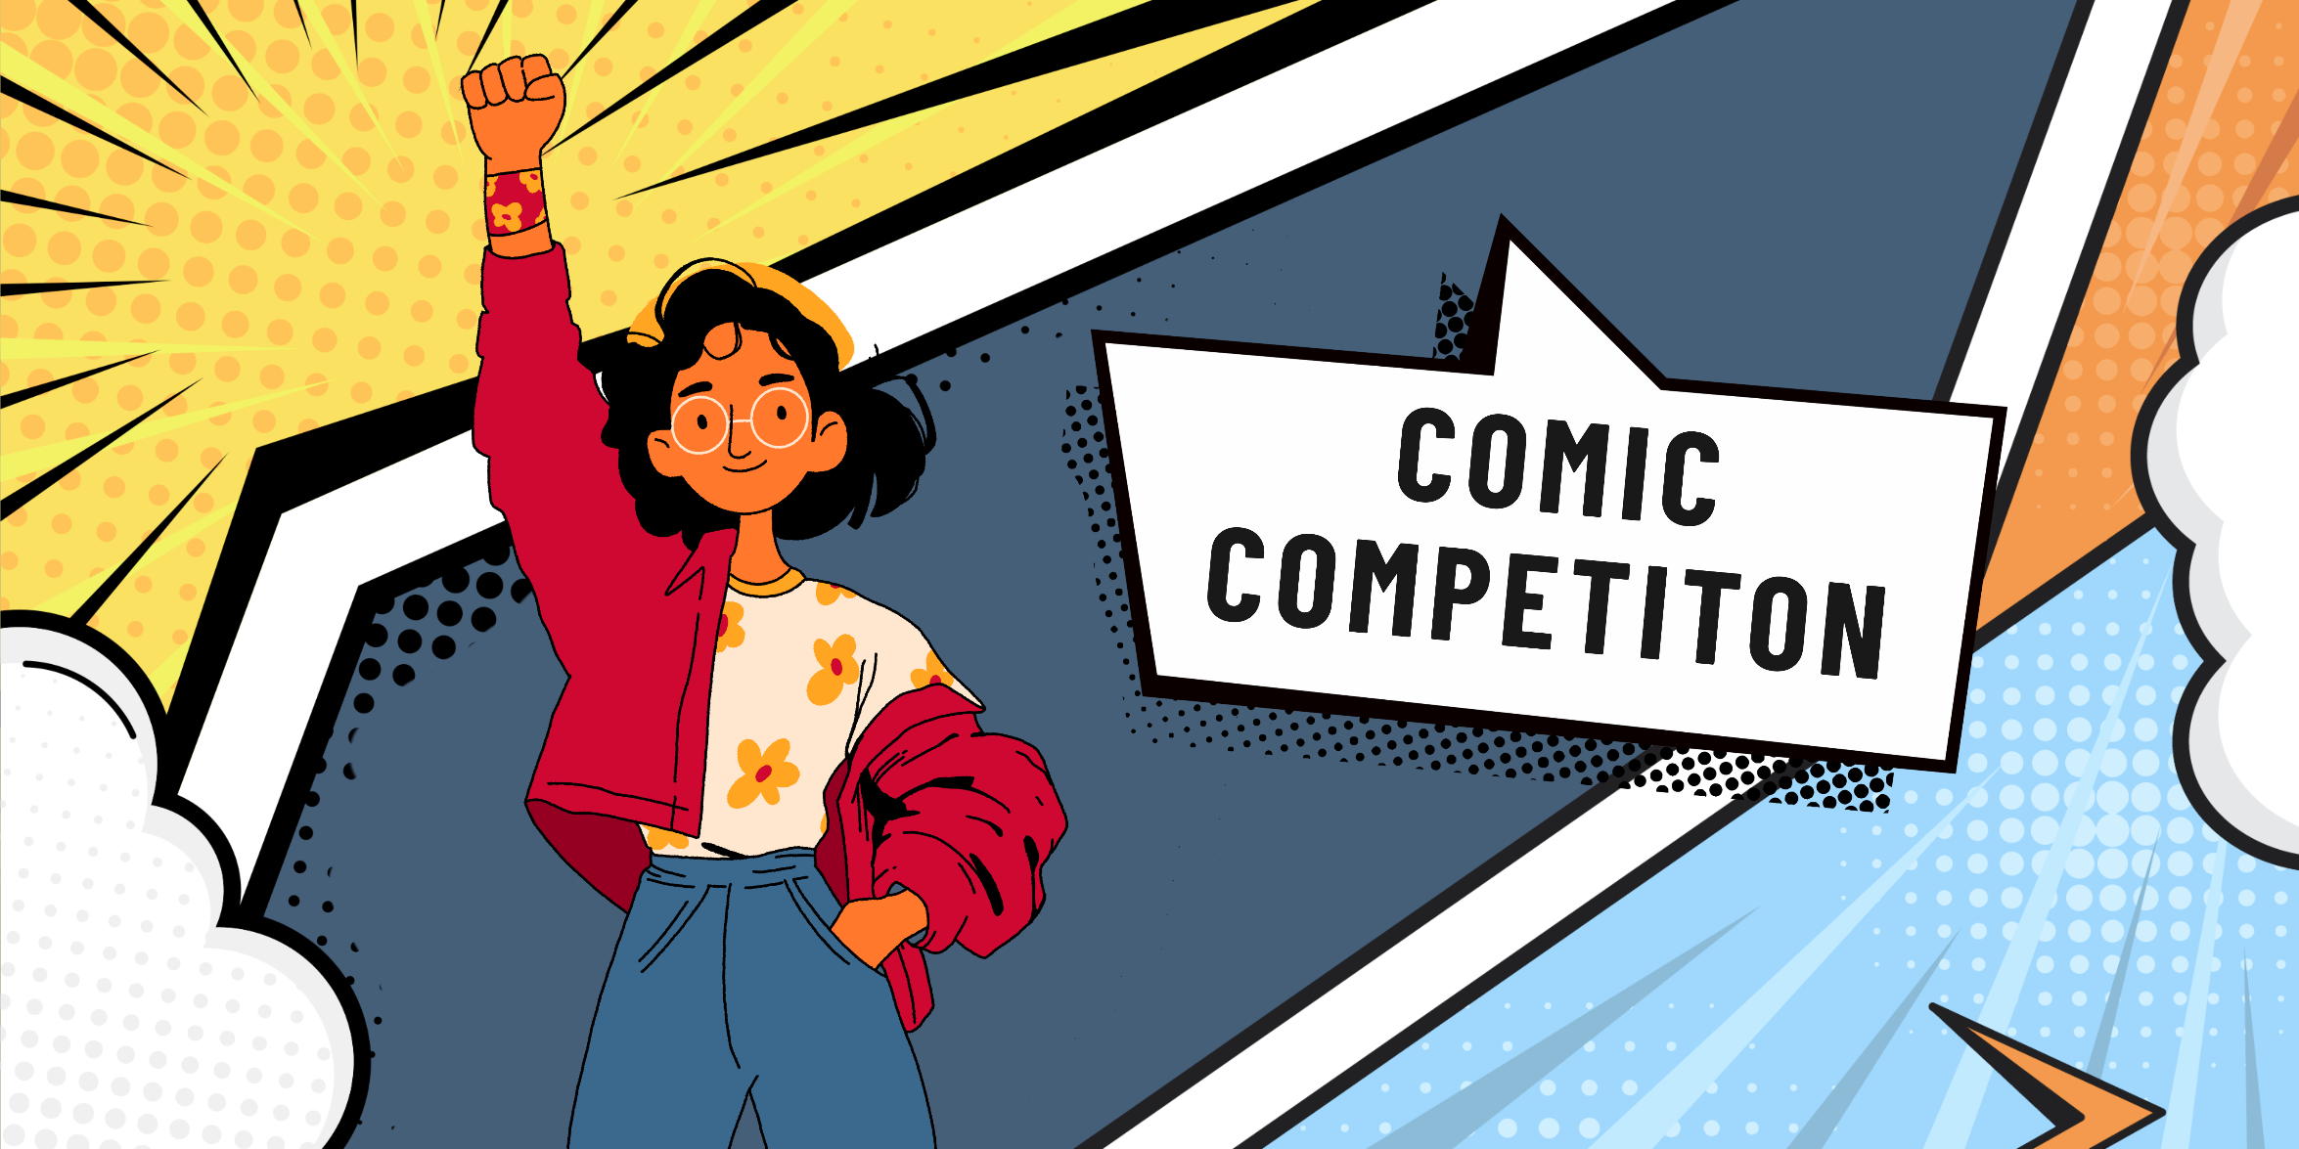

Devon County Council
Comic competition 2026-27
Teaching pack

This document is to help teachers and educators with ideas on how to relate lessons to comics about buying too much stuff and waste.
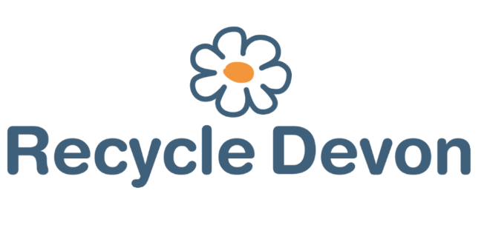

Table of Contents
Introduction 3
DCC Comic Competition Terms and Conditions 3
All about comics 6
KS1 lesson plan 7
KS2 lesson plan 8
KS3 lesson plan 9
Create your own comic 11
Comic example 12
Additional resources 14

Introduction
Devon County Council is running a comic competition starting from November 2026. Entries will be accepted from any residents living in the administrative boundaries of Devon County (i.e. not Torbay or Plymouth). Comics should be created about the subject of buying too much stuff (i.e. consumerism) or waste. Comics could be about reducing waste, fast fashion, culture of having enough, 3Rs (Reduce, Reuse, Recycle), circular economy etc.
The competition will be open for entries from November to the closing date of 30th April, 2027. There will be four categories (KS1, KS2, KS3/4 and aged 16-19). Comics can be submitted either by post to the Waste Education Officer at Devon County Council, emailed to recycle@devon.gov.uk or dropped into your local Devon Library. Please include the name of the school the young person attends (or mark as home schooled).
The winners will be decided by a panel of judges in May 2027. The top prize will be a £50 book token, promotion on social media (such as a photo of the winning comic), a goody bag of Recycle Devon supplies and the possibility of having the story displayed at their local library. Runners up prizes will be a £10 book token and a goody bag of Recycle Devon supplies.

DCC Comic Competition Terms and Conditions
- By entering the competition, the entrant’s parents/guardians are deemed to have read, accepted, and agreed to be bound by, these Terms and Conditions.
- Entry to the competition is open to all residents in Devon (excluding those from the Unitary authorities of Plymouth and Torbay and those excluded under 23) below).
- The closing date for entries is midnight on Friday 30th April 2027.
- Entrants must draw an original comic, at school or at home, on one of the following themes: buying too much stuff (i.e. consumerism) or waste. For example, reducing waste, fast fashion, culture of having enough, 3Rs (Reduce, Reuse, Recycle), litter, circular economy etc.
- Entries will be judged on several factors such as: Is there a consumerism or waste related theme? Is it creative and original? Is there good storytelling?
- The comic must be submitted on a maximum of two sides of an A4 format, either portrait or landscape. Recycle Devon comic box templates will be provided on the website, but it is not mandatory to use them.
- The comic can be drawn on paper or digitally, in colour or black and white.
- There is no limit to wording on the comic.
- Schools may submit multiple entries, but only one entry per pupil will be accepted.
- For the purposes of judging, entries will be divided into four categories:
  - KS1 (years 1-2)
  - KS2 (years 3-6)
  - KS3/4 (years 7-11)
  - 16+ (16-19 years old)
- Entries can be submitted using any of the following methods (Please include the name of the school you are attending if not home-schooled):
  - By email to recycle@devon.gov.uk
  - By post to: Lucy Mottram, Waste Management Team, Room 120, County Hall, Topsham Road, Exeter EX2 4QD
  - Dropped into your local Devon Library
- Entries sent electronically should be in JPEG, PDF or PNG format. If submitted from a school, file names should include the school’s name, pupil name and the year group of the pupils (e.g., Silverton_HartleyJ_Y5). Otherwise, the file name should include the persons’ name and age: e.g., HartleyJ_10.
- The use of artificial intelligence software (AI) to draw and or write the comic will mean disqualification.
- The use of clip art and or existing graphics on digital drawings will mean disqualification.
- The winning entry and two runner-up entries will be selected for each of the age categories detailed above.
- In case of a high number of entries submissions may be shortlisted prior to judging, at the discretion of Devon County Council.
- The winning person in each category will win £50 of book tokens, a goody bag of Recycle Devon goodies and the possibility of having their comic displayed at their local library. They also win the opportunity for their comic to be shared on Recycle Devon’s social media channels, including Twitter (X), Facebook, Instagram and YouTube.
- The runners up will be awarded £10 of book tokens and a goody bag of Recycle Devon goodies.
- The winners and runners up will each receive a framed certificate.
- There are no cash alternatives for any of the prizes.
- The winners will be announced in May 2027.
- Devon County Council accepts no responsibility for late, lost, incomplete, incorrectly submitted, delayed or misdirected entries.
- Entries will not be accepted from any children of the DCC Waste Management Team, Resource Futures Waste Education Team or Suez.
- Devon County Council will appoint a fair and impartial judging panel to judge the entries and select winners. The winners will be selected from all valid entries. In the event of either poor quality or no valid entries being received from pupils in a particular age category, the judging panel reserves the right not to award all prizes.
- Schools, young people (with parent/guardian permissions), and parents/ guardians must be willing to participate in publicity surrounding the winning of the prize and consent to Devon County Council and partner organisations using the submitted short stories for publicity. Winning entries may be used to promote the 3Rs, composting and climate activities through Recycle Devon, Libraries Unlimited and Devon Climate Emergency’s events, exhibitions, websites, social media, newsletters and publications for both commercial and non-commercial usage.
- The copyright of the short story belongs to the author/s but by entering the competition you are deemed to agree to grant a royalty-free perpetual licence to Devon County Council and partner organisations for the promotional purposes set out in paragraph 25 above.
- Devon County Council will not be liable for any loss (including, without limitation, indirect, special or consequential loss or loss of profits), expense or damage which is suffered or sustained (whether or not arising from any person’s negligence) in connection with this competition or accepting or using the prize, except for any liability which cannot be excluded by law (including personal injury, death and fraud).
- The judges’ decision is final, and no correspondence will be entered into other than to notify the winning entrants.
- If any winning entry is deemed not to comply with these Terms and Conditions, the entry will be discarded, and an alternative winner of the prize will be determined by the judges.
- These Terms and Conditions are governed by English Law and shall be subject to the exclusive jurisdiction of the English Courts.
Any queries relating to this competition should be directed to: Lucy Mottram, Waste Education Officer, Devon County Council; email: lucy.mottram@devon.gov.uk; telephone number: 01392 383519.

All about Comics

Comics come from across the world in different art styles and genres.
Here are some examples you may have heard of:
The superhero, action MARVEL Superman or Spider-Man comics is written with capitalised text. While short comic strips were found in newspapers (back in the day!) like Calvin and Hobbes, Garfield, Peanuts and more linked here.
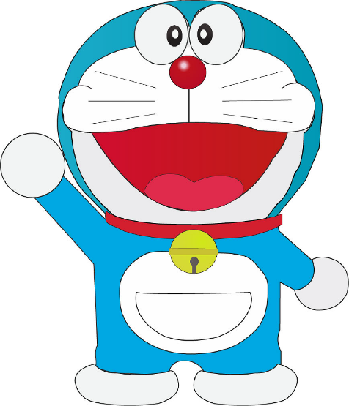
In Japan, comics are called manga, reading from right to left. Some famous examples include: Haikyuu!!, Naruto, Demon Slayer, Dragon Ball, Doraemon etc..
(Images from Pixabay, Doraemon by illustrationfiles, Spiderman by yalanois)

Comics are a great way to share a powerful message through a few pictures and words. Below are some links to environmental comics:
environmental comic strips linked here too.
https://www.instagram.com/p/CmrdYtTqvNs/
Home | Climate Comic

Although comics started out being created on paper, many of them have been digitalised onto online reading platforms such as Webtoon, or even onto the big screen as animations!

KS1 lesson plan
Comic Competition Lesson Plan – KS1

 | Subject: English / Art |  | Year: Y1-2
Topic: Writing a comic strip story |  |  | Links to National Curriculum: Participate in discussions about books that are read to them. Consider what to write, re-read, evaluate and re-write.
Learning objectives: Draft and write a comic strip story about waste or consumerism
Lesson structure |  | Teacher notes
Starter:  Read through the story books “Too Much Stuff” and /or “Tidy” by Emily Gravett. |  | Talk about the underlying messages of the books. Describe how the story could become a shorter more concise story or comic script.  Talk about the difference between different types of comics and short graphic stories.  Talk about characters from comics that children will relate to: Lego Star wars or Batman characters, Spiderman, I Am Groot – it might be helpful to look at: Marvel Age-by-Age Guide | Common Sense Media  Discuss how to create a comic: How to write a comic - BBC Bitesize  Show the class a wide range of comic strips. Snoopy is a good one: https://www.peanuts.com/activities/peanuts-lesson-plans and https://www.boredpanda.com/environmental-comics-inspiring-to-take-action-rewriting-extinction/  Discuss what a message in a story is – relate back to the stories told at the beginning of the lesson: Too Much Stuff and Tidy.  Planning is vital for short comic strips. Make sure plenty of planning happens before anything goes down on paper.  Provide plenty of time for evaluating the story, re-reading and re-writing.
Main Activity:

Develop a story that could be told as a comic strip.

Plenary:

Share the story ideas.
Extension:
Finish your drawing and submit to the DCC Waste Comic Competition

KS2 lesson plan - Comic Competition Lesson Plan – KS2
 | Subject: English / Art |  | Year: Y3-6
Topic: Writing a comic strip story |  |  | Links to National Curriculum: Read a wide range of literature. Plan, draft and write stories.
Learning objectives: Draft and write a comic strip story about waste or consumerism
Lesson structure |  | Teacher notes
Starter:  Read a variety of comic strip texts.  Share with a partner your favourite one and consider why. |  | BBC Bitesize has a good video on comic creation: How to write a comic - BBC Bitesize  There are some great resources about Earth Day on the Snoopy website: https://www.peanuts.com/activities/peanuts-lesson-plans  You could use these videos: https://youtu.be/14072Vp_0u4?si=rvCOBMW9pNFAtBd8 and https://youtu.be/WvL-Di5mKQ4?si=tiW24saDnq55tgiH and ask students to turn it into a comic strip.  For older age groups there are lots of comics available here: Read Comics Online Daily | Calvin and Hobbes, Garfield & More  There are some environmental comic strips here: https://www.boredpanda.com/environmental-comics-inspiring-to-take-action-rewriting-extinction/  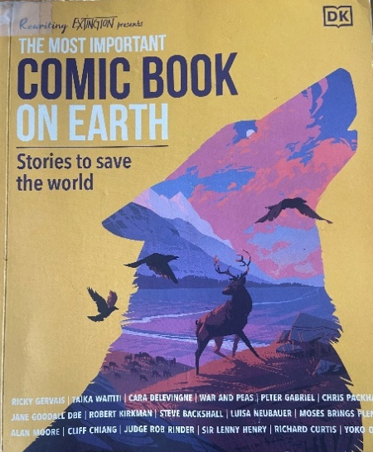  If you can get hold of this book it contains lots of good environmental based comic strips / stories to use as inspiration:
Main Activity:
Think about the prompts:
Consumerism;
Reduce, Reuse, Recycle
Circular Economy
Culture of Enough

Develop an idea into a comic strip.
Think about:
- Character (doesn’t have to be human – what about a mushroom or tree?)
- Style
- Message

Plenary:

Share the idea with others
Extension:

Finish your drawing and submit to the DCC Waste Comic Competition

KS3 lesson plan - Comic Competition Lesson Plan – KS3
 | Subject: English |  | Year: Y7-9
Topic: Writing a comic strip story |  |  | Links to National Curriculum: Writing imaginatively, Reading a wide range of texts.
Learning objectives: Draft and write a comic strip story about waste or consumerism
Lesson structure |  | Teacher notes
Starter:  Look at a range of comic strips and stories, from newspapers and books. |  | There are some great examples of comic short stories from newspapers collected here:  Read Comics Online Daily | Calvin and Hobbes, Garfield & More  This book: (The Most Important Comic Book on Earth) also has a great selection of comic strips about environmental issues. Copies are available from online second-hand book shops.  How to write a comic - BBC Bitesize has a great video and tips about writing a comic strip.  Students could finish their comic strips for homework or you could extend to a further lesson.
Main Activity:
Develop an idea for a comic strip, using the one of these prompts:
Consumerism;
Reduce, Reuse, Recycle
Circular Economy
Culture of Enough

Partner talk – discuss your idea with your neighbour.

Think about:
- characters,
- punchline,
- style of drawing.

Planning is really important! Think and draft before you draw anything on the frames provided

Plenary:
Share your comic strip with the class.
Extension:
Finish your drawing and submit to the DCC Waste Comic Competition

Create your own comic
Photo Prompts
Choose one of these the photos below to draw a comic based on them. Or pick your own photo as a reference point.
Consumerism or Buying too much stuff
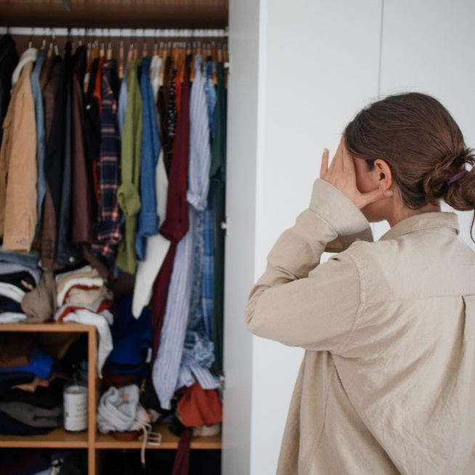
Left: Lady with lots of shopping bags. Right: Lady on the right feeling overwhelmed with having too many clothes.
Waste
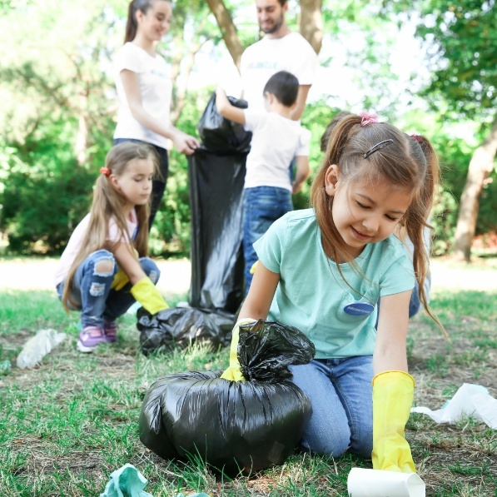
Left: Children litter picking. Right: Donation box with toys and clothing.
Photo prompt credits: Canva
Top Tips:
- Suggest students to create a draft before they start
- Think about expressions of the characters
- Consider putting down speech bubbles first if they are using them, so they don’t run out of space to write.
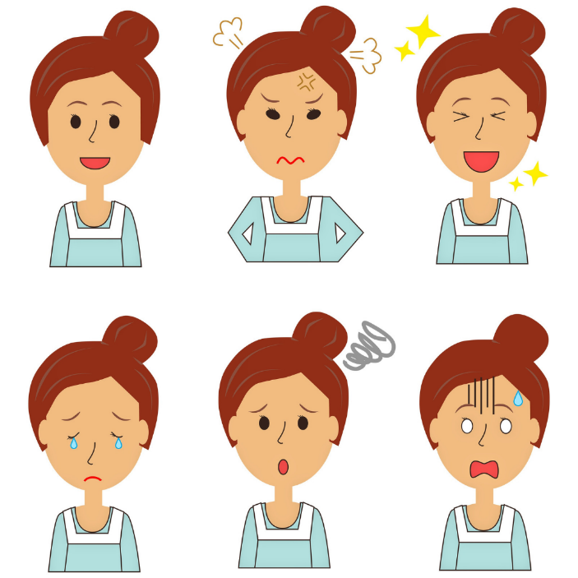

Image of expressions credit: Canva

Comic Example
We have comic templates available if you wish to use them. You can find them linked here: Download Comic Competition Templates
Below is an example of a comic that your students could make.
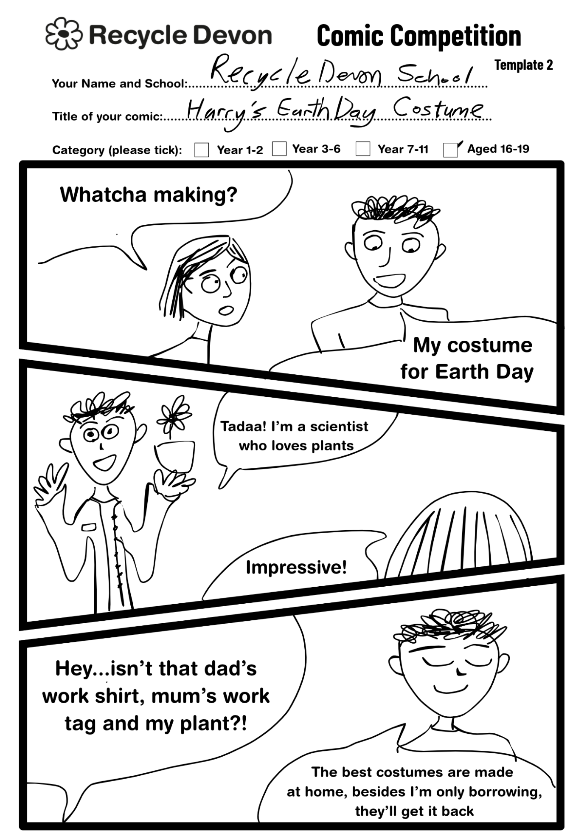

Additional resources
Here is a Libraries Unlimited YouTube playlist featuring Joff Winterhart, an illustrator and writer, who shares his tips on finding inspiration, develop characters and storyboarding. Link: What If YOU Spoke? Joff Winterhart - 1. Introduction

Steve Cutts' animation is a jolting view of modern day 'Happiness' that will get you thinking about what consumerism really means for the characters living in the 21st century life. Watch here: Happiness - YouTube (not suitable for young children)
A cautionary rhyme about consumerism. Watch here: https://youtu.be/PSznbYe2H0k?si=C7FHqz55HA9ws2Oj
Inspiring stories of circular economy by the Ellen MacArthur Foundation. Link: Leading the Transition to a Circular Economy | Ellen MacArthur Foundation
The Climate Comic. Link: Home | Climate Comic
Informative page about plastic pollution by the Plastic Soup Foundation. Link: One wave towards a plastic free future - Plastic Soup Foundation
The Challenges of Circular Economy - comic - Business Illustrator (nice free digital comic, but rather long)
A good video from the Ellen McArthur Foundation that explains the Circular Economy and How Society Can Re-think Progress | Animated Video Essay.
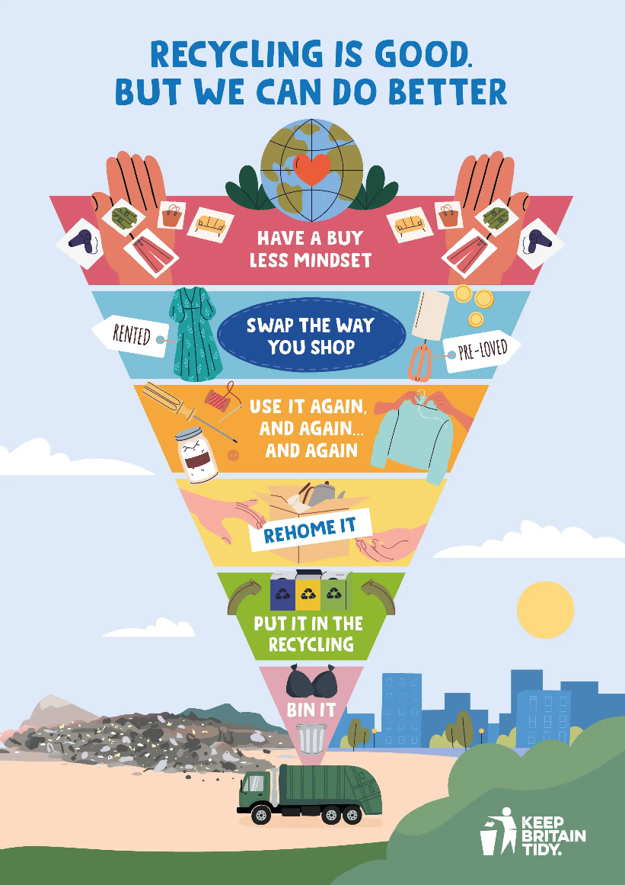
Keep Britain Tidy’s waste hierarchy can inspire your students. Image source: Recycling | Keep Britain Tidy

