COOK – A recipe for summer pea and bean soup stew

Ingredients:

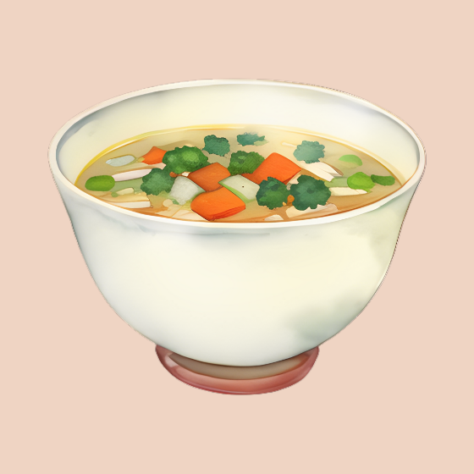
1 onion (chopped)
1 carrot (chopped)
1 stick of celery (chopped)
1 tbsp Olive oil
1 vegetable stock cube
800ml boiling water
1 courgette
200g podded broad beans (fresh or frozen)
200g podded peas (fresh or frozen)
8 cherry tomatoes, halved
Salt and pepper

To serve: Crusty bread, a tbsp of basil pesto or pistou, extra virgin olive oil and a sprinkle of parmesan cheese.

Method

Prepare all the ingredients.
Add the olive oil to a saucepan, along with the onion, carrot and celery. Fry until soft and glistening.
Add the boiling water and stock cube and heat until it has returned to the boil. Add the other vegetables and bring back to the boil.
Simmer for 5-10 minutes, until the vegetables have cooked. Season to taste
Serve in a bowl while still hot, topped with a dollop of pesto, a swish of olive oil and a sprinkle of cheese. Eat!

