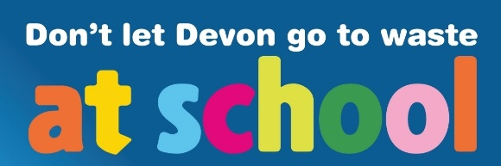
Worksheet: Definitions of waste related words.

Can you write out your own definitions of these waste related words?

avoid means: __________________________________________________________________________________________________________________________________________

biodegrade means: __________________________________________________________________________________________________________________________________________

climate change means: __________________________________________________________________________________________________________________________________________

compost means: __________________________________________________________________________________________________________________________________________

decompose means: __________________________________________________________________________________________________________________________________________

disposable means: __________________________________________________________________________________________________________________________________________

energy from waste means: __________________________________________________________________________________________________________________________________________

greenhouse gas means: __________________________________________________________________________________________________________________________________________

incineration means: __________________________________________________________________________________________________________________________________________

landfill means: __________________________________________________________________________________________________________________________________________

methane means: __________________________________________________________________________________________________________________________________________

ocean means: __________________________________________________________________________________________________________________________________________
plastic means: __________________________________________________________________________________________________________________________________________

pollution means: __________________________________________________________________________________________________________________________________________

recycle means: __________________________________________________________________________________________________________________________________________

reduce means: __________________________________________________________________________________________________________________________________________

repair means: __________________________________________________________________________________________________________________________________________

reuse means: __________________________________________________________________________________________________________________________________________

rubbish means: __________________________________________________________________________________________________________________________________________

waste means: __________________________________________________________________________________________________________________________________________

