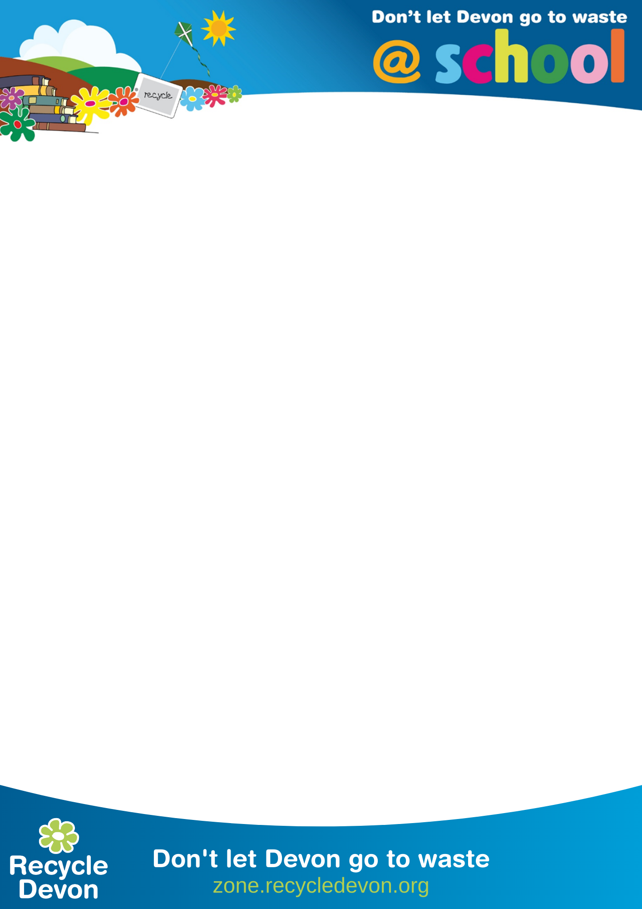

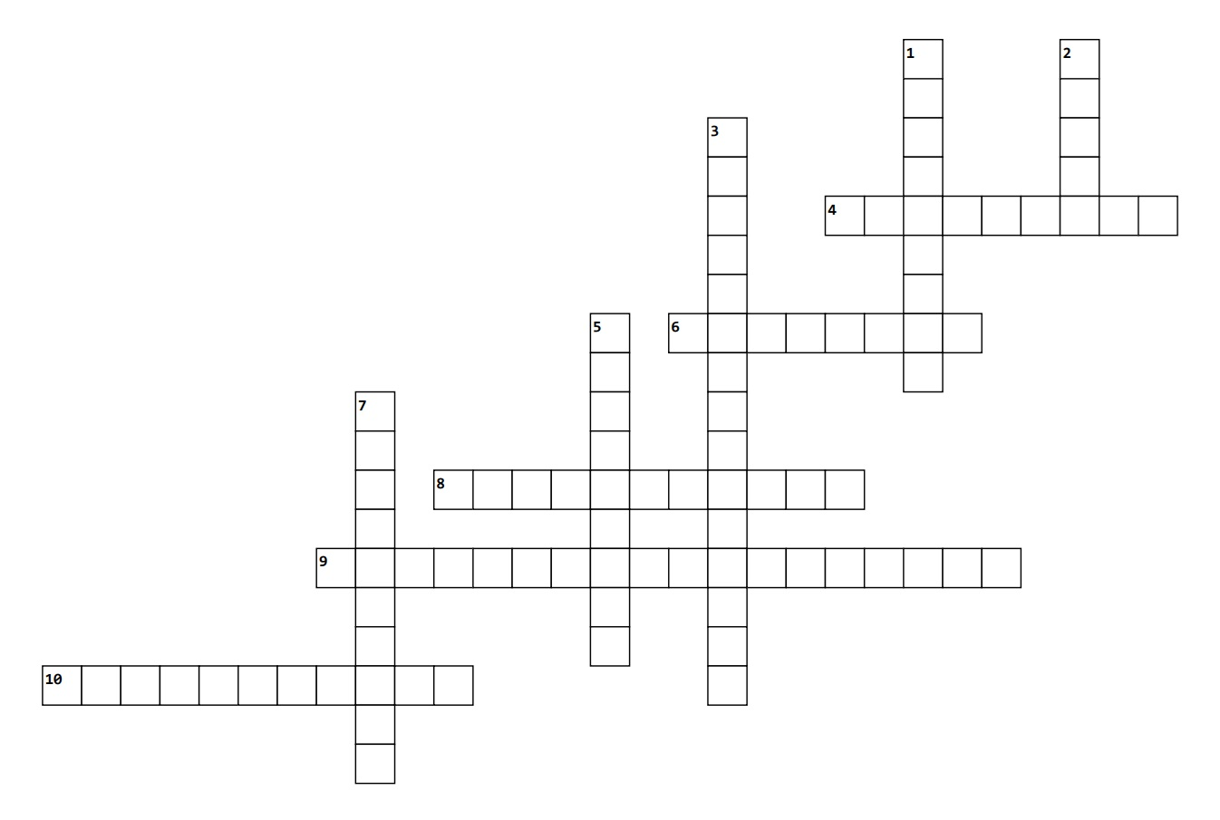
Community Fridge and Food Waste Crossword
Across
4. Put your food waste in this bin at home for recycling.
6. The amount of food produced wasted around the world.
8. Food that supermarkets and businesses throw away.
9. Food waste in Devon is recycled through this process which produces electricity and fertiliser for fields.
10. A great way to use up bananas that are past their best.
Down
1. Food left on your plate is called:
2. The most commonly wasted food, often made from wheat flour.
3. A place where surplus food is put for everyone to use.
5. The town with the first Community Fridge in Devon.
7. People who collect surplus food.

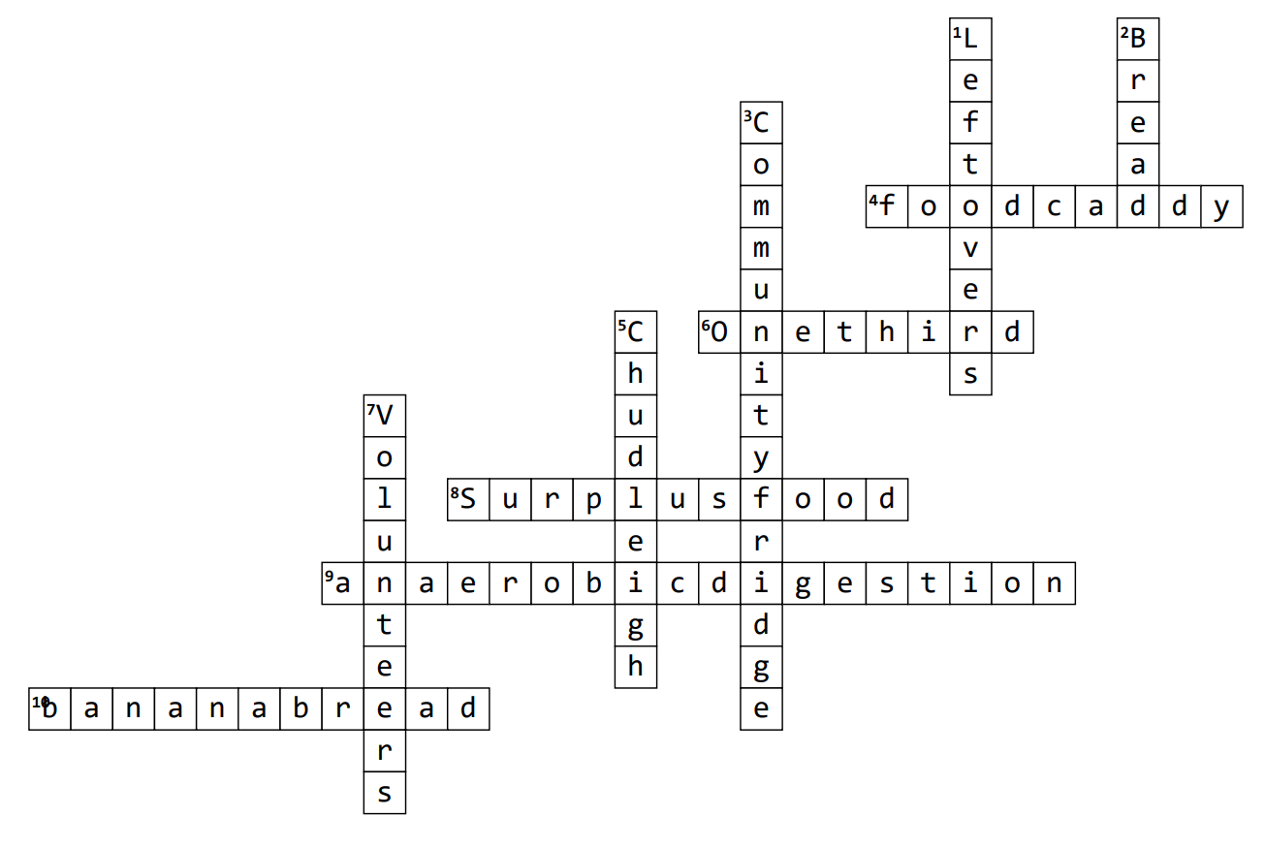
Answers.

