Cardboard Home Activity: What can you make from a cardboard box?

Lesson Objective:

To reuse a cardboard box, describe the properties and locate the forces acting on the box.

Science National Curriculum links:

KS1 Science: Everyday materials - Describe the simple physical properties of a cardboard box and find out how shapes of solid objects can be changed.

KS2/Y5 Science: Properties and change of materials - give reasons for the uses of everyday materials.

KS2/Y5 Science: Forces – identify the effects of air resistance and friction.

KS3/4 Science: Chemistry – chemical and allied industries – the viability of recycling certain materials.

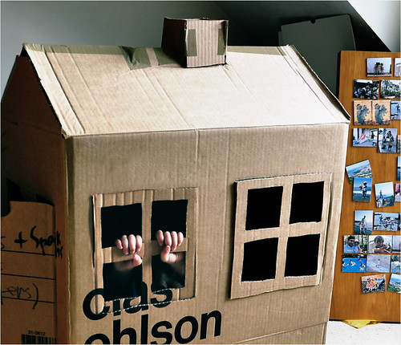
Resources:
- paper
- pencil
- cardboard box
- scissors
- coloured pens
- tape
- other items like pipe-cleaners, ice lolly sticks, aluminium foil, feathers, sticks, whatever else you have lying around at home!
- your imagination
Time required: 1 hour
Photo from Daniela on Flickr: free to use.
The rise of the cardboard house | Flickr

Introduction to Activity:
Reuse is the second best thing to do with your rubbish! (The best is to Reduce – so you don’t create the rubbish in the first place!)
Playing with a cardboard box is one of the simplest and potentially most creative things a child can do!
Many things can be made from an old cardboard box, from a pinball machine to a flying car. What can you make?

DID YOU KNOW?
Cardboard is made from cellulose from trees. The first cardboard box was made in 1817, though corrugated card was invented in China some time in the 15th Century. Corrugated card was first made at an industrial scale in 1874 by G. Smyth. The American Robert Gair invented the corrugated cardboard box in 1890.

Cardboard boxes usually have a high recycled fibre content. The Covid-19 pandemic saw a huge shift in public demand for cardboard boxes as more things were delivered to people stuck at home. This caused supply chain problems as more card was in people’s homes and council recycling collections struggled to keep up with the amount to pick up.

Main Activity:
Turn the cardboard box into something else! First design the object on a piece of paper. There are some ideas on the next page if you get stuck, but be as creative as you like! Can it fly? Travel to other worlds? Does it make wishes come true, or just act as somewhere safe to play?

Results:
What were the original properties of the cardboard box? Was it hard. soft, absorbent, waterproof, light, heavy, flexible, brittle?
How have you managed to change the box? Did you need to cut it to form your new object? Could you squash or bend the cardboard?

Discussion:
What are the stages of the cardboard box’s life? Investigate where was it made (useful video here: https://youtu.be/cfV_L1mOtZM)
Discuss why it is better to reuse a cardboard box, before turning it into something new (think in terms of energy and resources).

Extension Activity:
Think about the forces that act on the carboard box. Draw a diagram to show how they act on the box. How do air resistance, gravity and friction act on the box?

Extra Resources:
For further information:

- https://www.pinterest.co.uk/therapyshoppe/imagination-boxes/
Share your pictures with us on Facebook, Twitter or Instagram by tagging @RecycleDevon #recycledevon

Make sure you have permission to share any photos first.

