Food Home Education: Make your own zero-waste lunch

Lesson Objective:

Pupils learn to construct a healthy and nutritious packed lunch for a school or a picnic, using items that are not wrapped in single use plastic.

Science National Curriculum links:
Y2: Animals (including humans) – describe the importance of eating the right amounts of different types of food.
Y3: Animals (including humans) – identify that humans need the right type of nutrition, which they get from what they eat.
Y6: Animals (including humans) – recognise the impact of diet on their bodies.
KS3: Nutrition - content of a healthy human diet.

Resources:
- Copy of an Eat Well Plate (see attached sheet)
- Ideas sheet
- Food to make lunch!
- Reusable lunch containers – including pots of different sizes
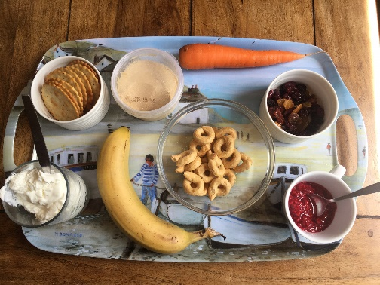
Time required: 1 hour

Introduction to Activity:
Lunch is an important meal, providing energy and nutrients for the rest of the afternoon, and providing a well-needed break for the brain in the middle of the day. It’s especially important for young, growing brains to eat well at every meal.

Whether you’re at home for the holidays, home-schooling because of a pandemic or just looking for some activities why not try this fun way of planning waste-free lunches. A zero-waste or waste-free lunch will contain items without single use packaging or anything else that must be thrown away, except compostable food waste.

Main Activity:

Have a conversation with someone about foods that should be included in a healthy lunch – taking a look at the Eat Well plate. Read through the tips below for creating a zero-waste lunch.

Raid the fridge and food cupboards to find items that can be used to make a zero-waste lunch. Remember – no single use plastic! Use the attached meal planner to plan what you could pack in your lunch.

You can use bigger packets and split them up into smaller portions. Perhaps there are some crackers you could split up from a bigger box, or some yogurt from a big pot you could spoon into a smaller reusable container. Maybe there are some leftovers in the fridge! Cold pizza for lunch – yum!

Perhaps you could cook some pasta or rice to turn into a salad by mixing with a dressing and some vegetables (see recipe ideas below).

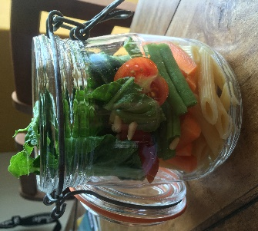
Pack your zero-waste lunch in reusable containers. These don’t have to be anything expensive or fancy, but could just be takeaway containers or ice cream tubs. If you feel like doing something a bit more Instagrammable why not try to find a Kilner jar or reuse an old jam jar for a salad or some yogurt.

Think about if you need cutlery and a napkin. You can easily carry normal metal cutlery wrapped in a cloth napkin for your lunch.

Results:
Eat your lunch! This could be at school or at home, or you could find a nice place to walk to and eat your lunch as a picnic outdoors.
Rate your lunch out of 10 – 10 being the best lunch in the world, 0 being a terrible lunch. think about what could make it better.

Discussion:
Talk to the person who does the shopping in your house and tell them what you have found. Did you find lots of items you could use for a zero-waste lunch. What changes to shopping could you suggest? Could you buy big packets of things like yogurts to split up?
Think about other ways to save waste – if you usually have a cereal bar for a snack or lunch could you find a flapjack recipe to cook at the weekend?

Extension Activity:
Find out what happens to lunch waste at your school or at home. There are lots of resources about food waste on our website (https://zone.recycledevon.org/food-and-compost/). Could you compost fruit peelings at school or home? What types of packaging can be recycled at school and home?

Extra Resources:
Food for Life: https://www.foodforlife.org.uk/schools
Healthy lunchbox advice from the British Nutrition Foundation: https://www.nutrition.org.uk/healthyliving/helpingyoueatwell/healthypackedlunches
Share your pictures with us on Facebook, Twitter or Instagram by tagging @RecycleDevon #recycledevon

Make sure you have permission to share any photos first.
Create low cost healthy lunches without the waste!
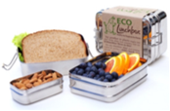
There are lots of lunches and snacks readily available from the supermarkets, but they often create a lot of rubbish. With a little bit of forward planning you can save money, eat healthily and make less rubbish …

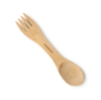
- Pack your lunch in a reusable wrapper or container. There are lots of options to choose from, including retro or funky modern lunchboxes to a new trend in beeswax food wrappers.

- Use a reusable drinks bottle or flask rather than disposable bottles, pouches or cartons.

- Avoid disposable items such as plastic forks, spoons and paper napkins. Try packing a spork!

- Many favourite foods can be bought in bulk saving you money and reducing packaging. Try buying your favourite foods, such as yogurt, raisins, biscuits and crisps, in larger quantities and placing the amount you need in a smaller reusable container.

- Eat more fruit. It’s healthier and a lot of fruits have their own natural wrappers which can be composted. Remember to buy them loose at the supermarket to avoid extra packaging

- Need Inspiration? Turn over for ideas for healthy packed lunches…

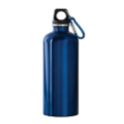
- Remember to keep foods that need to be refrigerated cold using a reusable, insulated lunch box/bag or including a reusable ice pack in your lunch.

For more ideas visit the following websites …
- www.pinterest.co.uk/recycledevon/waste-free-lunch-box-ideas/
- https://www.bda.uk.com/foodfacts/home
- www.nidirect.gov.uk/information-and-services/healthy-eating-different-ages/healthy-lunchbox-ideas-children

Recipe Ideas

Quick Pesto Pasta Salad

Makes enough for 6 portions

Ingredients
400g Pasta shapes
200ml crème fraiche
4tbsp green pesto
½ cucumber (chopped into small chunks)
16 cherry tomatoes
200g peas
Handful of fresh basil leaves

Method
Cook the pasta for about 10 minutes in salted boiling water, drain and put in a bowl. Stir through the crème fraiche and pesto and leave to cool. Cook the peas in boiling water for a few minutes and allow to cool.
When the pasta has cooled stir through the cucumber, tomatoes and peas. Then add the basil.
Keeps in the fridge for 2 days.

Rice Salad

Ingredients
300g brown basmati rice
75ml olive oil
200g peas
410g can lentils, rinsed and drained
410g chickpeas, rinsed and drained
juice 2 lemons
2 spring onions, finely sliced
Some coriander, chopped

Method
Cook the rice in boiling water for about 15 mins, drain and drizzle with some olive oil, then leave to cool.
Cook the peas for 2 minutes and leave to cool. In a large bowl, mix the rice with the peas, lentils, chickpeas, remaining olive oil, lemon juice and the spring onions. Season to taste.
The rice salad will keep in the fridge for up to 2 days. Stir through some coriander.

Recipes from BBC Good Food website: https://www.bbcgoodfood.com/
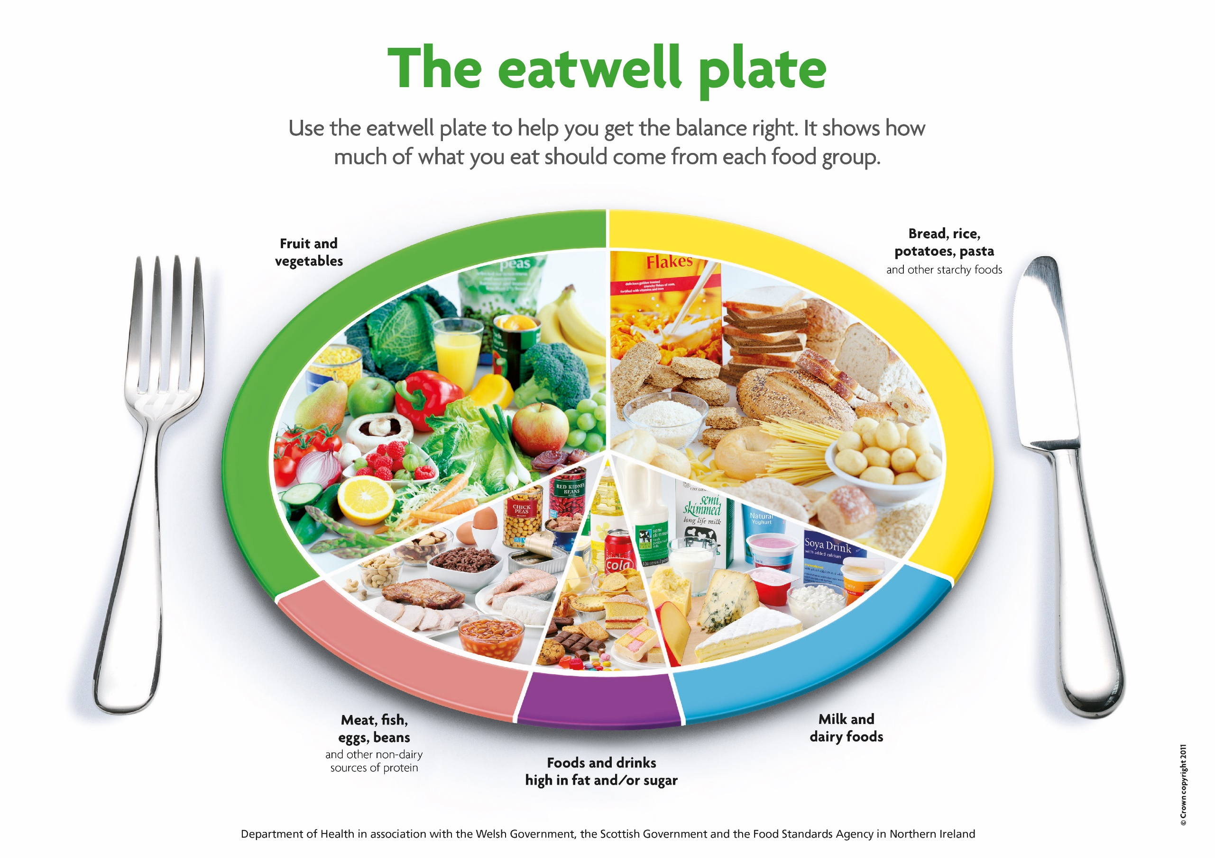
Fill up on Fibre |  | Protein Options and/or Sandwich Fillings |  | Five-a-day Options |  | Good for Growing Bones |  | Snacks
Sandwich or wrap  Wholemeal, granary, multi-grain or white bread, bread roll, pitta bread, tortilla/wrap, naan, chapatti or bagel.  Alternative ideas:-  - Pasta salad  - Rice salad  - Couscous  - Potato salad  - Quiche  - Frittata/Spanish omelette  - Samosa  - Pakora  - Spring roll  - Savoury muffin  - Savoury scone  - Potato cake  - Oat cakes |  | Vegetarian  Hummus  Quorn slices  Veggie sausages or pâté  Egg salad/egg mayo  Nut butter e.g.: peanut, almond  Mixed bean pâté  Lentil bake  Cheese spread  Cream cheese  Cheddar cheese – try mixing grated cheese and carrot with a little mayo or salad cream.  Fish  Mackerel and cucumber  Sardine and tomato  Crab paste/pate  Meat  Leftover cold meats (chicken, turkey, meatloaf, sausages etc) |  | Salad pot - any combination of prepared raw vegetables such as cucumber, pepper, celery, cherry tomatoes, carrot.  Whole fruit - satsuma, apple, banana, pear, peach, plum, grapes.  Fruit salad pot - any combination of prepared fruit (strawberries, orange, melon, kiwi etc.)  Tinned fruit in natural juices mandarins, pineapple, peaches, fruit salad.  Dried fruit - raisins, apricots, dates, prunes.  Fruit jelly made with fruit pieces and fruit juice. |  | - Fruit yogurt or fromage frais  - Small pot of cold rice pudding or custard  - Greek or plain yogurt – add fruit for sweetness  - Cottage cheese with pineapple  - Dips - tzatziki, raita, cream cheese  - Cheese portion  - If you don’t eat dairy, try adding a fortified non-dairy alternative. |  | - Crackers  - Crisp bread  - Oatcakes  - Rice cakes  - Savoury biscuits  - Savoury flapjack  - Bread sticks  - Homemade popcorn  - Hard-boiled egg  - Scotch/savoury egg  - Mini sausages  - Falafel  - Cubes of cheese  - Small piece of cake  - Slice of malt loaf  - Fruit or plain scone  - Small piece of flapjack  - Low/no salt crisps  - Handful of seeds & nuts
Top Tips | Avoid having too many fatty baked foods - keep them as an occasional treat | Top Tips | Try a few meat free days | Top Tips | Use fruit and veg that is in season. | Top Tips | Avoid pre-packed individually wrapped items as they often work out more expensive. | Top Tips | Collect small reusable air tight containers to create individual portions for lunchboxes
Thirst-quenchers: Remember to use a reusable bottle  - Water  - Plain milk (whole, semi-skimmed, goats or soya)  - Pure fruit juice (no more than 150ml per day)  - Well diluted high-juice or low sugar squash  - Smoothie made with plain milk, yogurt and fruit. |  |  |  |  | Do you regularly have leftover food in your lunchboxes?  Reduce food waste by thinking about portion size – how much do you or your child need to eat?  Find out more about portion sizes and how to reduce food waste at:-https://www.lovefoodhatewaste.com/portion-planner
Zero Waste Lunch Ideas

