Paper Home Education Activity: How absorbent is your toilet paper?

Lesson Objective:

To find out which toilet paper is the strongest through scientific experimentation.

Science National Curriculum links:

All age groups: Working scientifically

Resources:
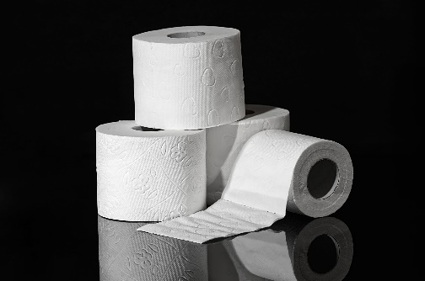
- different brands of toilet paper or toilet paper, tissues and kitchen paper
- empty glass
- rubber bands
- dropping pipette, medical syringe or straw for dripping water
- bowl or jug of water

Time required: 1 hour

Introduction to Activity:
Toilet paper was one of the must have products of 2020 (along with masks and hand sanitizer) and stockpiling them led to lots of news stories. But have you ever wondered how absorbent your toilet paper is? In this experiment you can find out and compare it to other brands and/or types of paper.

This experiment can be done at home, either as a fun holiday activity, or as part of home schooling. It is suitable for all ages, with variations if you would like to be more scientific, for example, as part of a home-schooling project.

Main Activity:

Collect together the items needed as listed above, including different kinds of toilet roll – if you only have one brand at home maybe you could ask friends or neighbours for a few sheets of their toilet paper to test.

Tear off one sheet of paper. Attach over the empty glass with a rubber band. Carefully start dropping water onto the sheet, counting each drop.

Record in a table how many drops of water it takes before the water appears through the paper, in the glass.

Results:
DID YOU KNOW?
Paper can be made from any kind of wood fibre – from bamboo to birch, pine to eucalyptus. Most often scrap and offcuts from the lumber industry is used to make new paper.
Compare the results using a table like this:
Toilet paper | Brand (examples) | No. of drops | Absorbency Rating
1 | Tesco recycled
2 | WGAC
3 | Cushelle
4 | Andrex
Work out the Absorbency Rating by giving the most absorbent paper a higher number, eg. the most absorbent is given the number 1.
Discussion:
Does the material the toilet paper is made of make a difference to the absorbency? Is recycled paper more or less absorbent than toilet paper made of bamboo?
Are there other ways to rate the toilet papers? What about softness? Or you could give them a sustainability score – so recycled toilet paper made in the UK rates most highly, followed by FSC paper made in Scandinavia, then bamboo paper made in China and shipped to the UK.
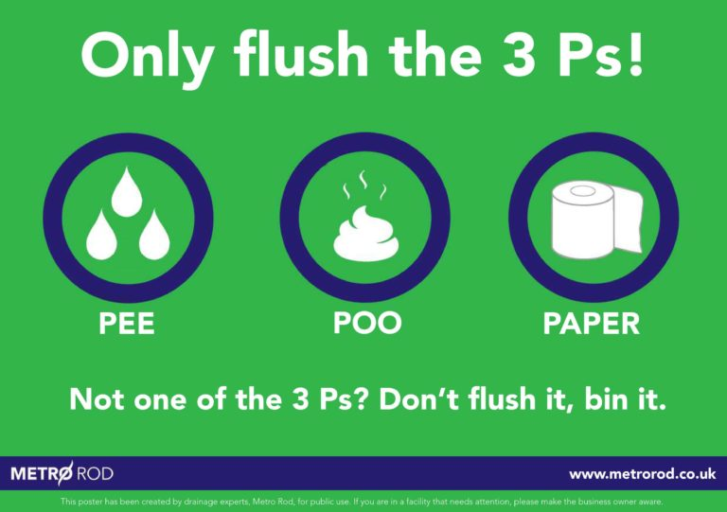
Extension Activity:
Do you know about the 3Ps? Watch this video to find out: https://youtu.be/kvmUpl3fCZw
Could you teach other people this information? Many people are unaware that wet wipes cannot biodegrade and should never be flushed down the toilet. Some people still flush nappies and period products down the loo.
Extra Resources:
On our Zone education website we have a variety of resources about having a sustainable period: https://zone.recycledevon.org/pshe-life-skills/periods-and-sustainability/
Share your pictures with us on Facebook, Twitter or Instagram by tagging @RecycleDevon #recycledevon

Make sure you have permission to share any photos first.
Check out our other materials worksheets at https://zone.recycledevon.org/materials-worksheets/
Share your pictures with us on Facebook, Twitter or Instagram by tagging @RecycleDevon #recycledevon

Make sure you have permission to share any photos first.

