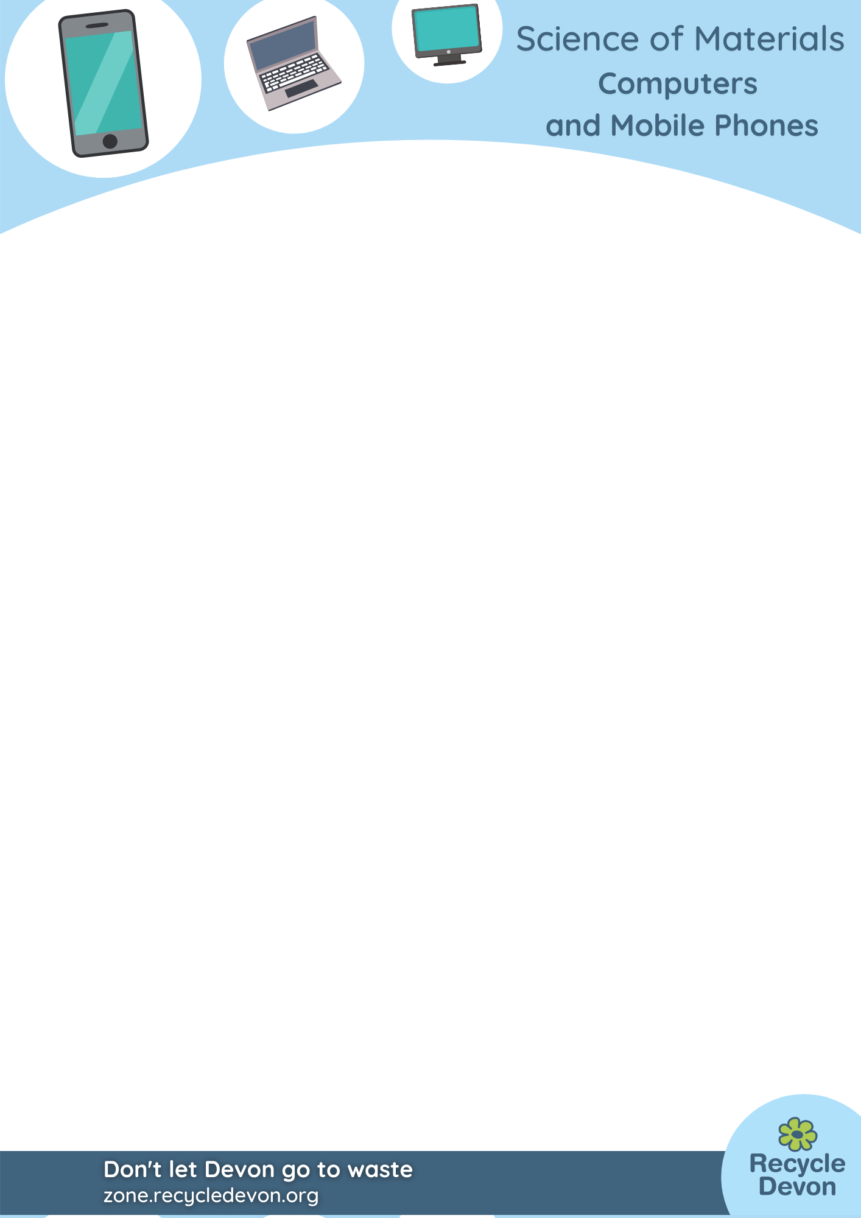

Computers and Mobile Phones Home Activity: Hunt for Hidden Treasure!

Lesson Objective:

To hunt out how much treasure (mobile phones and computers) you have at home and see if any could be mended.

Science National Curriculum links:

KS1 Science: Everyday materials – distinguish between an object and the materials its made from.

KS2 Science: Working scientifically - record findings in tables.

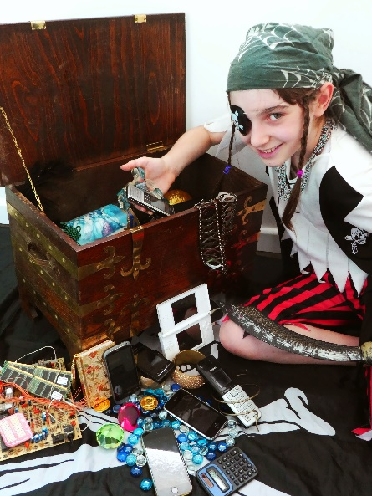
Resources:
- Pencil and paper
- Ruler
- Coloured pens or pencils
- Recording Sheet (last page of this worksheet)
- Permission from a responsible adult to search your house
- A box to collect up any old electronic equipment
- Optional – pirate outfit and eye patch

Time required: 1 hour

Introduction to Activity:
“Ahoy thar – me hearties! There’s treasure in that there old equipment!”
Your electronic equipment contains gold and silver. In this activity hunt out how much you have at home and see if any could be mended.

Main Activity:
Your first task is to draw a map of your house using a ruler to draw straight lines and drawing out all the different rooms. This is your treasure map! You could even make it look old by dipping it in a dish of cold tea and ripping the edges.
Move from room to room (dressed as a pirate if you like!) looking for any electronic equipment – these might be computers, laptops, tablets, mobile phones, cables, plugs, Wi-Fi routers. Find out if they work.

Mark where you find them with a cross on your treasure map.


DID YOU KNOW?
In the UK we purchase around 22.5 million phones every year. These phones will contain nearly 1 tonne of gold, over 9 tonnes of silver and over 300 tonnes of copper.
We have nearly 40 Repair Cafés in Devon and there are several hundred in the UK. This network and other repair shops could help mend your broken devices.
Gold is more valuable in the real world than in Minecraft.

Results:
Record how many devices you find in each room on the recording sheet.

Discussion:
Discuss with your family how many you found, how many work and how many are broken. Are there items you don’t use? Could you give them to a friend or relative? Discuss what to do with the broken ones – could they be mended?

Extension Activity:
Can you work out how much gold is in your waste electrical equipment and how much it would be worth? Look up the current value of gold per gram. Each mobile phone contains about 0.02857g of gold. https://www.bbc.co.uk/news/blogs-magazine-monitor-28802646

Extra Resources:

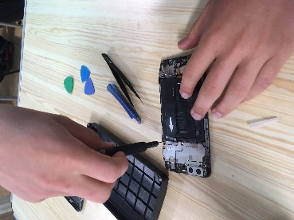
What is e-waste and what can we do about it? | Natural History Museum (nhm.ac.uk)

Mending old electricals:
Ask around your local community or on the Recycle Devon Facebook page about places to repair anything that is broken. If you fancy a challenge yourself there are lots of places online to find videos of how to mend many common items – though ask an adult to help you with this.

Recycling old electricals:
You should take old electrical items to your local Recycling Centre. Find your local recycling centre here: https://www.devon.gov.uk/wasteandrecycling/centre/

Find out more about batteries: https://zone.recycledevon.org/materials/batteries/
Share your pictures with us on Facebook, Twitter or Instagram by tagging @RecycleDevon #recycledevon

Make sure you have permission to share any photos first.


Treasure Hunt Recording Sheet

Name of room | Number of mobile phones / computers | Number of broken mobile phones / computers

