Home Education Activity: How quickly does fabric decompose?

Lesson Objective:
To set up a rot pot to find out how quickly different textiles decompose.

Science National Curriculum links:

KS1 & KS2 - Working scientifically, recording observations over time;

Y5 – Properties and changes of materials – explain changes may be reversible or irreversible;

KS3 – Material cycles and energy;

KS4 – The role of microorganisms (decomposers) in the cycling of materials through an ecosystem; the nitrogen cycle.

Resources:

- large plant pot
- compost
- different pieces of material from old clothes
- scissors
- string
- card for labels

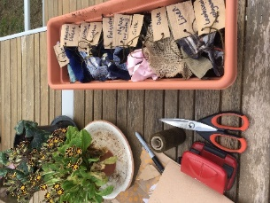
Time required: 45 minutes plus weekly/monthly checks for 12 weeks/months?

Introduction to Activity:
Textiles are the name given to the material used to make clothes, bedding and towels. They are flexible, strong and durable, while some are insulating or waterproof.

Humans have been making fabric out of fibres from animals or plants for millennia – the oldest fibres ever found were from flax grown over 40,000 years ago. It is likely that some of the first crops were grown for making textiles, while sheep and goat wool would have been woven or felted into fabrics at a similar time. In modern times plastic polymers have been used to make fabrics like nylon and polyester.

Across the world many clothes end up buried in landfill sites. Textiles made from natural materials will decompose naturally in soil, but clothes made from plastic will never degrade fully. This fun experiment looks at how fast different materials take to degrade.

Main Activity:
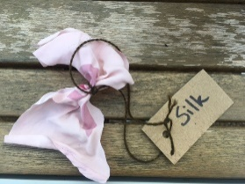
Put some active compost or soil in a large pot. Cut the fabric into pieces of the same size and tie a label onto them. Write the type of fabric on the label (you may need to look at the clothes label to find out what the fabric is made from). Predict from your knowledge of materials which fabrics will last longest in the soil.
Bury the pieces of textiles in the soil, with the label showing. Leave in a somewhere the pot will remain undisturbed.
Look at the textiles each week for 12 weeks and see what happens to the cloth. You could even leave them untouched for a year and see what happens.

Results:
Were your predictions right? Which materials persisted in the environment and which decomposed? Can you rank the textiles in order of time it takes to decompose?

Explanation:
Natural materials like bamboo viscose and sheep’s wool will decompose quickly. This is because micro-organisms in the soil will eat them and turn them back into soil nutrients. This process is natural recycling called composting.
Synthetic materials like nylon, polyester and lycra will never decompose fully as there are no micro-organisms that can use them as nutrients. They will be broken down by the wind and sun into small pieces called microplastics, but if buried will last forever in the soil.

Extension Activities:
Recycling textile is difficult as they need to be unwoven and reworked into new clothes. Reuse is the best option as they are long-lasting and can be worn again. Many second-hand clothes are good quality as they are often unworn. In recent years it is estimated that about half of people’s wardrobes remains unworn and the average item is only worn 10 times before disposal.
A good phrase to remember is Buy Less, Wear More, or Love What you Own. Take a look at your wardrobe or those of the adults around you and see what you could pass on to someone else, through second-hand shops or local clothes swaps.

Extra Resources:
Take a look at our resources about clothes on our Zone Education website: https://zone.recycledevon.org/clothes/ and on our Recycle Devon website: https://new.recycledevon.org/love-your-clothes.

There are some great resources for more lessons on textiles and clothes at TRAID: https://traid.org.uk/education/education_resources/.
Share your pictures with us on Facebook, Twitter or Instagram by tagging @RecycleDevon #recycledevon

Make sure you have permission to share any photos first.

