Home Education Activity: Rainbows in a Glass

Lesson Objective:

To use a glass to split light into colours and make a rainbow indoors.

Science National Curriculum links:

KS1 & KS2 – Working scientifically

Y6: Light – extend their experience of light to include rainbows.

KS3: Light waves – colours and prisms

Resources:

A tall clear glass

Water

Sunlight through a window

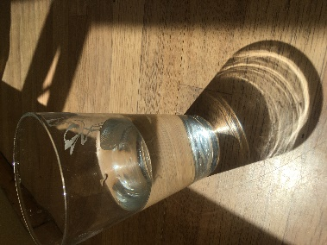

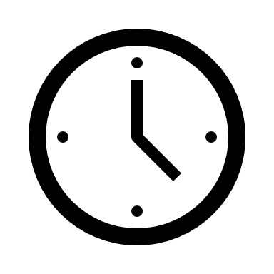
Time required: 30 mins

Introduction to Activity:

Glasses are very useful for a range of science experiments as they are designed to hold liquids and are clear so you can see what is happening!
You can also use a glass of water to split light into the colour spectrum, as happens naturally when a rainbow forms when it’s raining and sunny.

Glass is a material with the unique property of being clear enough for light to pass through it easily: which is why it is used for windows! It was the first man-made material invented that was transparent enough to do experiments with light.

In 1666, when he was studying at Cambridge University, Newton placed a prism in a narrow beam of light, which he created by making a small hole in the dark curtains in his parents’ house in Lincolnshire. He noticed that a glass prism not only turned white light into a rainbow of coloured light, but could also do the opposite, turning a rainbow of light back into white light.

You can recreate his early experiments at home and use it as a learning opportunity to discuss light, spectrums and rainbows.

Main Activity:
- Fill a tall glass with water. This acts as your prism.
- Wait for a sunny day!
- Find a shaft of sunlight through a window into a dark room. This is best in morning or evening light.
- Place the glass directly in front of the light.
- Watch the rainbow appear!

Results and Discussion:

What do you think causes this spectrum of colours?

Do the colours look the same as a rainbow?

Why is there a particular order behind the colours?

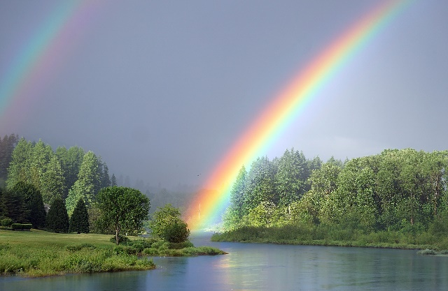
Newton’s work revolutionised the study of light. From his initial findings scientists developed theories about the electromagnetic spectrum. They also founded the science behind spectroscopy which discovers what other planets and stars are made from. All this from working out what caused rainbows!

White light contains all the colours of the rainbow. There’s a good description of the science (suitable for KS3 students) behind the experiment here: https://micro.magnet.fsu.edu/primer/java/scienceopticsu/newton/
Photo of a rainbow over trees and water from Pixabay. Image credit: sharonjoy17

Further Work:

Could you place another prism (glass of water) in the rainbow? What does it do?

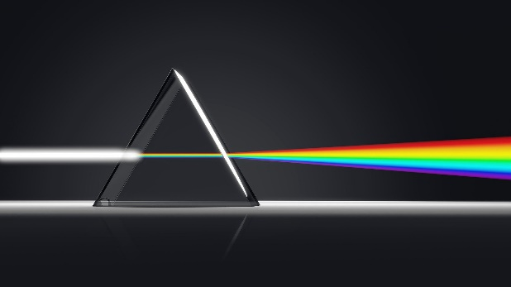
Extra Resources:

Find out more about glass as a material, including how it is recycled, on our website: https://zone.recycledevon.org/glass/

The Royal Society of Optometrists have a good Virtual Gallery of Newton’s work into light and prisms: https://www.college-optometrists.org/the-college/museum/online-exhibitions/virtual-observatory-gallery/newton-and-the-colour-of-light.html
Image of a prism dividing white light into rainbow spectrum from Pixabay. Image credit: Daniel Roberts

We would love to see your rainbow glass photos! Share them with us on our social media by tagging us in! @RecycleDevon #ScienceOfMaterials

