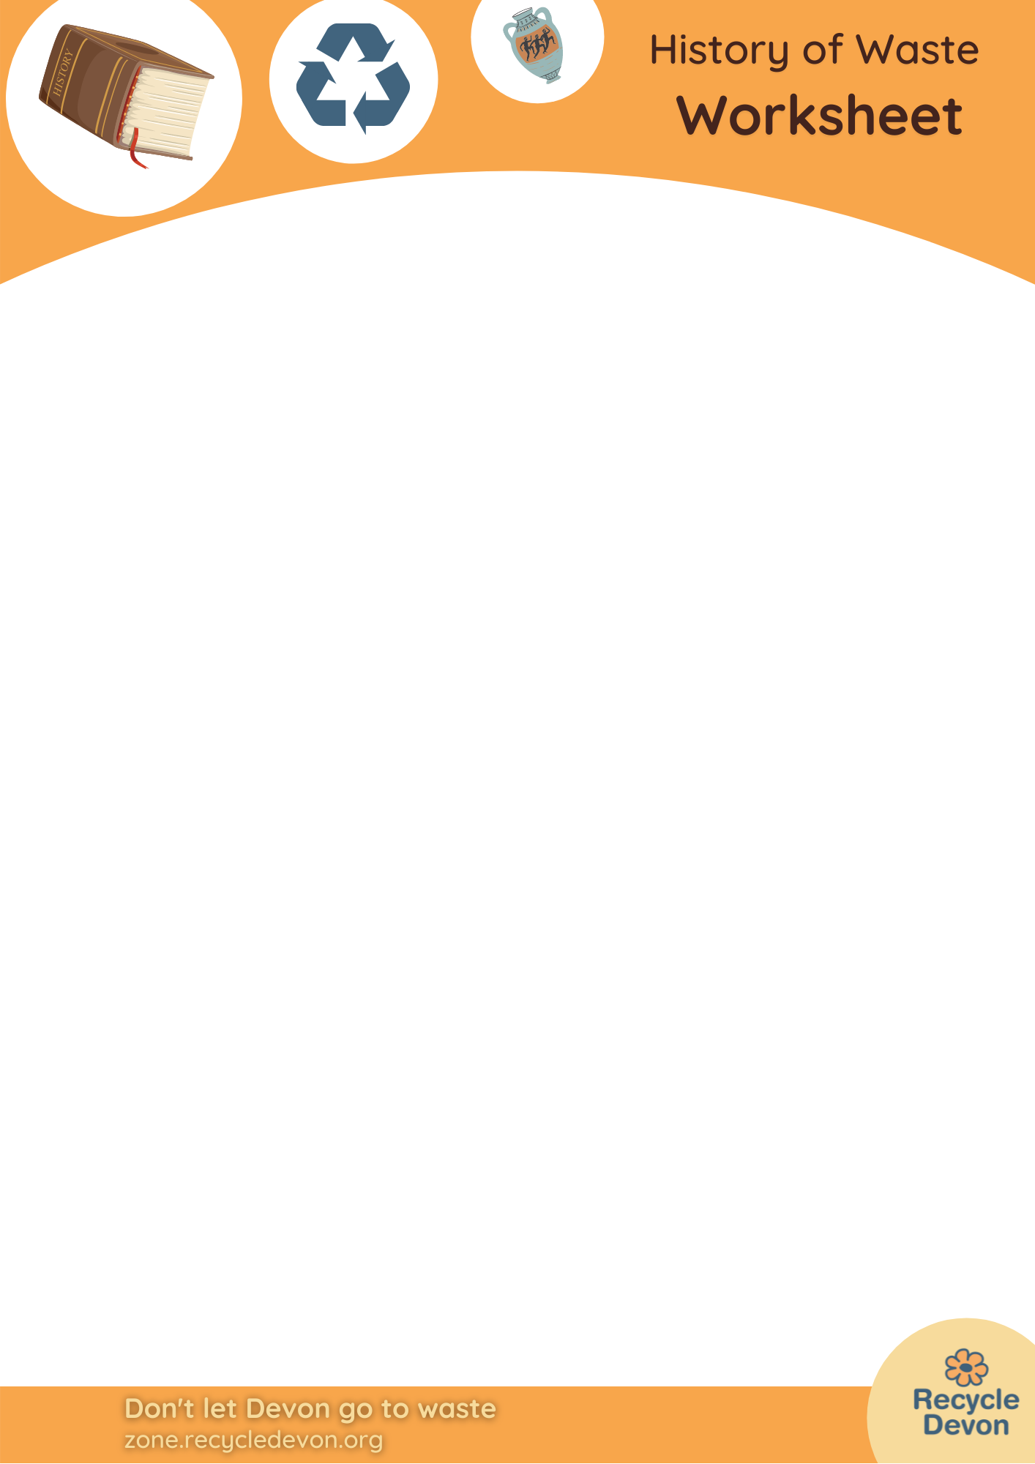

Waste in the Iron Age

What would I have thrown away in the Iron Age?

Choose from these words:
Sawdust
Old Needles
Bones
Clinker or slag
Pot Shards
Millstones
Broken plough blades
Loomweights
Broken toys
Job | Picture of tools | Description | Waste
Potter | 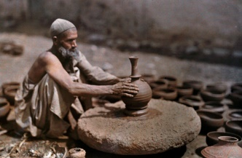 | Potter’s wheels were made of stone, rope and wood. Pots were made from clay. Clay would have been remoulded if it broke apart, but pots become too hard to rework (recycle) when they are fired in a kiln.
Carpenter | 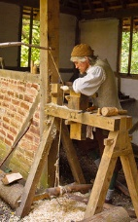 | Lathes were made from wood and string, while tools like chisels had metal blades, like today’s hand tools. Wood shavings would have been used as kindling to start fires.
Metalworker | 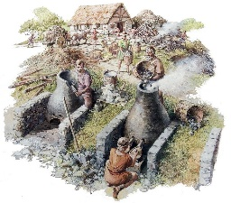 | Smelting iron to produce metal tools was vital to Iron Age society. Metals would have been recycled.
Farmer | 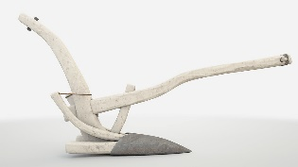 | Ploughs had metal blades.  What other tools do farmers use?
Weaver | 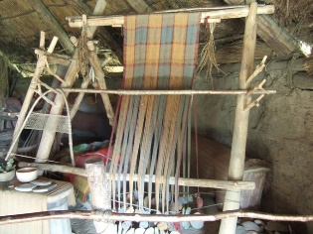 | Looms and spindles were made of wood while loomweights were made of stone. Fabric was always made from natural materials like wool or linen.
Miller | 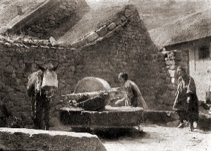  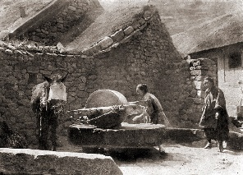 | Grain was milled into flour by hand with a rotary quern, or bigger stones were driven by mules or donkeys.
Child | 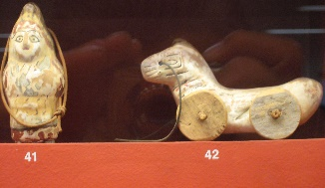 | Toys would have been made of wood.  Do you think you would have left any food on your plate?
Cook | 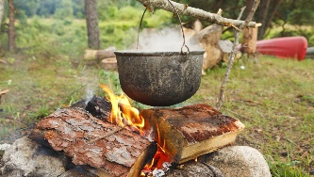 | Cooking was done in pots over fires or on hot stones near the fire. Food was valued and eaten quickly.
Tailor or seamstress | 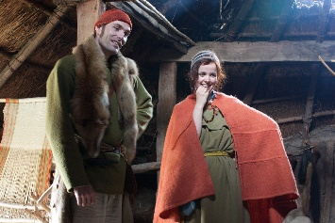 | Woven fabric would have been sewn with bone needles and yarn made from natural fibres. Brooches or toggles held clothing together.

Extension Questions

1. When was the Iron Age?
2. What other occupations and their associated rubbish can you think of?
3. How has rubbish changed since the Iron Age?
4. Describe the difference between things that are lost and things that are thrown away?
5. Look at the Iron Age finds in the British Museum (these are available online here: https://www.britishmuseum.org/collection/galleries/britain-and-europe-800-bc-ad-43) What was lost, what is from burial sites and how much is domestic rubbish?
6. What will archaeologists of the future find from the Modern Era?

