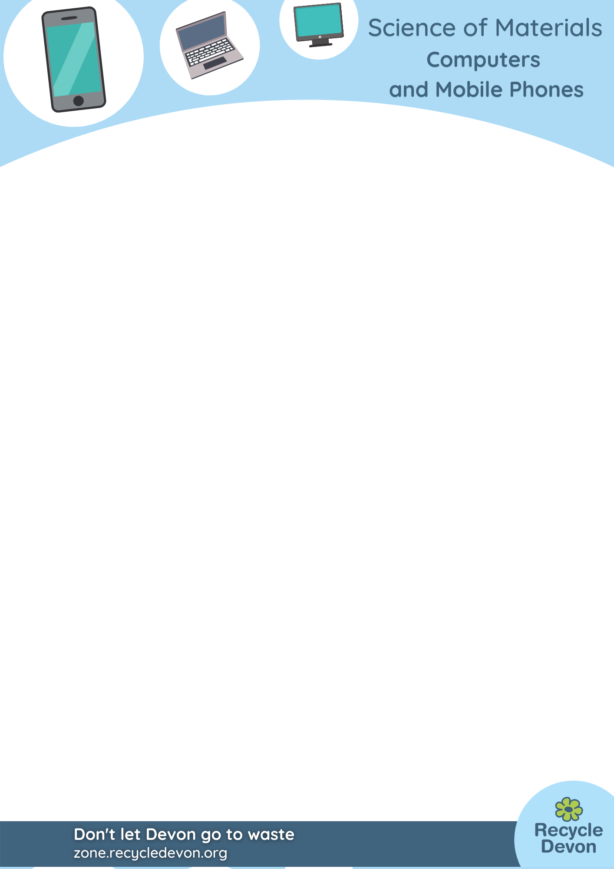

KS1 Computers and Mobile Phones: What’s in a phone?

Lesson Objective:

To sort out natural and man-made materials and objects

Science National Curriculum links:

Y1 Science: Everyday materials – Distinguish between an object and the material from which it’s made.

Y2 Science: Uses of everyday materials - Identify suitable materials for particular uses.
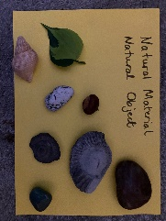

Resources:
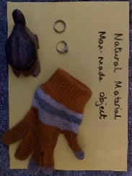
- A selection of materials and objects that are both natural: pebble, mineral crystal, shell, bone, feather, fossil, bamboo cane, seed, fruit (nuts/seed-heads), sheep fleece, raw cotton.

- Natural material, man-made objects: carved or polished stone, carved or turned wood, woollen clothing, cotton clothing, woven basket, roof slate/tile, bottle cork, gold or silver jewellery
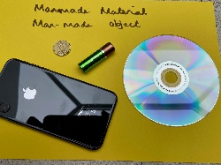
- Material and object both man-made: glass bottle, plastic bottle, cardboard box, book, mobile phone, laptop, tablet, battery.

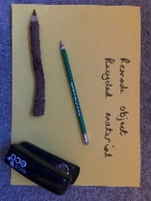
- Recycled or re-made objects: recycled pencil, stapler made from recycled plastic, a clipboard made of a computer mother-board, a bag made from recycled plastic bottles, a water bottle made from recycled material.

Time required: 1 hour

Introduction to Activity:
In order to make decisions about complex materials and their properties children must first understand that different materials are used to make different objects. This helps them understand that mining materials from the ground means that they will run out, unless we recycle them.
This activity helps children sort out man-made materials from natural materials and understand how complex items like computers and mobile phones are made from lots of different materials.

Main Activity:
DID YOU KNOW?
A smartphone can contain up to 30 different elements. Some of these are mined from the ground and will run out.
There are an estimated 40 million devices sitting unused in drawers in people’s homes. It would be amazing if these can all get recycled!
Talk about the items, have they seen them before, what do they think are they made from?
Introduce the difference between man-made and natural materials. Explain how oil is taken from underneath the sea, then refined into plastic and that metals are mined from rock. You could use the pictures in the Resource Gallery to help explain this. Talk about clothing made from plastic and wool. Use the pictures to help.
Ask children to sort the objects/items into the four different categories. Use labelled tables or pieces of paper to help them move the objects around. This could be done as a class or as groups, depending how many objects you have been able to collect.
Now fill in the table. This could be done as a whole class activity, or as smaller groups with guidance.

Results:
Object  (What it is) | Material (s)  (What it’s made from) | Man-made or Natural

Discussion:
Discuss what materials make up our everyday objects like smartphones and laptop computers. Substances with special properties called semiconductors are vital, as are special rare earth and precious metals like gold and platinum.
Talk about why recycling items is so important – so we can use the resources again and don’t have to mine new materials from the ground.

Find out if your school could have a recycling collection for old devices. Many companies will collect and take back mobiles, and even give schools money back if they collect up a number of devices. See https://zone.recycledevon.org/funding/

Extension Activity:
Find out some of the substances that make up smartphones and where they come from.

Extra Resources:
For further information about smartphones and other gadgets languishing in our homes read: https://www.bbc.co.uk/news/science-environment-49409055 and the Royal Society of Chemistry teaching resources: https://sustainability.rsc.org/

