Electrical Equipment KS1 Activity: Sorting Salt & Pepper

Lesson Objective:

To find out how to separate salt and pepper using static electricity.

Science National Curriculum links:

**KS1: Working Scientifically** - Asking simple questions and recognising that they can be answered in different ways; observing closely; using their observations and ideas to suggest answers to questions.

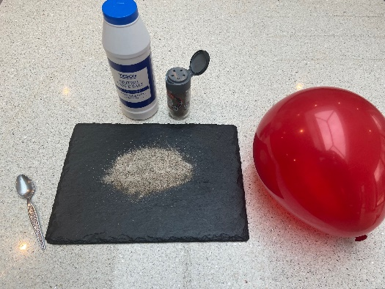Resources:

* Balloon
* Black paper
* Salt (free flowing fine grain)
* Pepper (ground black)
* Teaspoon
* Microfibre cloth or item of clothing/material made from polyester



Time required: 1 hour

Introduction to Activity:

*Have you ever got an electric shock from a person or door handle?*

*Have you seen lightning?*

*Have you noticed dust collecting on screens of TVs or computers?*

If you have noticed any of these you have seen or felt the effect of static electricity! This experiment uses static electricity to separate salt and pepper which have been mixed together. It gives the opportunity for using good scientific questions:

*Why is this happening?*

*What could explain this experiment?*

*What could we do with this knowledge?*

Main Activity:

Each group or table should have the equipment in front of them. Mix a teaspoon of salt with a teaspoon of pepper on the black paper or slate.

Ask how they think they could separate them. Depending on the scientific knowledge of the group answers might include sieving, filtering, dissolving.

Get them to blow up the balloons. Now ask them to rub the balloon on some polyester or acrylic cloth – this could be microfibre cloths, a school jumper or a fleece type material. Now place the balloon above the salt and pepper mixture and observe and record what they see.

**DID YOU KNOW?**

Static electricity is used in lots of our everyday electrical equipment like photocopiers and computer printers.

It can cause problems for people making and repairing electrical items. At electrical repair shops or Repair Cafés people repair electrical equipment on special insulating mats to stop static electricity damaging the electrical equipment.

Results:

Children should record that the pepper separates from the salt by sticking to the balloon. They could do this with a picture or a photo (if tablets are available in class.)

Discussion:

Why do they think this happens? Enable a discussion around what it could be that makes the pepper stick to the balloon. Maybe ask if the balloon would separate the mixture without being rubbed on the cloth. What has the cloth given to the balloon?

Here’s some revision in case you don’t know what causes static electricity: <https://www.bbc.co.uk/bitesize/guides/zt7t4j6/revision/2> It only enters the science curriculum at GCSE level.

***A Simple Explanation:***

***The balloon collects charged particles from the cloth which attract small, light pieces of pepper. The heavier salt particles stay on the mat.***

Extension Activity:

Act out what is happening as a class! Some children could be salt, some pepper, some the balloon and some charged particles. This could be played like a Tag game in the playground.

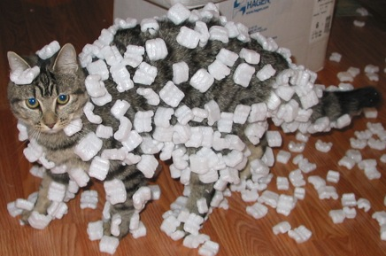Extra Resources:

Take a look at the video showing salt and pepper being separated using a plastic spoon: <https://youtu.be/k0OoLyEaf1k>

There are some other static electricity experiments to try: <https://youtu.be/_DwNuxNQ_5M>

By Original image: Sean McGrath from Saint John, NB, Canada

**Share your pictures with us on Facebook, Twitter or Instagram by tagging @RecycleDevon #recycledevon**

Make sure you have permission to share any photos first.