Glass KS1: Making Glass Music

Lesson Objective:
To make music with glasses and play around with sound.

Science National Curriculum links:
Y1 Science: Everyday Materials – pupils should be taught to distinguish between an object and the materials from which it is made; identify and name a variety of everyday materials; describe the simple physical properties of everyday materials; compare and group together a variety of everyday materials on the basis of physical properties.

Resources:
- A selection of glasses (maybe include some crystal wineglasses for demonstrating)
- Water
- Jug
- A spoon for tapping
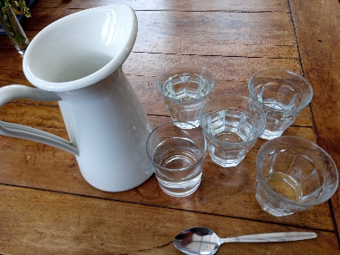
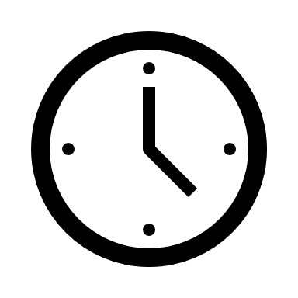
Time required: 45 mins

Introduction to Activity:
This activity is fun and a true learning experience if it goes well. The first time a child hears a note from a crystal wine glass is magical.
However, this activity requires a certain amount of trust and bravery, as children play around with making music with glasses. You know your group best – do not attempt if you think this is too difficult for them. Do attempt if you want a challenge and to make some musical magic, but do be prepared for possible breakages.

Place a collection of drinking vessels in the middle of each table.
Start the activity by talking about materials that drinking vessels can be made of, compare a mug with a paper cup, plastic beaker and a glass. What are the similarities? What are the differences? What are the properties of a good holder for liquids?

Possible link to History: what did Iron Age people, Vikings or Romans use for drinking? How do we know? (Answer: Pictures from the past and by archaeologists uncovering lost and buried items.)
Archaeologists find old pieces of metal, glass and ceramic. Why do these last well?
Main Activity:

Arrange for each table to have several glasses (enough for one per child). Fill the glasses with different amounts of water. Demonstrate how to get a sound from the glass by gently tapping the spoon on the glass. (NOTE: this is safer and more hygienic than the classic lick your finger and rub it round the rim of the glass method.)

Show the video: https://youtu.be/D-mRZUa9NO4
Ask the children to play the wine glasses. Can they get a good sound? Encourage gentle tapping and musical sounds.

Link to KS1 Music: Pupils should be taught to: play tuned and untuned instruments musically; experiment with, and create and combine sounds.

Results:
Use these words to describe the properties of the drinking vessels:
Flexible (bendy) / rigid (not bendy)
Transparent / translucent / opaque
Heavy / light
Smooth / rough
Shiny / dull
Floats / sinks

Discussion:
Discuss sounds that came from the glasses.
Why do children think the best and clearest sounds come from crystal glasses? (Demonstrate this if possible)
Why are wine glasses better than beakers?

Extension Activity:
Can they make a tune on their table? Try something easy like “3 Blind Mice”. You could even award prizes or house points for the most musical table.

Home Schooling:
This activity could be done by children at home with help from an adult, using glasses from around the house.

Extra Resources:
See our webpages (https://zone.recycledevon.org/glass/) for more information about glass and how to recycle glasses.
The Youtube playlist that accompanies this activity has videos about playing the wineglasses and making a glass organ.
Share your pictures with us on Facebook, Twitter or Instagram by tagging @RecycleDevon #recycledevon

Make sure you have permission to share any photos first.

