Paper KS1 Activity: Tearing Newspaper

Lesson Objective:

To find out how and what paper is made from and learn about paper recycling

Science National Curriculum links:

Y1: Everyday Materials – to distinguish between an object and the material from which it is made.

Y2: Uses of Everyday Materials – find out how the shapes of solid objects can be changed.
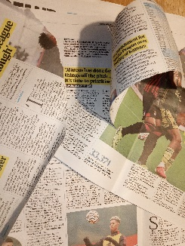

Resources:

- Newspaper
- Extension activity: different colours of sugar paper & glue

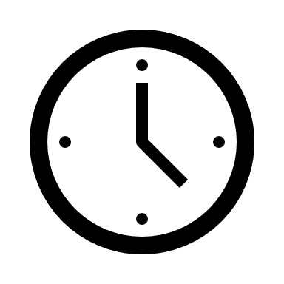

Time required: 1 hour

Introduction to Activity:
Paper comes from trees. trees are chipped into small pieces then turned to a mush, then rolled or squashed in big machines. The fibres all line up in the paper, which creates a grain within the paper. You can see this when you try to tear it.

Start the session by asking about different types of paper, what they think it’s made from, whether children recycle paper at home and at school and where they think it goes after it is put in a recycling truck.

Now show the video showing the journey of paper from kerbside pick-up to recycling depot, then off to be turned back into paper again: https://youtu.be/To7f-wPgomI

Main Activity:

Children take a sheet of paper and try to tear it one way, then turn 90 degrees and try to tear.

Results:
It will be easier to tear in one direction than the other. Ask children to think about why.
DID YOU KNOW?
Paper can be made from any kind of wood fibre – from bamboo to birch, pine to eucalyptus. Most often scrap and offcuts from the lumber industry is used to make new paper.

Discussion:
Paper is made of fibres of wood called cellulose. These line up in one direction because of the action of the rollers in paper factories.

Newspapers (and most other papers) have a “grain,” a direction in which the wood fibres are lined up. If you tear parallel to these fibres (“with the grain”), the tear is straight. If you tear perpendicular to these fibres (“against the grain”), the tear is rough and jagged.

Children could compare different kinds of paper to see if different types of paper have different kids of “grain”.

Extension Activity:
Strips of torn up newspaper don’t need to be thrown away. Use them in our papermaking activity: https://zone.recycledevon.org/papermaking/

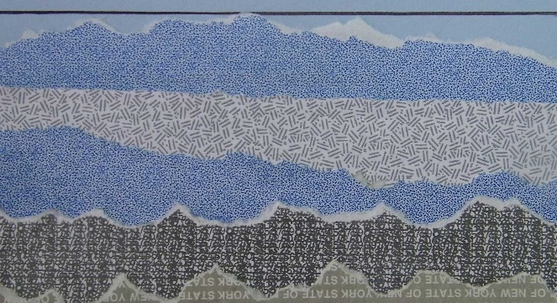
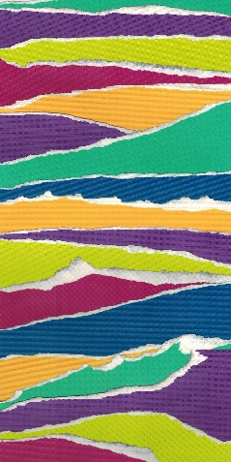
Paper tearing could lead to a satisfying art project using different coloured sugar paper or strips of magazines:
Extra Resources:
This activity can be done with nursery, pre-school and reception age groups: https://earlylearningideas.com/tearing-paper-activities/

Set up a scrap paper tray in the classroom to reuse paper. The school should be able to have a free paper collection from your local District Council or other waste collection service. Check the school is making use of this!
Share your pictures with us on Facebook, Twitter or Instagram by tagging @RecycleDevon #recycledevon

Make sure you have permission to share any photos first.

