Plastics KS1: Properties of plastic

Lesson Objective:
To name materials that everyday objects are made from;
To understand that plastic has many different properties that make it useful for different applications.

Science National Curriculum links:
Y1 Science: Everyday Materials – pupils should be taught to distinguish between an object and the materials from which it is made; identify and name a variety of everyday materials; describe the simple physical properties of everyday materials; compare and group together a variety of everyday materials on the basis of physical properties.

Resources:
- A selection of plastic items such as plastic bottles, clingfilm, plastic bags, plastic toys, Lego.
- Bowl of water big enough to fit the objects
- Torch
- Scales

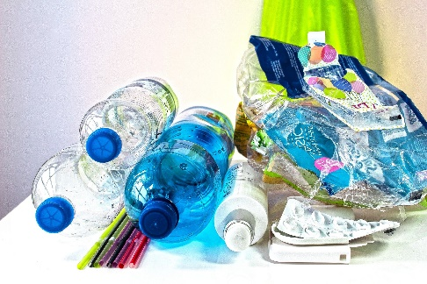Image from Pixbay
.
Watch a video of this activity on our Zone website.
Go to http://zone.recycledevon.org
Time required: 60 mins

Introduction to Activity:
- Ask the class to think of some materials and then name objects made from those materials.
- Plastic search – send children around the classroom (or home) looking for items made of plastic. How many can they find in one room? Too many to count? Can they estimate?

Main Activity:
Place a collection of plastics with different properties on each table. These should include plastic bags, cartons, plastic film, plastic tubs, like yogurt pots, plastic toys like Lego.
Ask children to find items with different properties – use the words listed over the page. They can use the torch to decide if an object is transparent and a bowl of water to decide if the object floats or sinks. Weigh the objects to find which are heavy and which are light. How would they decide if an object was smooth/rough or hard/soft?

Results:
Use these word pairs to describe the properties of the plastic items:
Flexible (bendy) | Rigid (not bendy)
Transparent | Opaque
Heavy | Light
Smooth | Rough
Shiny | Dull
Floats | Sinks

Some plastic items may have more than one property – can the items be sorted in different ways? Using different categories?

Discussion:
Discuss as a class the properties of plastic that make it an excellent material for some items (light, hard, durable, long-lasting). Make sure the children know that most plastic is made from oil which is a non-renewable resource as it will run out. Ask if this can keep on happening. Make sure children understand that making plastic is not a sustainable use of resources.
Discuss how long-lasting plastic is. It will never break down entirely, but splits into smaller and smaller pieces called microplastics that end up in small animals like plankton and insects, which are eaten by bigger animals. These eventually end up in humans.
Discuss the importance of recycling plastic at home and not littering plastic so that it does not end up in the environment and eventually the sea. Talk about the issues around litter in your local area.

  - Extension Activity:
Different plastics can be recycled in different areas – check your local recycling collection (https://zone.recycledevon.org/practical-information/). Most other plastics can be recycled at Recycling Centres – see if children know their nearest one (see map: https://www.devon.gov.uk/wasteandrecycling/centre/).
Ask the children to make a pile of all the plastic items that can be recycled at home. Discuss what to do with items that can’t be recycled. Think about ways to reduce plastic rubbish. This could include reuse like using containers or drinks bottles again and again, dividing up bigger bags of items like crisps and snacks.

  - Home Schooling:
This activity could be done by children at home with help from an adult, using objects from around the house. Use our video resources below.

  - Extra Resources:
See our webpages (https://zone.recycledevon.org/plastic/) for more information about plastics. Our video channel has videos about plastic pollution and microplastics (https://zone.recycledevon.org/videos/).

We have also created a video playlist to accompany this activity: https://youtube.com/playlist?list=PLHby835r5GWXOeei5OEQJanEC4znXUOm

