KS1 Activity: Keeping us warm

Lesson Objective:

To understand how well different clothes keep us warm.

Science National Curriculum links:

KS1 – Working scientifically: observing closely, use observations to suggest answers.

Y2 – Uses of everyday materials: identify and compare the suitability of everyday materials for particular uses.

Lower KS2 – Working scientifically: make systematic and take accurate measurements using a range of equipment, including thermometers; record findings in tables.

Resources:

- Several plastic bottles (squash, water or fizzy drink)
- Hot water
- Pieces of clothing made of different materials, like nylon, wool, cotton, linen, polyester fleece (see Table of Results for examples)
- Rubber bands
- Thermometer
- Stopwatch

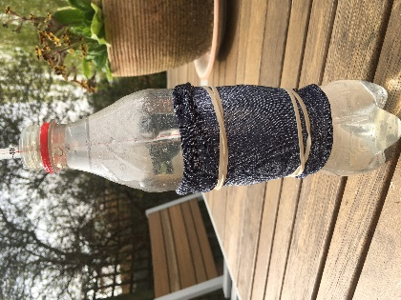
Time required: 1hr

Introduction to Activity:

Textiles is the name given to clothes and other fabric items like bedding and towels. We use clothes like jumpers and coats to keep us warm during the day and bedding like duvets and blankets to keep us warm at night. As a preparation for the experiment ask children to bring in clothes that they don’t wear any more and can cut up for the experiment (check with parents).

This simple experiment helps KS1 children measure and understand how clothes made of different fabrics insulate us.
Lesson Starter: Use Mix and Match Cards for a fun icebreaker.
Watch this video together: https://youtu.be/HALlE-aJotM Discuss which clothes keep us warm. Introduce the experiment – keeping a bottle warm to show how clothes keep us warm.
Main Activity:
Get into groups (as many as samples of fabric). Predict which fabrics (groups) will keep the bottle warm best. Talk about how to measure temperature (temp) with a thermometer.
Put some hot water from the tap in the bottle. Wrap the fabric around the bottle and secure with elastic bands.
Take the temperature (groups may need adult help with this if using liquid thermometers rather than digital) and record on the sheet. Start the stopwatch.
Record the temperature in the Results table after 5, 10 and 15 minutes (adult support may be needed at this point too).

Results:
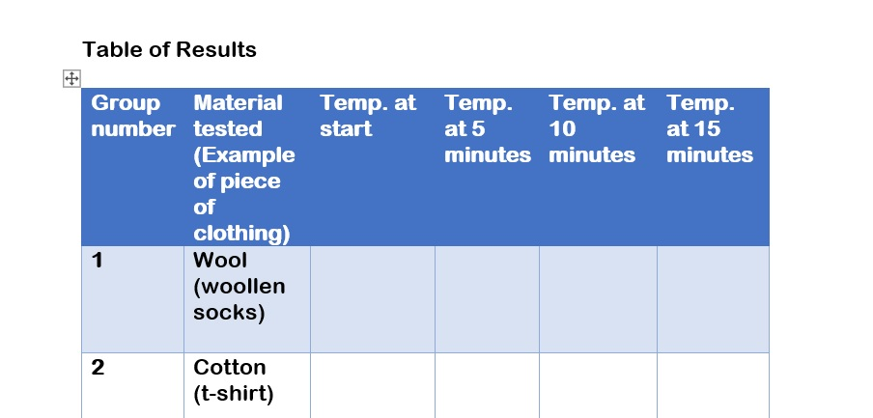
Discuss the results as a class and take answers from each group.
Compare the materials: Which was the fabric that kept the water warm for the longest? How do you know?

Explanation:
Different fabrics have different insulation properties. That’s why we wear big warm coats, hats, gloves and scarves in winter.
It’s better to pass clothes on than waste them. Give clothes that you’ve grown out of to someone else. Homeless shelters and refugee charities often collect winter clothes so people can keep warm. Some towns or libraries have a Give and Take rack for coats in winter. Maybe your school could organise a clothes swap to pass clothes on.

Extension Activities:
What are your warmest clothes?
Do different layers work better?

Extra Resources:

See our pages about textiles on the Zone website to discover what happens when clothes are recycled.
Share your pictures with us on Facebook, Twitter or Instagram by tagging @RecycleDevon #recycledevon

Make sure you have permission to share any photos first.

Table of Results

Group number | Material tested (Example of piece of clothing) | Temp. at start | Temp. at 5 minutes | Temp. at 10 minutes | Temp. at 15 minutes
1 | Wool (woollen socks)
2 | Cotton  (t-shirt)
3 | Polyester (fleece)
4 | Linen (trousers)
5 | Nylon (pair of tights)
6 | Viscose (pair of socks)

