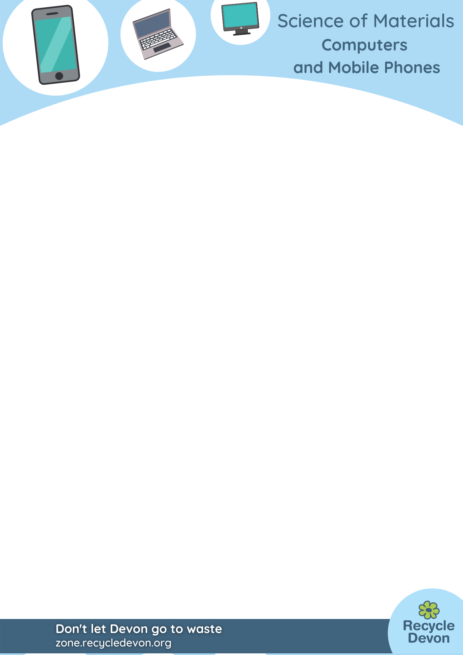

Computers and Mobile Phones: Taking apart your phone (and mending it!)

Lesson Objective:

To learn what’s inside computers and mobile phones, and to learn that repair and reuse is better than throwing old items away.

Science National Curriculum links:

Y4 Science: Electricity - Identify common appliances that run on electricity.

Resources:
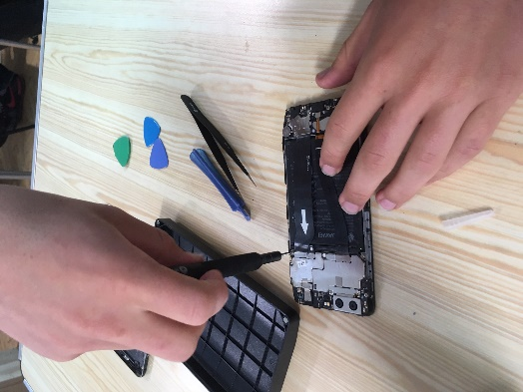
- old computer parts like keyboards and mice (not screens)
- laptop, tablet or mobile phones – old and unused ones that have not been charged for at least a month
- set of small screwdrivers
- magnifying glass
- tray
- plastic tubs to hold small screws

Time required: 1 hour
Phone repair at a Repair Café. Photo credit to Lucy Mottram, Devon County Council.

Introduction to Activity:
All of us probably have a non-functioning laptop or mobile phone somewhere in our homes. This activity helps children to see that these can be taken apart and mended, and what is inside them

Main Activity:
The aim of the main activity is for children to have an opportunity to look inside mobile phones and laptop computers. This helps with understanding about how different materials are used and the variety of components inside a complex digital item, plus will help children understand that even these complex items can be taken apart and mended. Many of our greatest engineers learnt their trade by disassembling machines and learning how to put them together.

NOTE: There is lots of advice about household items that should not be taken apart. These include microwaves, cathode ray tube (CRT) televisions (or old CRT computer screens) and anything containing old capacitors. Modern equipment with lithium batteries should not be tampered with if the lithium battery is hot or damaged as they can be dangerous.
Results:
DID YOU KNOW?
An estimated 5 billion phones are thrown away every year across the world. Less than 20% of electrical equipment (e-waste) is recycled, and even less is repaired and reused. Britain is rapidly becoming the worst country in the world for e-waste, with 103,000 tonnes of electricals (including phones and computers) discarded every year. The average home has 30 unwanted electricals hiding in cupboards, drawers and attics.
Recycle mobile phones - What you can do with old phones
Children should learn that mobile phones, tablets and laptops are difficult to get into, often with tiny screws and covers that are glued in place. Many are not designed to be mended, meaning they are thrown away when they get old and break.
Items like computer mice and keyboards are easier to take apart. Can they work out how they work?

Discussion:
Can students think of reasons why throwing away mobile phones, computers and laptops is bad for the environment and for human health. It might help to break impacts of e-waste into 4 categories:
- Resources
- Economy
- Financial value
- Climate change
Discuss how many chemical elements there are inside a mobile phone. See the poster attached below.
Discuss why repair is important and discuss how it fits into a Circular Economy. (See All about the circular economy - National Geographic Kids for a useful guide for children). Should manufacturers be building more repairable mobiles and laptops?

Extension Activity:
Visit a local repair café (there are nearly 40 across Devon) or ask them to come into school and demonstrate what they do.
There’s a Repair Club and educational resources around repair for 10-14 year olds here: Team Repair. Ideal for a school STEM club.

Extra Resources:
For further information about Repair Cafes in your area check out the Recycle Devon pages: Repair Cafe - Recycle Devon.
Share your pictures with us on Facebook, Twitter or Instagram by tagging @RecycleDevon #recycledevon

Make sure you have permission to share any photos first.
