Cardboard KS2 Activity: Can you make cardboard out of cardboard?

Lesson Objective:

To make recycled cardboard out of an old cardboard box

Science National Curriculum links:

**Y5 Science: Properties and changes of materials –** know that some materials will dissolve in liquid to form a solution and describe how to recover a substance from a solution; use knowledge of solids, liquids and gases to decide how mixtures are separated, including through filtering, sieving and evaporating.

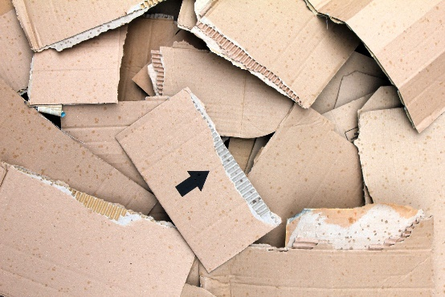Resources:

* old cardboard box
* packaging tape
* tray of water
* scissors
* blender
* flat surface/draining board
* 2 J-cloths, a tea towel, piece of an old sheet or similar
* container for blended card slurry

Corrugated cardboard picture from Pixabay: free to use.

* heavy objects such as 1kg weight
* space to leave card to dry



Time required: 1 hour (plus 1-4 days drying)

Introduction to Activity:

Introduce the activity by talking about cardboard boxes and how useful they are. Ask the class about where they have seen cardboard boxes being used?

Cardboard is a fantastic material as it is light, sturdy yet flexible and easy to shape into different sizes, easy to recycle and cheap. We use cardboard boxes for carrying items, posting items as parcels, moving house, storing items – but where do they come from and how do we recycle them?

Much of the cardboard coming into our homes, schools and business does so when it is delivered as boxes. Then we flatten it for collection by our local councils and recycling by specialist cardboard recyclers. Most cardboard in this country has a recycled content of over 50%, some boxes can have up to 80% recycled content. Discuss as a class why they think it isn’t 100%.

Main Activity:

**DID YOU KNOW?**

An average British family throws away 6 trees worth of paper each year. In the UK, cardboard has the highest recycling rate compared to any other packaging material in the world.

At the moment, cardboard is the most environmentally friendly and carbon efficient packaging solution available. Cardboard is cheaper, easier and uses less energy than other packaging types, mostly because of the amount of recycled cardboard present in corrugated boxes (up to 80%).

Cardboard is easier to recycle than it is to make new. Recycling a ton of cardboard saves 3182 litres of water, 210 litres of oil and only uses 75% of the energy needed to make new cardboard. Recycling saves 390 kWh of energy. A cardboard box could be recycled into a new recycled cardboard box in just 2 weeks, and delivered back to you!

Tear cardboard into small pieces and submerge in water. Leave to soak until soggy (20 minutes). Drain some of the excess water off, then use an electric blender to turn the card and water mixture into sludge.

Spread the sludge out on one of the pieces of cloth and cover with the other. Lay the other piece of cloth on top and place on a draining board. Weigh down with a heavy weight and leave to dry. This may take between 1 day or 3 days. When dry peel the new card away from the cloth (you won’t be able to do this until the recycled card is dry).

Results:

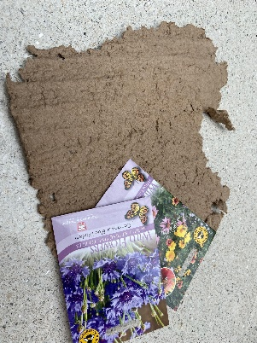What has happened to the card? Did it dissolve in the water? How did the new cardboard form? Is it more fragile than the corrugated box that it was made from?

Discussion:

How could strength be added to the new recycled cardboard material? Could you make it back into a box?

Extension Activity:

Add seeds to the mixture as it dries to make seed card and decorate when dry – an ideal Mother’s Day gift!

Extra Resources:

For further information: <http://zone.recycledevon.org/materials/card>

**Share your pictures with us on Facebook, Twitter or Instagram by tagging @RecycleDevon #recycledevon**

Make sure you have permission to share any photos first.