Electrical Equipment KS2 Activity - Ice cube tray battery

Lesson Objective:

To make a battery out of simple household objects.

Science National Curriculum links:

Y4: Electricity – Identify common appliances that run on electricity; Construct a simple circuit; Identify whether a light will turn on in a simple circuit; Recognise common conductors and insulators and associate metals with being good conductors.

Y6: Electricity – Use recognised symbols when representing a simple circuit; compare and give reasons about what might affect the brightness of a LED light.

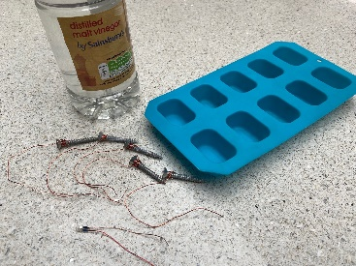
Resources:
- Ice cube tray
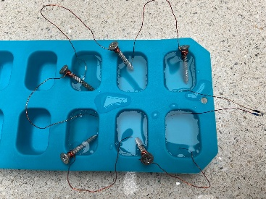
- Vinegar
- LED light
- 5 Galvanised nails
- Length of bare copper wire cut into 5 equal lengths
Time required: 1 hour

Introduction to Activity:
How many electrical circuits are present in your classroom/house?
How many batteries do you use?
Where does the electricity in batteries come from?

Children should be able to recognize that anything with a battery or plug and cable runs off electricity. Ask them to identify how many small electrical items there are in their classroom or house. The BBC and Twinkl have some useful electrical safety resources: https://www.twinkl.co.uk/resource/ks2-electricity-safety-powerpoint-t-p-732 https://www.bbc.co.uk/bitesize/topics/zjrrd2p/articles/z96ckqt

Main Activity:
Wrap the pieces of copper wire around the nails, leaving a long tail of wire. Fill 6 of the ice cube trays with vinegar. Place the nails into the vinegar, with the copper wire in the neighbouring one. Place the LED light between the two last trays. It should turn on. If not turn the LED light around as the flow of current might be going in the opposite direction.

IMPORTANT: Make sure there is a single point of entry into each ice cube pod (pool of vinegar) for both the galvanised nail (zinc) and the wire (copper).
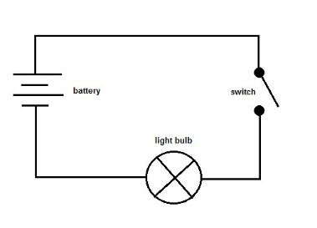
DID YOU KNOW?
The battery was invented by Italian scientist Alessandro Volta in 1800, but the English chemist John Daniell designed and built the first practical battery in 1836. Lithium-ion batteries, now used in all our smartphones and laptop computers, were invented in 1990.

Results:
Draw a circuit diagram for the circuit you have created using the symbols for a battery and light. What would a switch look like in this circuit?

Link to BBC Bitesize info about circuits: https://www.bbc.co.uk/bitesize/topics/zq99q6f/articles/zs7g4j6

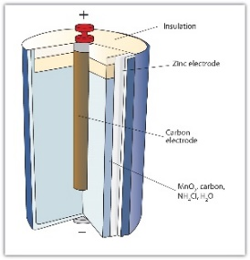
Discussion:
Can you work out what is happening in this experiment?
Why is current being carried around the circuit?
What happens if you replace the nails and wire with other conductive materials? How could you increase the brightness of the LED light? Is this a series or a parallel circuit?

Electric circuits need a power source like a cell or battery to work. An electric circuit is created when charged particles (ions) can travel through a connected set of conductive materials – like copper wire in a series circuit. In this experiment zinc and copper work together to create a cell battery with vinegar.
Many of our small electrical devices like electric toothbrushes, phones and use rechargeable batteries. This means that the battery has a longer life as it can be recharged and used again, not disposed of every time it discharges. They are more expensive but a better option in the long run and more sustainable. Try and encourage people to buy rechargeable batteries to help reduce waste.
Discuss how electrical equipment and batteries are recycled. There is information on the Zone webpages about Electrical Equipment and Batteries: https://zone.recycledevon.org/electrical-equipment/ & https://zone.recycledevon.org/batteries/

Extension Activity:
Use the vinegar circuit to find out if a material is a conductor or an insulator. Find out if other types of metal can work in this way.

Extra Resources:
This is a fun activity for revising circuits:
https://www.stem.org.uk/resources/elibrary/resource/30669/electricity

