Food KS2: Dying eggs using food waste

Lesson Objective:

Pupils learn how to dye the shells of eggs using items of food waste.

Science National Curriculum links:
All years: Working scientifically – asking relevant questions, setting up simple practical enquiries, recording results in a table.
Y3: Animals (including humans) – know that animals including humans, need the right types and amount of nutrition and that they cannot make their own food; they get nutrition from what they eat.
Y5: Properties and changes of materials – know that some materials will dissolve in a liquid.

Resources:
- Free Range Eggs (white, if you can find them)
- Vegetable peelings or scraps: beetroot peelings, onion skins, purple or red cabbage, avocado skins and pits,
- Water & Soap
- Saucepan & Timer
- Vinegar
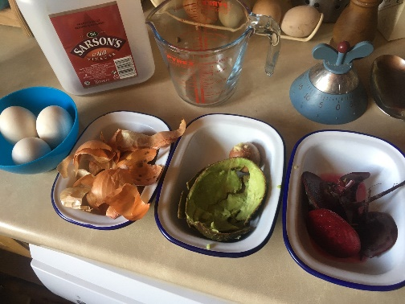
Time required: 1 hour

Introduction to Activity:
This is a lovely activity for teaching about food waste, as everything used as a dye would normally be thrown away. This would also be great as an Easter science activity. Oh – and you can even eat the eggs afterwards!

NOTE: This experiment will work well with scrap fabric too!

Main Activity:

Collect together the ingredients. Predict what colour each type of peeling will turn the eggs.

Hardboil the eggs by cooking them in boiling water for 10 minutes. When cool wash the eggs in soapy water to clean the wax from the outer shell.

In separate pans for each vegetable boil the peelings with 2tbsp of vinegar and enough water to cover them.

Cover the eggs with the hot coloured water and leave for about ½ hour.

Carefully remove the eggs and look at the colours of the shells. The vegetable peelings can now be put in your food recycling bin or compost heap. Remember to put the eggshells in the compost bin when you have finished with them.
Results:
Look at the colours and record the results in the table below. Photograph the eggs if possible.

Type of vegetable peeling | Colour of eggshell
Beetroot
Onion
Avocado

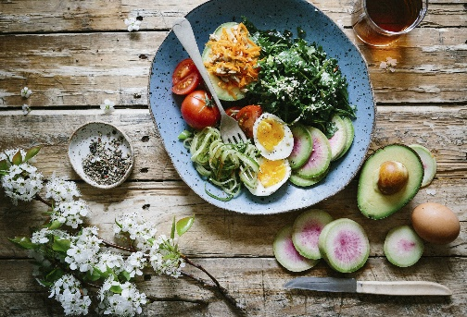
Discussion:
Discuss food and nutrition. Are eggs healthy? Which food group do they belong to? What about vegetables? Can students think of meals using the vegetables that are used in this experiment?
This experiment can be used as a way of eliciting discussion of results and prediction. What colour will the different eggs become? What is causing the colour change? Were the predictions correct? What other fruit or veg could be used? What other natural dyes are there?
The spices turmeric and saffron are lovely examples of natural dyes as they are used to dye fabrics in India and other Eastern countries.
This activity could also be used as an explanation of acids and alkalis. The calcium carbonate of the eggshells is primed for dying by using vinegar to dissolve the outer coating of the shells so it holds the dye better.

Extension Activities:
Eat the eggs! Maybe sow some cress and make egg and cress sandwiches for the class.
Experiment using peelings from different fruit and veg.
Plan and cook a balanced meal using the vegetables needed to dye the eggs.

Home Schooling:
This activity would work well when done at home, especially around Easter time.

Extra Resources:
The BBC has some good resources about Food and Nutrition at KS2: https://www.bbc.co.uk/bitesize/topics/z4d82hv/resources/1. There are also good cross-curricular resources available from: https://www.stem.org.uk/resources/community/collection/466479/ks2-cooking-and-nutrition
Share your pictures with us on Facebook, Twitter or Instagram by tagging @RecycleDevon #recycledevon

Make sure you have permission to share any photos first.

