Glass KS2: Making sugar into glass

Lesson Objective:
To make some sugar glass and learn about the properties of glass.

Science National Curriculum links:
Y3 Science: Light – recognise that they need light to see things and that dark is the absence of light; notice that light is reflected from surfaces.
Y4 Science: States of matter – compare and group materials together, according to whether they are solids, liquids or gases; observe that some materials change state when they are heated or cooled.
Y5 Science: Properties and changes of materials – Give reasons, based on comparative and fair tests, for the particular uses of everyday materials.
Y6 Science: Light – recognise that light travels in straight lines.

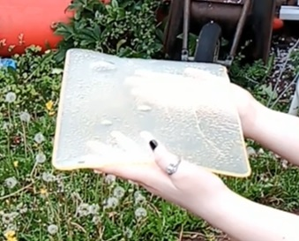
Resources:

- 790g granulated sugar
- 475ml water
- 240ml light corn syrup
- ¼ tsp cream of tartar
- Saucepan
- Hob or camping stove
- Silicone spatula
- Confectionery or jam thermometer
- Baking sheet
- Aluminium foil or cooking spray
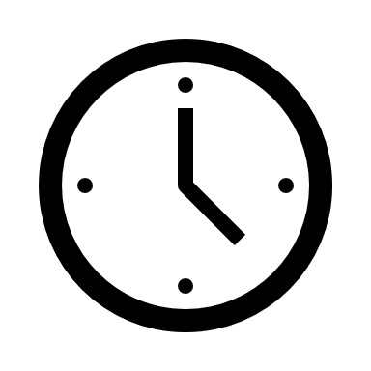
Time required: 60 mins plus 60 mins cooling
Watch a video of this activity on our Zone website.
Go to http://zone.recycledevon.org

NOTE: this activity heats sugar to high temperatures so ensure proper adult supervision is available. You may want to carry out this activity as a class demonstration.

Introduction to Activity:
One of the wonderful properties of glass is that it is brittle and so breaks into lots of little shards. These shards are sharp and dangerous, so alternatives had to be found for doing stunts in films. The answer is to use sugar!
Breakaway or sugar glass can be formed into many different shapes, looks and sounds like glass and when it breaks it does not cause injury – ideal for action films!
In this activity your class will make some sugar glass of your own!

Main Activity:

Firstly, prepare a large baking sheet, line the bottom with a spray of cooking oil or a piece of aluminium foil and put to one side.

To make the sugar glass, start by bringing 790g of granulated sugar, 475ml of water, 240ml light corn syrup, and 1/4 teaspoon of cream of tartar to a boil in a saucepan over a medium heat, stirring it continuously with a silicone spatula so it doesn't burn or discolour. You will get a clearer sugar glass product if you do this slowly and carefully, as the caramel colour will not appear.

WARNING: The sugar mixture is very hot. Do not let unsupervised children do this part of the experiment.

Place the jam thermometer in the sugar mixture, using the clip, if it has one, to secure it. Once the mixture reaches 149°C or the “hard crack phase”, take it off the heat and slowly pour it onto the baking sheet lined with foil or oil.

Leave the baking sheet on a flat surface and let the glass harden for at least 1 hour. After an hour, peel the hardened candy off the baking sheet or turn over carefully if using oil.

Results:
The sugar glass made in this activity may not be perfectly clear, as it could caramelize slightly to produce a brownish colour, or contain bubbles. A special ingredient called isomalt, also used in cakemaking, is used in the film industry. It produces a perfectly clear sheet which can be formed or moulded into bottles, glass sheets or windows. The sugar glass is perfectly edible; you have made hard candy.

  - Discussion & Extension Activity:
Discuss as a class the properties of glass. It is a hard and brittle solid, made from a superheated liquid which is moulded to shape as it cools. Watch some videos showing glass making (see our YouTube playlist). Talk about states of matter, what happens when you heat or cool different substances.
Discuss whether glass can be melted and reformed. Talk about glass recycling. Show videos of the process. It saves a lot of energy and resources to recycle glass rather than make it from new. Be sure that the students know that recycling is easy to do, whether glass is picked up from your kerbside or you take it to a recycling centre or bottle bank.
Talk about how glass is transparent. Is the glass they made transparent or translucent? Discuss how light moves in straight lines.

Students could experiment with different colours to make stained glass panels or swirl through different colours for a marbled effect.

  - Home Schooling:
This activity could be done at home under parental supervision.

  - Extra Resources:
See our material pages on the Zone website for more information about glass, recycling and reuse: http://zone.recycledevon.org/glass
You can watch the process broken into stages here: https://www.wikihow.com/Make-Sugar-Glass

