Paper KS2 Activity: Comparing strengths of different paper

Lesson Objective:

To find out the relative strengths of different kinds of paper and decide which is the strongest and which the weakest;

To suggest why the properties of different types of paper make them right for different jobs;

To find out about how recycling paper might affect the properties of paper.

Science National Curriculum links:

KS2: Working scientifically – setting up simple practical enquiries; making observations; gathering data; using results to draw simple conclusions.

Y5: Properties and change of materials - Give reasons, based on evidence from fair tests, for the particular uses of everyday materials.

Resources:
- Different kinds of paper, including recycled, eg. recycled printer paper, sugar paper, tissue paper, toilet paper, kitchen roll, wrapping paper.
- 100g weights
- Paper clips
- Holepunch
- Small plastic bag, eg. sandwich bag
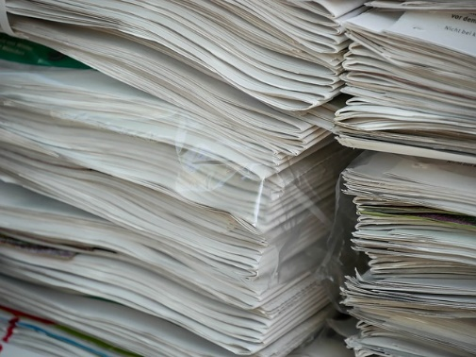
Time required: 1 hour

Introduction to Activity:
What different types of paper do you have at home and in your recycling bin? Do they have different properties? What paper can be recycled at school and home?

Talk about how paper is made. Watch the BBC Teach video explaining the paper making process: https://www.bbc.co.uk/teach/class-clips-video/science-ks1-ks2-how-is-paper-made/zryb92p

Introduce the activity by presenting the problem: plastic bags pollute the environment, show pictures of plastic carrier bags in trees and water (see attached photos) and so sustainable alternatives must be found. As material scientists the students must find out which paper would be the strongest for making a paper bag and won’t tear when carrying something heavy.
Main Activity:

Working in groups students should find out which paper is the strongest and which is the weakest. Give out the different paper samples and ask students to predict which paper will be the strongest and why. Write down the predictions.

Start by cutting strips of paper that are all the same length and width. Work together to punch holes in each sheet not too near the edge, and another in the top of a small plastic bag.

Open up a paper clip to make hooks, hooking it into the hole in the paper and the palstic bag and attaching the bag to the end of the paper strip.

Take it in turns to hold one end of the paper strip whilst someone carefully pops a 100g weight into the plastic bag, then carefully add weights to the bag until the paper tears.

A4 computer paper can sometimes hold 600g before tearing!

Make sure the groups are making notes of how many weights (grams) each strip of paper can take before tearing.

Results:
Fill in the recording sheet to answer the questions about which paper is the strongest and which paper is the weakest.

Discussion:
Decide as a group which paper you would use for to make your paper bag. Explain to the other groups which paper would make the best bag and why.

Discuss what makes paper stronger. Explain scientists are working on strengthening paper using other materials.
https://www.newscientist.com/article/dn12359-carbon-paper-is-the-strongest-yet/

Watch the Recycle Devon video about paper recycling: https://youtu.be/ohv9y8Bi3fU. Talk about the recycling process and how this might affect the properties of recycled paper.

Extension Activity:
Does the recycled content of the paper make a difference? Compare virgin printer paper to recycled printer paper. Which is stronger?

Extra Resources:
Why not make this into a special Christmas activity by comparing different wrapping paper?

Bring in an arty link by decorating and making paper bags: https://www.wikihow.com/Make-a-Paper-Bag
Share your pictures with us on Facebook, Twitter or Instagram by tagging @RecycleDevon #recycledevon

Make sure you have permission to share any photos first.
Recording Sheet: Which paper is the strongest?
I think ___________________________________________will be the strongest paper

because_________________________________________________________________________________________________________________________________________________________________________________________________________________________
Predictions
What I think will happen in this experiment
_______________________________________________________________________________________________________________________________________________________________________________________________________________________________________________________________________________________________________________________________________________________________________________________
I think ___________________________________________will be the weakest paper

because_________________________________________________________________________________________________________________________________________________________________________________________________________________________
Results
What actually happened in this experiment
_______________________________________________________________________________________________________________________________________________________________________________________________________________________________________________________________________________________________________________________________________________________________________________________
Conclusion
I would choose ___________________________________________________
to make a paper bag out of because ______________________________________________________________________________________________________________________________________________________________________________________________________
___________________________________________was the weakest paper

because_________________________________________________________________________________________________________________________________________________________________________________________________________________________
___________________________________________was the strongest paper

because_________________________________________________________________________________________________________________________________________________________________________________________________________________________

Photos of the Problem: Plastic bags in the environment

CAUTION: Use your discretion showing these images to students. Some children
might find them overly distressing.

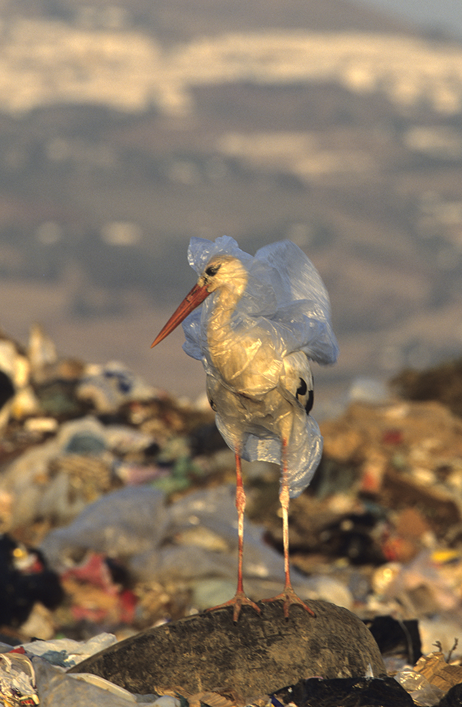
Image by John Cancalosi from https://www.nature-photography.us/stork-in-a-bag/
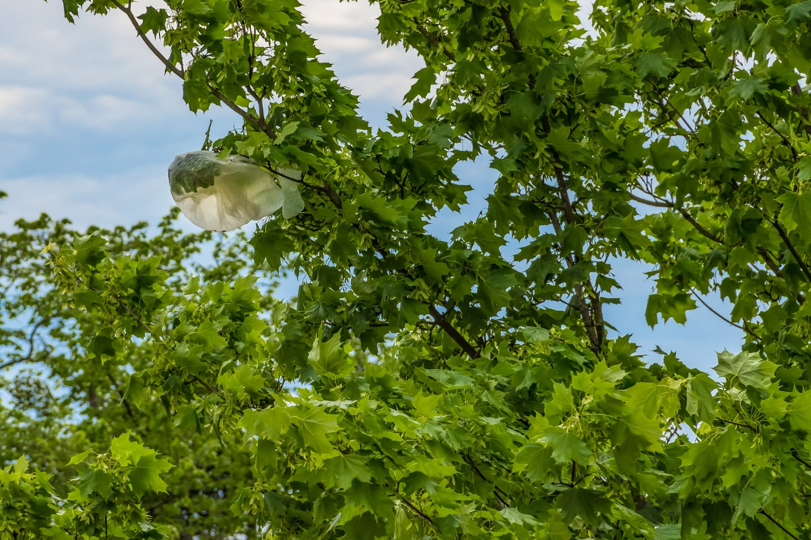
Image by Gundula Vogel, available from Pixabay
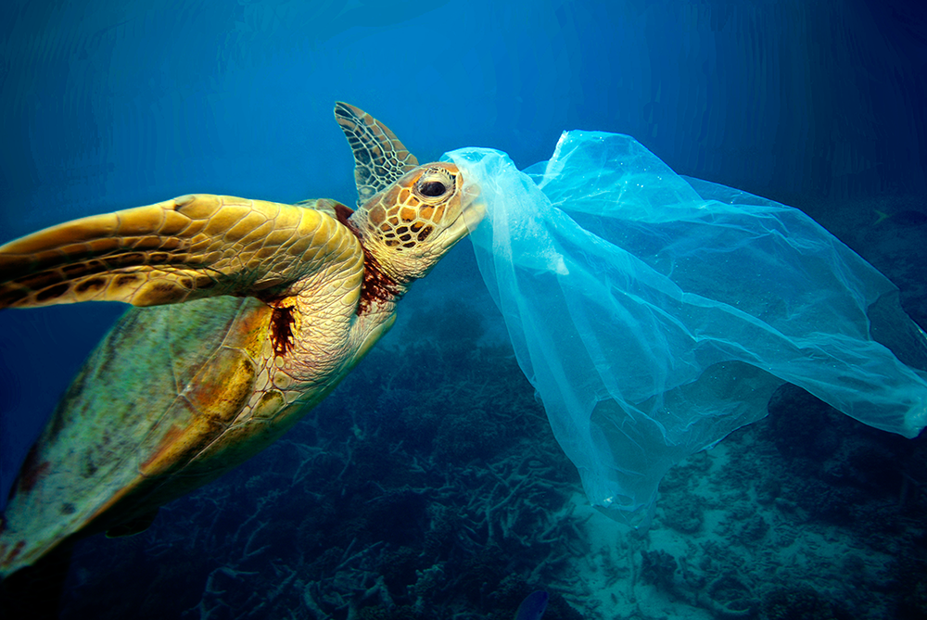
Image by Troy Mayne, found online.

