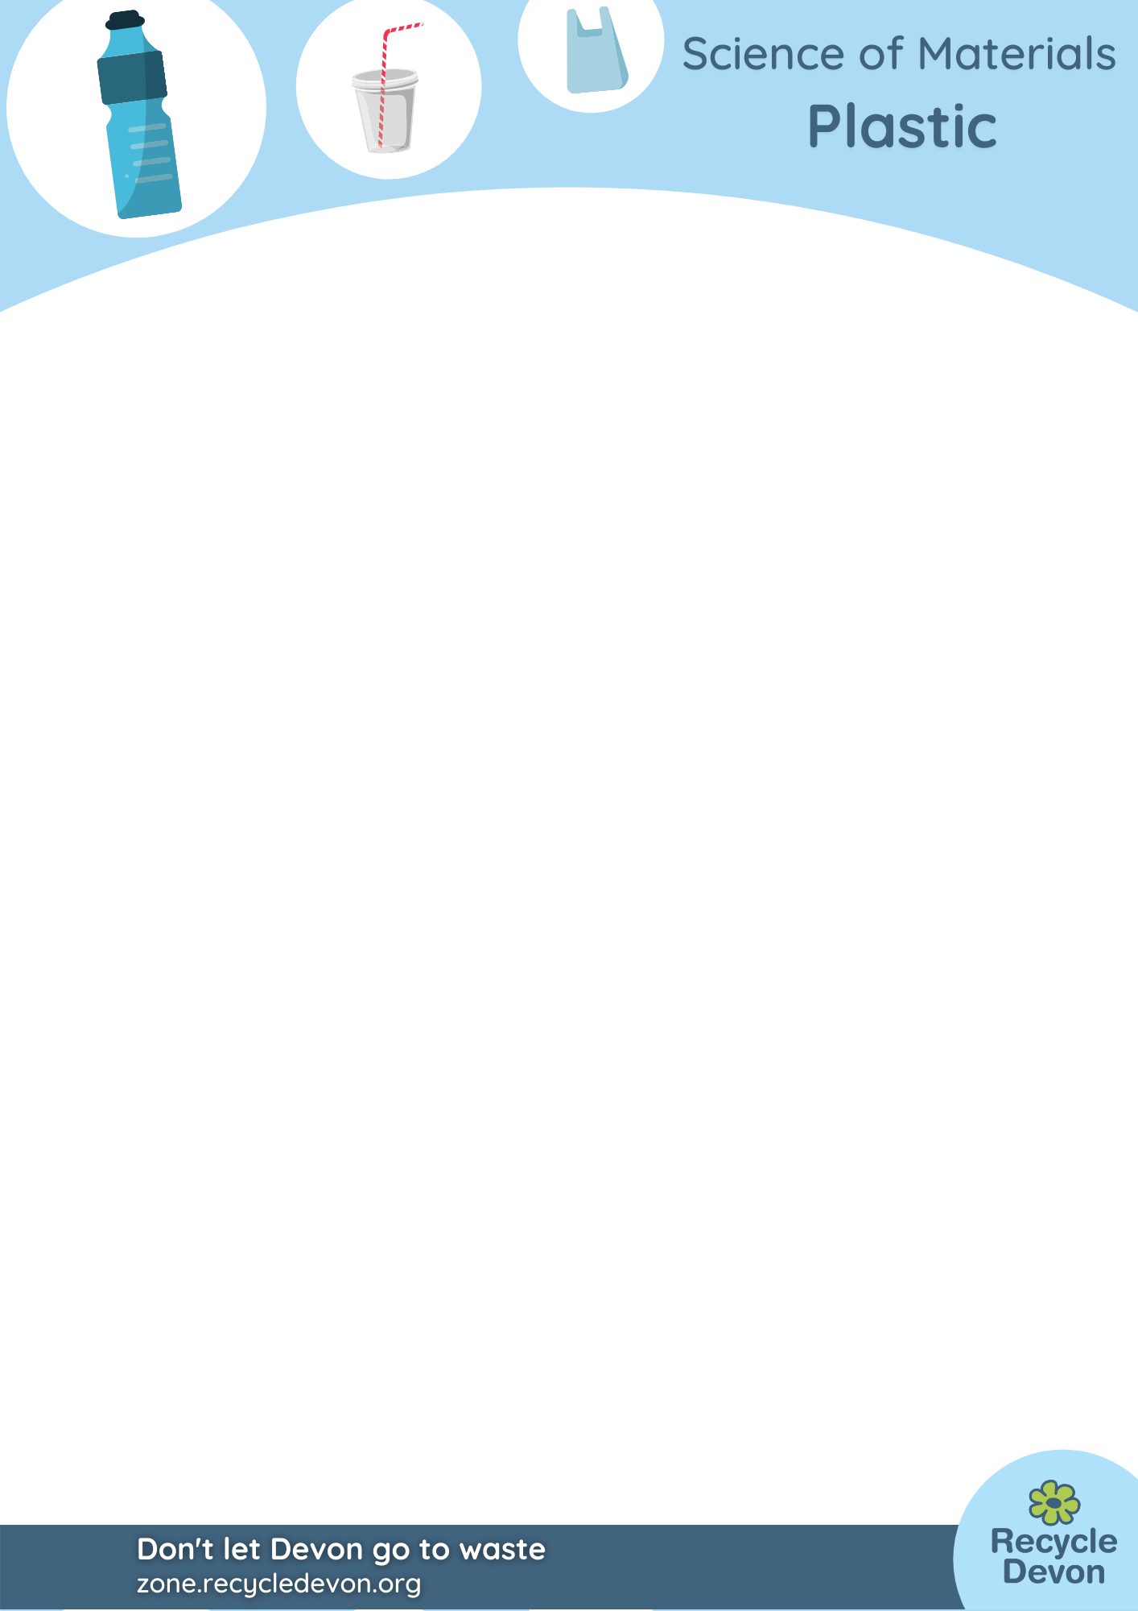Plastics KS2: Recording Sheet

|  |  |  |  |
| --- | --- | --- | --- |
| Type of Drinking Straw | How hard is it? | How transparent is it? | How long does it take to go soggy in water? |
|  |  |  |  |
|  |  |  |  |
|  |  |  |  |
|  |  |  |  |
|  |  |  |  |
|  |  |  |  |
|  |  |  |  |