Plastics KS2: Comparing straws

Lesson Objective:

To learn about ocean food chains and the threat to animals posed by plastic pollution like disposable plastic straws.

Science National Curriculum links:
Y4 Science: Living things and their habitats – environments can change and that this can threaten living things; Construct and interpret a variety of food chains, identifying producers, predators and prey.
Upper KS2 Science: plan scientific enquiries; take measurements using a range of scientific equipment; record data.
Y5 Science: Properties and changes of materials – compare and group together everyday materials based on their properties, including hardness, transparency and solubility.

Resources:
- Ball of string or wool
- 3 different colours of card or stickers
- A selection of straws (include disposable plastic and alternatives like bamboo and paper)
- Bowl of tapwater
- Bowl of saltwater
- Several beakers
- Stopwatch
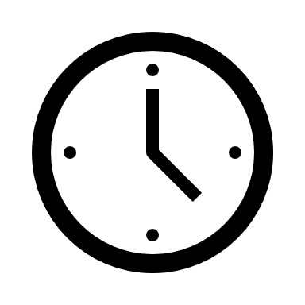

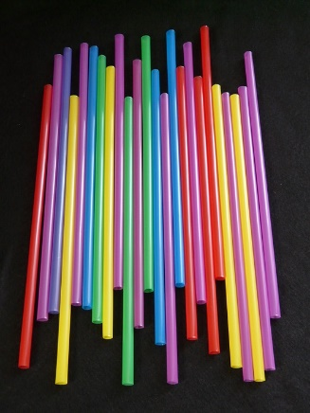
Picture from Pixabay
Time required: 2 hours (whole morning or afternoon)
Watch a video of this activity on our Zone website.
Go to http://zone.recycledevon.org

Introduction to Activity:
Start outdoors if possible. Take the ball of string and card or stickers with you.
Ask class to think about seas and the oceans. Ask each pupil to think of an animal or plant that lives in the ocean. If outdoors, then ask the group to stand in a large circle.
Ask the class to identify which of the animals are primary producers, primary consumers and predators. Label each category with a colored card or sticker.
Now use string to link up animals into food chains and webs across the circle.

When the food chains and webs are complete then introduce some straws or other plastic litter to the ocean. See the list on page 3. Who might eat plastic thinking it was food? Which animals’ lives will be disrupted by plastic bags or straws?
How would animals be affected by plastic items?

Main Activity:
Present groups of 4-5 pupils with a selection of straws, some jugs of sea water and tap water, beakers, stopwatches. Ask them to design a series of experiments to compare the properties of different straws. They should consider hardness, transparency and solubility of each of the straws.
Regroup to discuss different approaches. Then ask students to carry out their tests and record the results. Check they know what they are measuring and how to measure the value accurately.

Results:
Ask the students to record their data in tabular format (see Recording Sheet). Compare what different results the different groups obtained. Did different methods of carrying out the experiments get different results?
Which straw alternative is the:
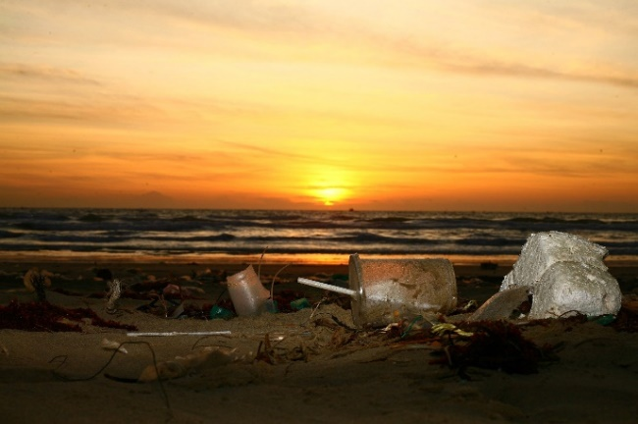
- Hardest / softest ?
- Most transparent / most opaque ?
- Most soluble ?

Discussion:
As a class consider the following questions:
- Why is plastic an ideal material for straws?
- What alternatives are there to disposable plastic straws?
Picture from Pixabay

Extension Activity:
Consider other single use items and their alternatives. Look at the list of the items most commonly picked up in beach cleans and think about alternatives.

Home Schooling:
This activity could follow on well from our online lesson about marine plastics (https://zone.recycledevon.org/marine-plastics) The animals named in the marine plastics quiz could be used in the initial food web activity. The experiments on straws could be done at home, though it will depend if students have plastic straw alternatives at home.

Extra Resources:
Watch this: https://youtu.be/0Puv0Pss33M
There is lots more information on marine litter and plastic pollution and other activities on our website:
https://zone.recycledevon.org/plastic & https://zone.recycledevon.org/litter-pack/

We have created a playlist of videos that might be useful too:
https://www.youtube.com/playlist?list=PLHby835r5GWVN13bLdyii9VVet_Th26j7
Share your pictures with us on Facebook, Twitter or Instagram by tagging @RecycleDevon #recycledevon
Make sure you have permission to share any photos first.

List of most littered items (found in beach cleans in 1 year):

