KS2 Activity: Seeking microfibres

Lesson Objective:

To extract and look at microfibres from a polyester fleece.

Science National Curriculum links:

Lower KS2: Working scientifically -recording findings using drawings.

Y4: Living things and their habitats – recognise that environments can change and that this can sometimes pose dangers to living things.

Y5: Properties and changes of materials – know that some materials will dissolve in liquid; use knowledge of solids, liquids and gases to decide how mixtures may be separated, including filtering, sieving and evaporating.

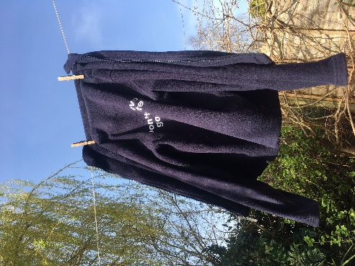
Resources:

- A brightly coloured polyester fleece jumper for each group
- A bucket for each group
- Some warm water
- A wooden spoon or clean stick
- Laundry powder or liquid
- Jug
- White saucer or plate
- Magnifying glass or lens

Time required: 1hr

Introduction to Activity:

Textiles are what we call the materials used to make our clothes and other fabric items like bedding and towels. The material can be made of lots of different fabric, with different origins including animals (wool from sheep, goats and llamas), plants (cotton, linen and viscose) and even from plastic polymers (polyester and nylon).

When we wash our clothes tiny pieces of fibre break off the main fabric and are washed away in the dirty water. This is fine if the fibres are natural (from plants or animals) as they can break down harmlessly in the environment. However, if the fibres are from synthetic plastic polymers, then they don’t break down and will remain in rivers and seas for hundreds of years.

This experiment will allow you to extract and look at the microfibres present in polyester fleece.
Main Activity:
Starter – Act out what a washing machine does - in groups)
Ask children to work out the actions in the sequence of a washing machine. Noises recommended!

Main Activity
Now we’re going to be washing machines!
Wash the fleece in a bucket with warm water and laundry liquid or powder. Mix with the spoon or stick – noises are optional! Keep the water that comes off the fleece. This contains the microfibres.
Take a small amount of water and put on a white plate or saucer. Practice using a magnifying glass correctly, by putting it close to the eye and moving towards the object to be magnified. Use magnifying glasses to try to identify microfibres floating in the water.

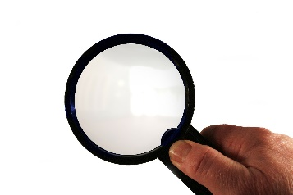
Results:
Draw what you see.
Discuss what children found in the water? Were they surprised?
How could you estimate how big each microfibre is?
How might you estimate how many fibres each fleece is producing during each wash?

Explanation:
Talk as a class about how we could stop these microfibres going into the environment.
Discuss how the microfibres might affect the environment, including tiny animals that might confuse them for food.
Discuss how to filter out the microfibres from dirty water. Discuss as a class how to separate solutions and suspensions, by filtering, sieving and evaporating. Do the microfibres dissolve like salt? Do they settle out like sand?

Extension Activities:
Students may want to see if they can measure the microfibres using rulers and their magnifying glass. Encourage them to experiment with different methods.

Microfibres are produced whenever synthetic fabrics are washed. How much washing does your household do? Can you wear your clothes for longer to reduce the washing?

Look at your clothes labels – are they made of plastic polymers? You could write to manufacturers asking them about microfibres. Are they doing anything to stop them?

Extra Resources:

Read more about what you can do to stop microfibres: https://www.fashionrevolution.org/our-clothes-shed-microfibres-heres-what-we-can-do/

See this video from Exeter University about plankton eating microfibres: https://youtu.be/FAi1okMUdQ8

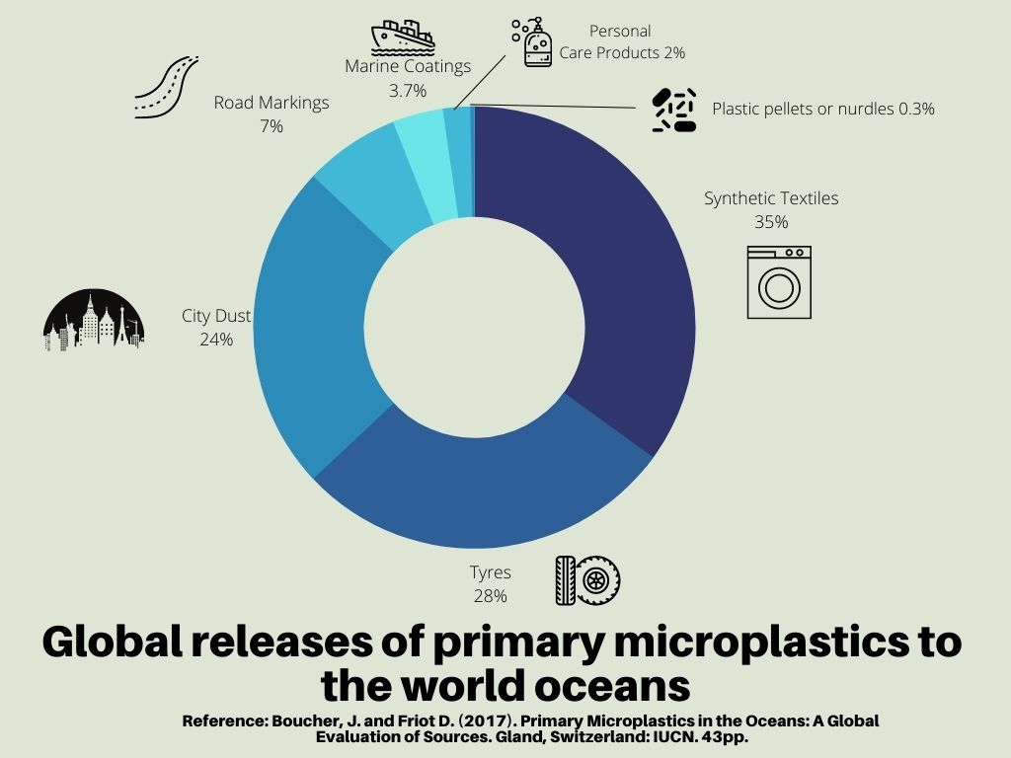

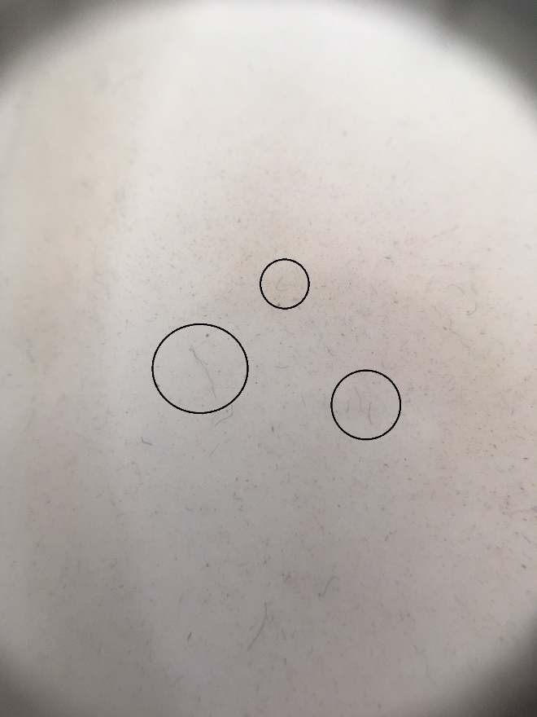
Picture of microfibres from a dark blue polyester fleece, extracted using the method described here. Magnified with a hand lens, photo taken with an iPhone.

Size of largest visible fibre estimated to be <1mm.

