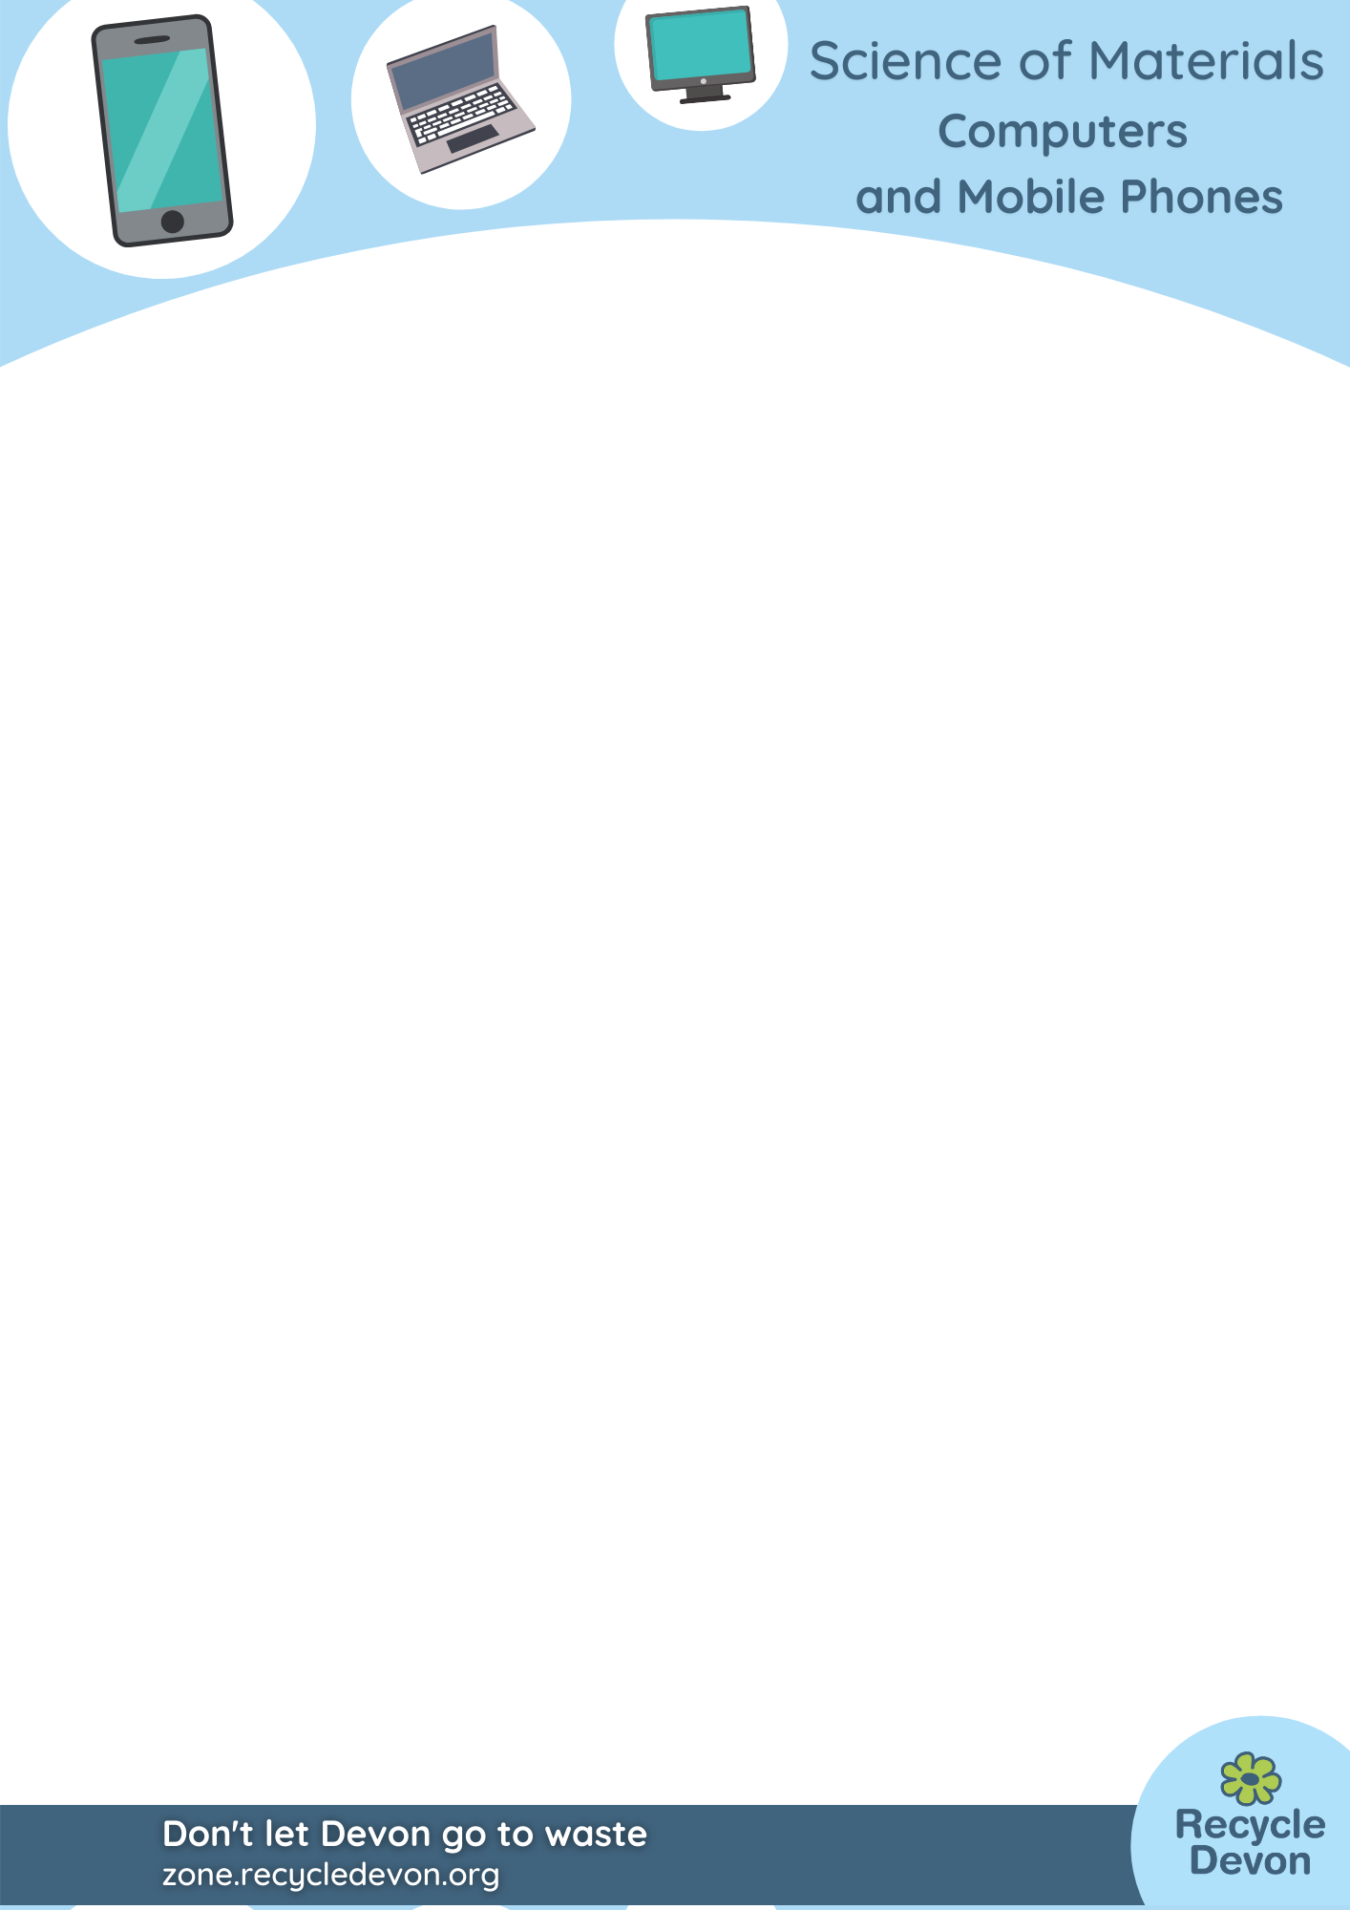

KS3/4 Computers and Mobile Phones: our precious and limited elements.

Lesson Objective:

To find out more about the elements within our computers and mobile phones.

Science National Curriculum links:

KS3 Chemistry: Earth and atmosphere – Earth as a source of limited resources and the efficacy of recycling.

KS3 Chemistry: The Periodic Table – the varying physical and chemical properties of different elements.

KS4 Chemistry: The Periodic Table – the modern Periodic Table showing elements arranged in order of atomic number.

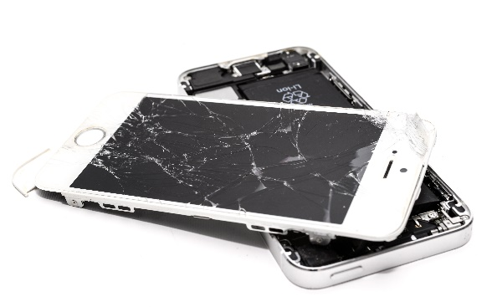
Resources:
- paper
- pencil
- ruler
- periodic table (https://www.rsc.org/periodic-table)
- Optional: map of the world

Time required: 1 hour
Wrecked iPhone picture by Skitterphoto from Pexels: free to use.

Introduction to Activity:
Hands up who owns a smartphone.
Hands up who uses a computer.
Hands up who has an old or broken phone of computer.
Ask students to estimate how many elements are in smartphones and computer chips. How far do they think they’ve come? How did they get there?
This activity should leave students appreciating the value of the elements found in their smartphones and old computers.

Main Activity:
Look at the map on https://sustainability.rsc.org/meet-the-precious-elements/
Use the information available on the Royal Society of Chemistry website.


Choose an element to investigate:
Ta: Tantalum | Nd: Neodymium
Ni: Nickel | Pr: Praseodymium
Ga: Gallium | Co: Cobalt
In: Indium | Al: Aluminium
Y: Yttrium | Dy: Dysprosium
Li: Lithium | Au: Gold

Answer these questions for each element:
Where are main places this element is found on Earth?
What are the main uses of this element?
How much of this element is predicted to exist in rocks?
Can this element be recycled from smartphones/computers?
DID YOU KNOW?
Reports show that there could be 40 million devices sitting unused and forgotten in drawers in our homes. See the article and video:
Millions of old gadgets 'stockpiled in drawers' - BBC News
Reduce: Watch this video: https://youtu.be/6cxZOQN6ULc
How could the use of sodium in batteries reduce the need for lithium in smartphones and laptops?

Reuse: Fixing and repairing mobile phones is really important. Mobile phones can be repaired if we learn micro-soldering skills and have some training. Watch this video: https://youtu.be/VNKNjy3CoZ4 and find out where your nearest repair shop is located.

Recycle: Read this article about new technology to extract gold from smartphones: https://www.bbc.co.uk/news/uk-wales-58978512

Discussion:
Talk about how all manufacturers must use the principles of the Circular Economy (https://ellenmacarthurfoundation.org/topics/circular-economy-introduction/overview) in production of mobile phones and computers. We have to find ways to reduce resource use and transition to renewable systems for energy and materials.
Discuss what this could look like in terms of phones – questions could include: should we return old phones to the manufacturers for repair, remanufacture and recycling.

Extension Activity:
Investigate the other elements that are found in smartphones. Investigate where they come from and how much is left to be mined from the Earth.

Extra Resources:
For further information about the elements found in smartphones the European Chemical Society has created a version of the Periodic Table: https://www.euchems.eu/euchems-periodic-table/

