Cardboard KS3/4 Activity: – the story of the cardboard cereal box

Lesson Objective:

To investigate the environmental impacts of the production of the cardboard box using a systems thinking approach

Science National Curriculum links:

**KS3 Chemistry: Earth and Atmosphere** – Earth as a source of limited resources and the efficacy of recycling; the carbon cycle; the composition of the atmosphere; the production of carbon dioxide by human activity and the impact on climate.

**KS4 Biology: Ecosystems** - positive and negative interactions with their environment.

**KS4 Chemistry: Chemical and allied industries** - the viability of recycling of certain materials; life cycle assessment and recycling to assess environmental impacts.

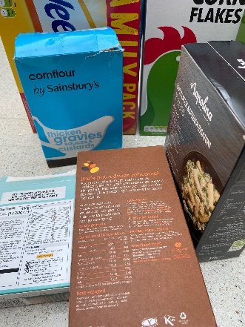

Resources:

* a variety of cardboard food boxes out on the student’s tables
* a copy of a blank Cause and Effect Web diagram
* information on the process of cardboard making
* information about local recycling for cardboard packaging



Time required: 1 hour

Introduction to Activity:

Everything is inter-related. The making of materials from their raw ingredients uses energy and adds to pollution in the atmosphere. In this activity students will use systems thinking to understand cause and effect in the cardboard manufacturing industry, while considering life cycle analysis and the place recycling and reuse plays within it. The idea of the circular economy will help students understand how human manufacturing systems can be made better and less polluting.

Main Activity:

1. Introduce the activity with videos on [Systems Thinking](https://youtu.be/17BP9n6g1F0), [Life cycle assessment](https://youtu.be/ScY_Yb1V8AY), [Circular Economy](https://youtu.be/zCRKvDyyHmI) and the [Cardboard Recycling Process](https://youtu.be/Bx0ozMweqoU).
2. Ask students to investigate the history of the cardboard box. This could be done as homework, or with tablets or computers in the lesson if available.

**DID YOU KNOW?**

Sir Malcolm Thornhill made the first cardboard box for packaging in 1817, but it wasn’t until 1850 when the Kellogg Company started using them for their cereals that the packaging went mainstream.

In 1890 the American Robert Gair accidentally invented the pre-cut cardboard box, when he realised he could crease and cut cardboard with the same machine. The future of food packaging had arrived!

1. Ask students [to watch this video about environmental effects of paper and card.](https://youtu.be/lbNBaxAUPCY) This article also explains the environmental impact: <https://www.worldatlas.com/articles/what-is-the-environmental-impact-of-paper.html>
2. Consider the process of cardboard production, as shown in the process diagram on the attached sheet and fill in the boxes for what the impacts of card production might be. Ask students to choose an environmental problem that could be associated with paper and card making. If they get stuck suggest things like: Deforestation, Water Supply; Climate Change, Water Pollution.
3. Use the cobweb diagram to ask students to think about the cause and effect of the issue identified. Break into groups to discuss this.
4. Round off with a class discussion about the system of cardboard production and recycling, thinking about it from a systems perspective and using the circular economy model.

Results:

Students should leave the lesson with a web of cause and effect of an environmental problem and notes about the circular economy, life cycle analysis and some real world solutions.

Discussion:

Discuss the life cycle of cardboard. Using the example of the environmental impact of cutting down trees ask the group to explain why it is so important to recycle cardboard.

Using a systems thinking approach allows for discussion of larger complex issues, within a single context. Students should consider whether this helps them realise the importance of recycling.

Extension Activity:

What journey has the cereal within the box gone on?

How many food miles does this represent?

How does this differ from the carbon footprint?

Extra Resources:

The Ellen MacArthur Institute has loads of good resources on its website about the Circular Economy.

See our playlist of Youtube videos about the issues explored: <https://www.youtube.com/playlist?list=PLHby835r5GWUaApiaKk2pTlYSGEPs0CLX>

The Processes of Paper and Card Making

Tree Harvesting - Trees are cut down from forests. Most tree harvesting will be followed by tree planting. Conifer trees are generally used for paper and card making.

De-barking - De-barking is the process of removing bark from tree – usually done with a large machine, often on-site, where the trees have been cut down. The bark can be used as fuel or as a soil improver once composted.

Chipping - Once stripped of their bark the logs are chipped into small pieces in machines with blades mounted in drums. Chipped wood can be sorted into the right size.

Thermomechanical pulp refiner - Hot water or steam is used to help soften the wood chips. The chips are refined mechanically to produce pulp. Bleach is sometimes used to whiten the pulp – this is chemi-mechanical pulp.

Card making machine - The pulp is squashed and pressed into shape, then rolled out and dried.

Box cutting and shaping – Boxes can be made any shape and size, depending on the end-use. Some companies can make boxes to fit the product.

Distribution & Use – Packaging will be distributed around the world, depending on their contents. The consumer will end up with a box once they have used the product.

Kerbside collection and sorting – the consumer/householder must put the cardboard in the right box/bin for recycling.

Recycling centre – Cardboard for recycling is bulked up and transported to a recycling centre.

De-inking – If de-inking is required, a de-inking agent is used to separate and remove the ink from the pulp, through a method known as flotation.

Cleaning and fine screening - De-inked pulp is cleaned and bleached.

Thermomechanical and recycling pulp mix – the recycled card is mixed with virgin paper/card pulp and formed into new cardboard items. Then they are ready to be distributed back to producers.

The Environmental Impact of Paper and Card Making

1. Deforestation – the purposeful clearing of forests for agriculture, animal grazing. fuel, manufacturing and construction. <https://www.nationalgeographic.com/environment/article/deforestation/>
2. Air Pollution – contamination of the environment by anything that changes the composition of the air, particularly if it impacts human health. <https://www.who.int/health-topics/air-pollution>
3. Water Use – water is crucial to human health and agriculture. Over use of water resources causes drought and famine, while polluted water can lead to disease. <https://www.worldwildlife.org/threats/water-scarcity>
4. Solid Waste – poor waste management can cause pollution of air and water, and reduces the world’s resources. <https://bit.ly/3Q1Ojqr>
5. Climate Change – humans have caused global warming through the release of greenhouse gases by burning fossil fuels. The current level of climate change is irreversible and is causing impacts like changing weather patterns, increasing sea level rise and increase in extreme weather events. <https://climate.nasa.gov/effects/>

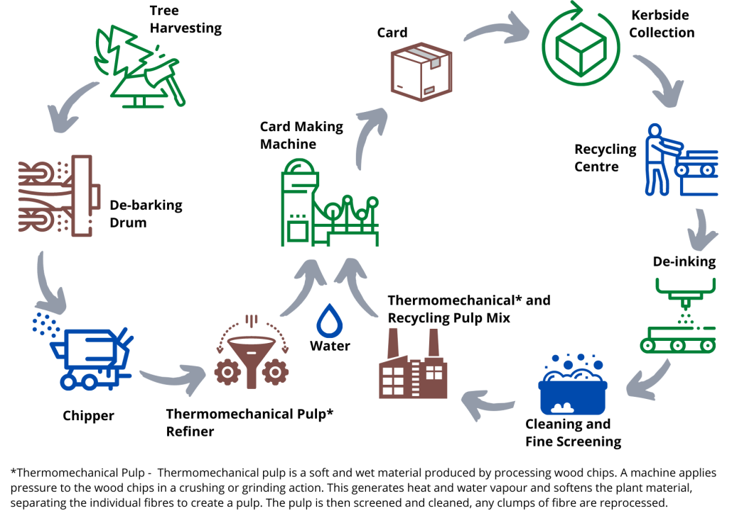

The Cardboard Making Process