Electrical Equipment KS3/4 Activity: The Physics of a Toaster

Lesson Objective:

To investigate and describe what physics is going on inside a toaster

Science National Curriculum links:

KS3 Physics: Current Electricity - electric current (in amps) in circuits; series and parallel circuits; potential difference (in volts), battery and bulb ratings; resistance, (in ohms), as the ratio of potential difference (p.d.) to current; differences in resistance between conducting and insulating components

KS4 Physics: Electricity – exploring current, resistance and voltage relationships for different circuit elements; drawing circuit diagrams; the domestic AC supply; safety measures.

Resources:
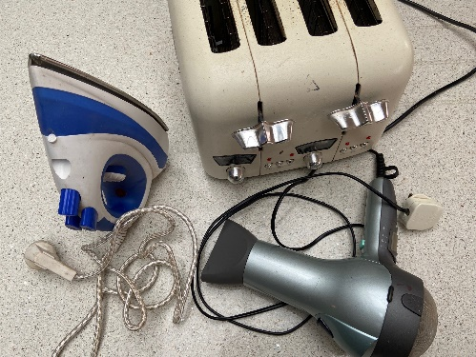
- assortment of small electrical equipment from list below
- a selection of screwdrivers
- small containers to collect screws
- PAT testing equipment and a qualified PAT tester
Time required: 2 hours

Introduction to Activity:
Toasters, coffee machines, fan heaters, hair dryers, hair curlers, and irons, (as well as electric showers, tumble dryers, washing machines, and cookers) all work in a very similar way. Can you work out what is going on inside?
This activity helps students understand the physics behind the heating elements found in common household electrical appliances, which will help in the application of concepts learnt at KS3 and KS4.

Main Activity:
Put a piece of small electrical equipment (eg. toaster, hairdryer, coffee machine, iron, etc.) on each bench.
Ask students to take apart the equipment to work out what is happening inside the machine. Draw a circuit diagram using the symbols on page 3 (KS4).
Ask them to find out the current, p.d. and resistance of the appliances and (for KS4) calculate the relationship between them.
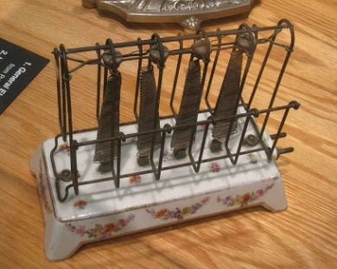
IMPORTANT: Electrical equipment that has been taken apart should not be plugged into the mains until a full PAT test by a fully trained electrician or experienced electrical engineer has been carried out.
DID YOU KNOW?
The first toaster was invented in Scotland by Alan MacMasters in 1893. Originally the toast had to be turned so both sides were toasted. The first pop-up toaster was invented in 1919.
The first commercially available toaster - picture from Wikimedia Commons

Results:
How difficult or easy was it to get into the electrical equipment?
Were the screws easy to find or was the plastic glued together?
Could it be put together again?

Discussion:
The electrical energy from the AC mains circuits in our houses enters a toaster via the plug and cable, then is converted to heat energy (and some light usually) to toast the bread. https://www.explainthatstuff.com/electrictoasters.html https://www.howitworksdaily.com/how-do-toasters-work/

Discuss how the new Right to Repair rules will affect electrical equipment. https://www.bbc.co.uk/news/business-57665593 https://www.which.co.uk/news/2021/06/new-right-to-repair-laws-introduced-what-do-they-actually-mean-for-you/

Extension Activity:
There are over 10 Repair Cafes in Devon, and over 100 across the UK. They use volunteers to mend broken items, including small electricals, brought in by people in their local community. They provide a brilliant service and often also teach people how to mend things. Find out where the nearest one is and if anyone has visited one. When is the next one? Why not visit and find out what goes on there!

Find out more about Repair Cafes in Devon at https://www.recycledevon.org/reuse/repair-cafe

Extra Resources:
There are plenty of videos to help revise Physics concepts for KS3 and GCSE. BBC Bitesize also has quizzes to help revision of these topics. https://www.bbc.co.uk/bitesize/topics/zq8wxnb
Fuse School Global Education has a range of easy to understand and accessible videos to help learn Physics concepts: https://youtube.com/playlist?list=PLW0gavSzhMlTWm6Sr5uN2Uv5TXHiZUq8b

