Plastics KS3/4: Experiments in floating and sinking

Lesson Objective:

To investigate floating, sinking and density of different types of plastics and use this knowledge to help solve the problem of microplastics in the ocean.

Science National Curriculum links:

KS3 Chemistry: Materials – properties of ceramics, polymers and composites;

KS3 Physics: Pressure in fluids - upthrust, floating, sinking;

KS4 Biology: Ecosystems – positive and negative human interactions with ecosystems;

KS4 Chemistry: Chemical and allied industries - the viability of recycling certain materials;

KS4 Chemistry: Earth and atmospheric pollutants - microplastics.

Resources:
- Small pieces of each type of plastic (look for polymer labels as in the table; include Lego pieces and plastic food packaging)
- Small beakers or jars with lids
- Water
- Food colouring
- Vegetable or sunflower oil
- Golden syrup

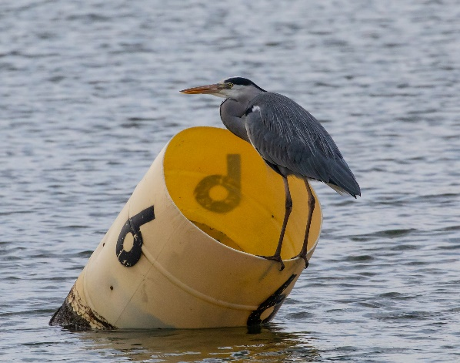 Heron on a buoy - image from Pixabay
Watch a video of this activity on our Zone website.
Go to http://zone.recycledevon.org
Time required: 120 mins

Introduction to Activity:
Use the activity described in this video (https://youtu.be/Z50jEi1igNQ) as an introduction to the activity. Ask students to add water and food colouring to a beaker, then they should introduce a layer of golden syrup, which will sink, followed by a layer of oil. Use a piece of Lego, a stone, a piece of sponge and a bottle top to demonstrate which items have higher or lower densities.

Main Activity:
Talk about plastics as polymers and review the chemical structure as long chains of molecules. Talk about the structure as the basis of the properties of plastics:

- chemically unreactive
- solids at room temperature
- plastic – they can be moulded into shape
- electrical insulators
- strong and hard-wearing

Provide each group with a selection of plastic objects. Try to include an item from each different plastic polymer category – see chart. Each group should predict and determine the relative densities of the plastic items in their trays. Then experiment with placing pieces of plastic in jars or bottles of water to see which items float or sink after agitating the jar. Groups should try to identify the plastic polymer type from the relative density (whether the plastic floats or sinks).

Results:

Discuss the results – were their predictions of different densities correct? Did some plastics float and some sink? Discuss any improvements they could make to the experiment.

Discussion:
Discuss how the findings might have implications for microplastics in the oceans and in rivers.
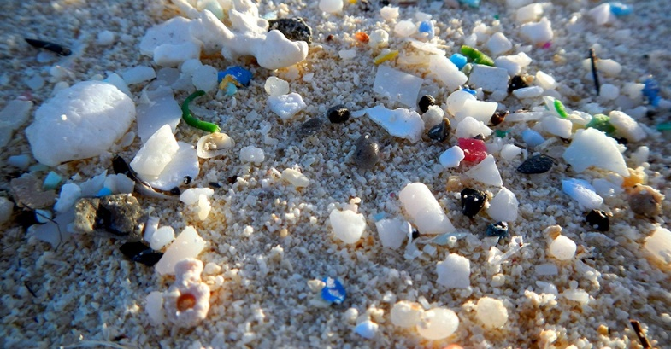
75% of all plastics float, while 25% sink. Plastics never fully degrade in natural environments like the sea. Small pieces of plastic called microplastic are now present everywhere on Earth. They have even been found high up on Mount Everest and even in the centre of Antarctica.

Extension Activity:
Image of microplastics courtesy of NOAA

Think about how to remove microplastics from the oceans and from the ocean floor. Show the videos from the Youtube playlist for this lesson https://youtube.com/playlist?list=PLHby835r5GWXqi_JT3tVTCRLkZOOF2_An

Home Schooling:
There is more information on ceramics, polymers and composites on the BBC Bitesize page: https://www.bbc.co.uk/bitesize/guides/ztxnsbk/revision/1

Extra Resources:
Check out our website resources on plastic: https://zone.recycledevon.org/plastic/
The University of Exeter has developed a GCSE Science investigation into microplastics and plankton: http://biosciences.exeter.ac.uk/microplastics/

Table of Plastic Polymer Types and their Density:

Plastic icon | Acronym | Polymer name | Uses | Density range (g/cm³)
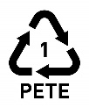 | PETE | Polyethylene terephthalate | Soft drink bottles, mineral water bottles, fruit juice and cooking oil containers. | 1.4
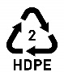 | HDPE | High-density polyethylene | Milk bottles, shampoo bottles, laundry detergents and washing-up liquid bottles. | 0.95
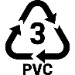 | PVC | Polyvinyl chloride | Packaging for sweets or fruit, bubble wrap. | 1.29
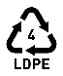 | LDPE | Low-density polyethylene | Plastic bags, film plastic, plastic wrap. | 0.92
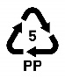 | PP | Polypropylene | Furniture, toys, suitcases, plastic storage boxes, car bumpers, dashboards. | 0.90
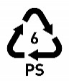 | PS | Polystyrene | Toys, packaging materials, refrigerator trays, costume jewellery, CD cases, disposable cups. | 1.07
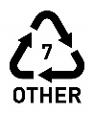 | Other | Other plastic polymers | Including lycra, acrylic, PLA, nylon, fibreglass, polycarbonate. | Variable
Values for plastic density from Polymer Academy website: https://polymeracademy.com/density-of-various-plastic/ Accessed 8 Feb 2020

Density of pure water = 1.0 g/cm³
Density of sea water = 1.03 g/cm³
Density of golden syrup = 1.4 g/cm³
Density of vegetable oil = 0.92 g/cm³
Density of Lego brick (ABS plastic) = 1.07 g/cm³

