Food KS3/4: What happens to food waste? Or understanding bacteria farts!

Lesson Objective:

Pupils learn about the process of anaerobic digestion by methanogenic bacteria, its relationship to climate change and what happens to food waste in Devon and Bangladesh.

Science National Curriculum links:
KS3: Nutrition and digestion – content of a healthy human diet, the importance of bacteria in the human digestive system.
KS3: Material cycles and energy – the dependence of almost all life on Earth on photosynthsis to convert sunlight to glucose.
KS3: Interactions and interdependencies – how organisms affect (and are affected by) their environment.
KS3: The Carbon Cycle & impact on climate of human activity.
KS4: Ecosystems – the role of microorganisms (decomposers) in the cycling of materials through an ecosystem.
KS4: Earth and atmospheric science – effects of increased carbon dioxide and methane on the Earth’s climate.

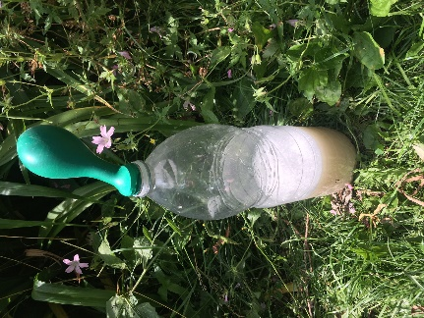
Resources:
- Plastic bottle
- Balloon
- Warm water
- Yeast
- Sugar
- Access to videos

Time required: 1 hour

Introduction to Activity:
Bacteria rule the world! Despite being amongst the smallest living organisms on Earth we rely on bacteria to help our planet’s ecosystems break down organic matter and to digest our food. Some bacteria cause diseases and can be harmful, but many are useful. There are more bacteria in our bodies than there are regular cells, meaning we are more bacteria than human!
Activity 1 will help students make the connection between bacterial growth and gas production, and to understand why bacteria farts are important in climate change.
Bacteria also help with food waste recycling, which we explore in Activity 2 below.

Activity 1:
Fill the bottle up with some warm water, about 1/3 full. Add the sugar and yeast to the water. Attach the balloon to the bottle top. Wait for the yeast to start to produce gas and blow up the balloon. If you like, release the balloon to make a fart noise to illustrate the story.
Now watch the following video: https://youtu.be/Md2M2SKExmI

Activity 2:

However, the good news is that we can use the same bacteria that produce methane in cows to help us recycle food waste.

Compare these two systems, one from Bangladesh: https://youtu.be/haf1h-THyJ0 and what we use here in Devon: https://youtu.be/PC7r4lTd8WI.

Discussion:

Discuss the carbon cycle and climate change. Talk about carbon dioxide and methane and how they both contribute to global heating. What do students think we could do to help?

There is growing consensus amongst climate scientists that eating a plant rich diet (less meat, more plants and vegetables) is one of the best things we can all do for planetary health.

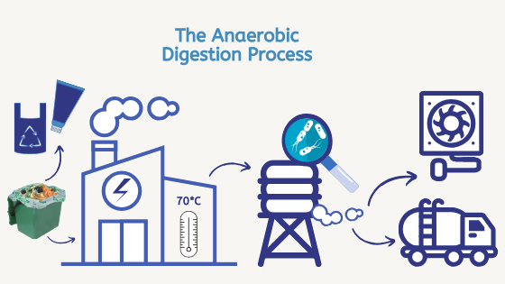
Discuss why there are differences between the two anaerobic digestion systems and what the similarities are. Can students produce a labelled diagram that describes both systems. Use our diagram (right) as inspiration if a prompt is needed.

Extension Activity:
Produce a fact sheet about food waste recycling, methanogenic bacteria, methane and climate change, including easy actions for your families and classmates.

Home Schooling:
This activity could easily translate into home schooling. All the materials are available online or easily from resources at home.

Extra Resources:
BBC Bitesize has useful revision resources about bacteria: https://www.bbc.co.uk/bitesize/topics/znyycdm/articles/z4f26yc
Find out more about food waste recycling at: https://zone.recycledevon.org/food-waste/

