Paper KS3 Activity: Building paper bridges!

Lesson Objective:

To construct and test a bridge from paper;

To think creatively around a complex engineering problem;

Science National Curriculum links:

KS3 Physics: Forces – using force arrows in diagrams; balanced and unbalanced forces; opposing forces and equilibrium – weight supported on a compressed surface.

Resources:
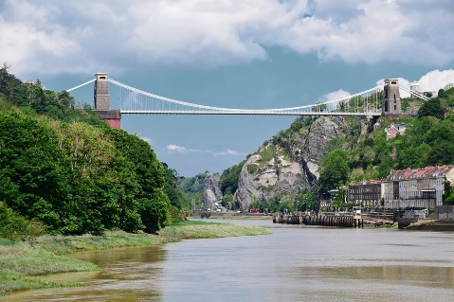
- paper (ordinary A4 printer paper is fine, you could reuse paper that has been printed on)
- 2 stacks of books
- tape
- weights of different mass and/or about 200 penny coins per table/group
- optional – glue

Time required: 1 hour

Introduction to Activity:
Bridges are amazing feats of engineering. For centuries humans have experimented with different constructions ranging from the smallest footbridges to massive constructs of steel and concrete covering huge widths of estuaries and bays, from early stone clapper bridges on Dartmoor to the amazing Victorian suspension bridges of iron designed by Isambard Kingdom Brunel over the Tamar and Avon. But what about using paper?

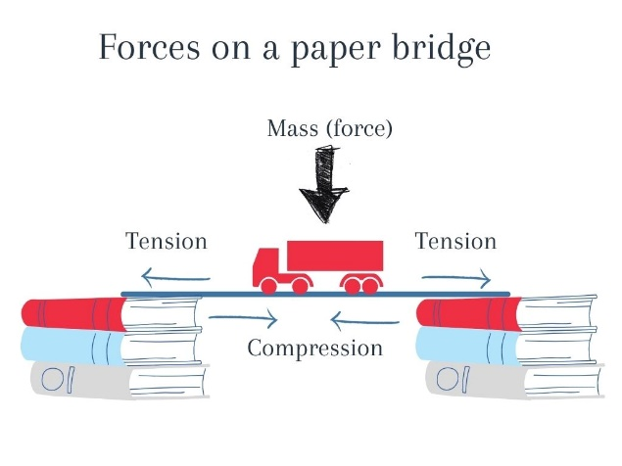
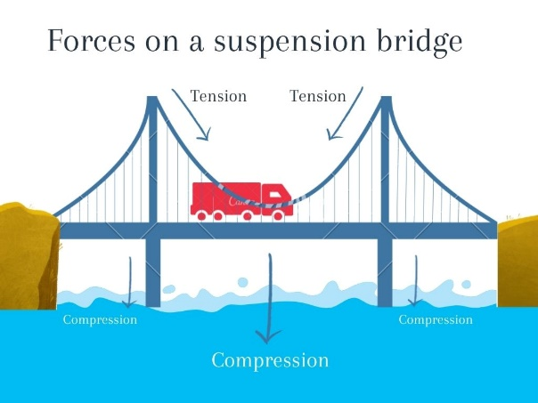
A bridge is actually a complex balance of the forces of compression and tension (see diagrams below). A sheet of paper by itself is not strong at all, but increase the tensile strength by changing the shape of the paper or adding sheets together and see what feats of engineering you can achieve.
Main Activity:
Prepare for the activity by getting into groups or pairs. Build two stacks of books, one or two books high and the length of a piece of paper apart.

First of all, test how much weight a single piece of paper can hold. Suspend a single sheet of paper between the pile of books. See how much weight the bridge holds before collapsing.

Now try to construct other types of bridge by folding, rolling or layering up paper together. The bridge must reach across the whole gap. Try using strong shapes like triangles in your structure.

Test each bridge design using weights or coins. Keep modifying the design until you have a really strong bridge.

Results:
Which is the strongest bridge? Was there a winning design amongst the whole class? You could take photos and share them with us, using the hashtag #ScienceOfMaterials, or record a video of a class competition, like these American college students:

Discussion:
Discuss as a group:
What makes a good bridge? Which shape makes the best and strongest type of bridge? Different shapes of trusses or struts can make all the difference. Did anyone manage to make a suspension bridge?
https://science.howstuffworks.com/engineering/civil/bridge.htm
https://youtu.be/oVOnRPefcno

Extension Activity:
Is paper the best material for a bridge? What else could you use to strengthen it? Think about these: layering up materials – eg. plywood; structural strength – eg. corrugated cardboard.

The best thing about paper is it can easily be recycled in household collections after you’ve made your bridge. What other materials can be recycled at school and home? Have a look through your recycling and see if you can make a different type of bridge using what’s there.

Extra Resources:
Have a look at the World Record for a Paper Bridge: https://youtu.be/gtUZcIDrwoo
Share your pictures with us on Facebook, Twitter or Instagram by tagging @RecycleDevon #recycledevon

Make sure you have permission to share any photos first.

