Home Education Activity: Can Balancing

Lesson Objective:
Students will learn the cool trick of how to balance an aluminium can on its side and consider the forces at work on it.

Science National Curriculum links:
Y3 – Pupils are taught about forces
Y5 – Pupils are taught about gravity
KS3 (Y7/8/9) – Pupils are taught about forces as pushes or pulls on objects and balanced and unbalanced forces.

Resources:
- An empty aluminium can
- Water
- Jug
- Funnel
Watch a video of this activity on our Zone website.
Go to http://zone.recycledevon.org
Time required: 45 minutes
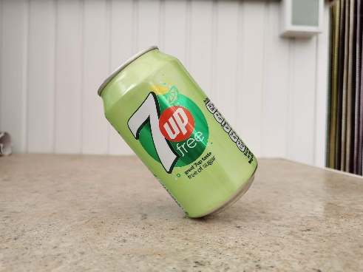

Introduction to Activity:
- Explain this trick is a little bit of physics magic.
- Explain this activity looks at forces working together to balance the can.
- Children should watch the can balancing video here: https://youtu.be/L3duJ-W2o9g
- Can children work out why this works?

Main Activity:
Ask the children to try balancing the empty can, using the jug and funnel to measure out the volume of liquid needed. Encourage them to play with water volumes and find exactly how much or little water is needed for the trick to work.

Extension Activity:
Older students could sketch the can and draw what is happening inside the can as well as sketching the forces acting on the can.

Extra Resources:
https://www.bbc.co.uk/bitesize/topics/zn77hyc/articles/zptckqt
https://www.bbc.co.uk/bitesize/topics/zvpp34j/articles/zywcrdm
https://www.bbc.co.uk/bitesize/topics/z4brd2p

