Extraction methods of iron and aluminium

Extracting iron from iron ore using a blast furnace

Iron is extracted from iron ore using carbon and limestone inside a blast furnace. Iron ores are present as iron oxides in rocks like magnetite and haematite. These are mined from the ground in massive open cast mines in the USA, Canada, Brazil, Australia, China, Russia and Sweden.

The iron is usually pelletised before being transported to a blast furnace, where the iron is extracted using a reduction reaction where limestone and coke (made from coal) react with heat to remove oxygen from the iron oxide in the iron ore.

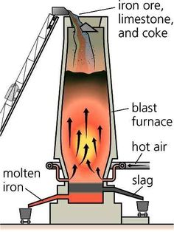
  - Diagram of a Blast Furnace

Smelting of Iron: Chemical Equations

The coke burns:
C + O₂ CO₂

Carbon + oxygen carbon dioxide

The carbon dioxide then reacts with more coke to give carbon monoxide.
CO₂ + C 2CO

Carbon dioxide + carbon carbon monoxide

The limestone is thermally decomposed:

CaCO₃ CaO + CO₂

Calcium carbonate + heat calcium oxide + carbon dioxide

Carbon monoxide reduces iron oxide to leave iron and carbon dioxide:

Fe₂O₃ + 3CO 2Fe + 3CO₂

Iron oxide + carbon monoxide iron and carbon dioxide

Impurities are removed by the calcium oxide combining with sand to form liquid slag which floats on top of the liquid iron.

CaO + SiO₂ CaSiO₃

Calcium oxide + silicon oxide calcium silicate

Extracting aluminium from bauxite using electrolysis

Aluminium occurs naturally as aluminium oxide in the rock bauxite. It is mined from the ground in huge open cast mines in Australia, Jamaica, Guinea, Brazil and Russia.

The aluminium oxide is purified into alumina (a pure white powder form of aluminium oxide) so it is easier to transport to refineries across the world.

Electrolysis is used to extract aluminium from the alumina. See the diagram below. Carbon (graphite) cathodes and anodes are used to provide free electrons for the reaction. These must be replaced fairly often as the carbon is used up in the process.

The bauxite or alumina is usually dissolved in a cryolite solution formed from synthetic sodium aluminium fluoride, which means the process uses less energy. The process does still require a huge amount of energy as the solution must be heated to well over 750°C so that the molten aluminium can be removed.

  - Simplified diagram of aluminium electrolysis (Hall-Héroult process)

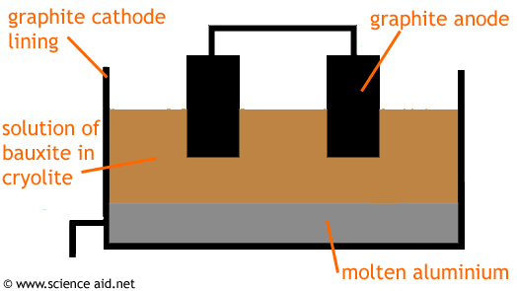

Electrolysis of Aluminium: Chemical Equations

Overall reaction:

2Al₂O3 (l) 4Al (l) + 3O₂ (g)

Aluminium oxide (liquid) Aluminium (liquid) + oxygen (gas)

At the negative cathode - the aluminium ions from the molten aluminium oxide-cryolite mixture are reduced (gain electrons):

Al³⁺ + 3e⁻ Al

Aluminium ions + free electrons Aluminium

At the positive anode – the carbon of the graphite reacts with the oxygen to form carbon dioxide:

C (s) + 0₂ (g) CO₂ (g)

Carbon (solid) + oxygen (gas) carbon dioxide (gas)

Questions:

- In what form is iron found in rocks?
- What other compounds are needed in the extraction of iron from its ore?
- What is the name of the structure used in the extraction of iron from iron ore?
- Explain why the extraction of iron ore uses a lot of energy.
- What process do you think would be better than mining iron from the ground?
- What form is aluminium present in rocks?
- Name two countries where bauxite is mined.
- What name is given to the process of extracting aluminium?
- Explain why aluminium processing contributes to climate change.
- Can you think of a method of obtaining aluminium that would contribute less to climate change?

Sankey Diagrams

– flow of materials to map efficiency

