Compost Creatures
Here’s some amazing facts about our friendly compost loving creatures. Can you spot these creatures in the compost bin?
Slug | 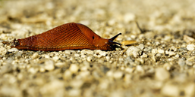 | Slugs live about 2 years. They like warm damp conditions and in cold, dry weather they stay buried underground.
Centipede | 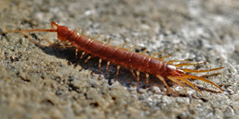 | Centipedes never have 100 legs as they always have an odd number of pairs. They can regrow their legs if attacked by a predator.
Earwig | 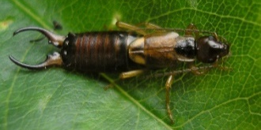 | Earwigs are brilliant mothers and protect their 30-50 eggs through the winter. The babies or nymphs are looked after until they can hunt for food themselves.
Spider | 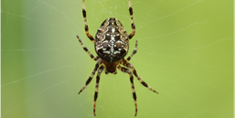 | Only 17 of the 37 species of spiders living in the UK actually build webs to catch their prey. Others sit-and-wait for their prey or actively hunt for them.
Millipede | 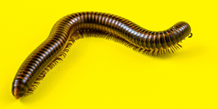 | Fossils tell us that millipedes were some of the first animals to breathe air and live on land. They are long-lived and can live up to 10 years in captivity.
Ant | 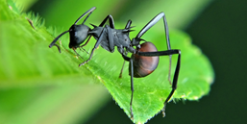 | A single ant can carry up to 50 times its own bodyweight. The largest ant’s nest ever found was 3,700 miles wide – it contained billions of ants.
Worm | 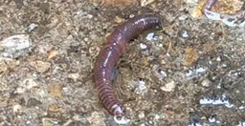 | Worms live in the dark and although blind can detect light with their skin. If exposed to light they can become paralyzed and unable to burrow into the soil or compost.
Snail | 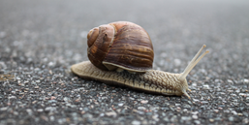 | Snails need damp and moist conditions to survive. If it gets too dry they can hibernate for up to 3 years.

Compost Creatures
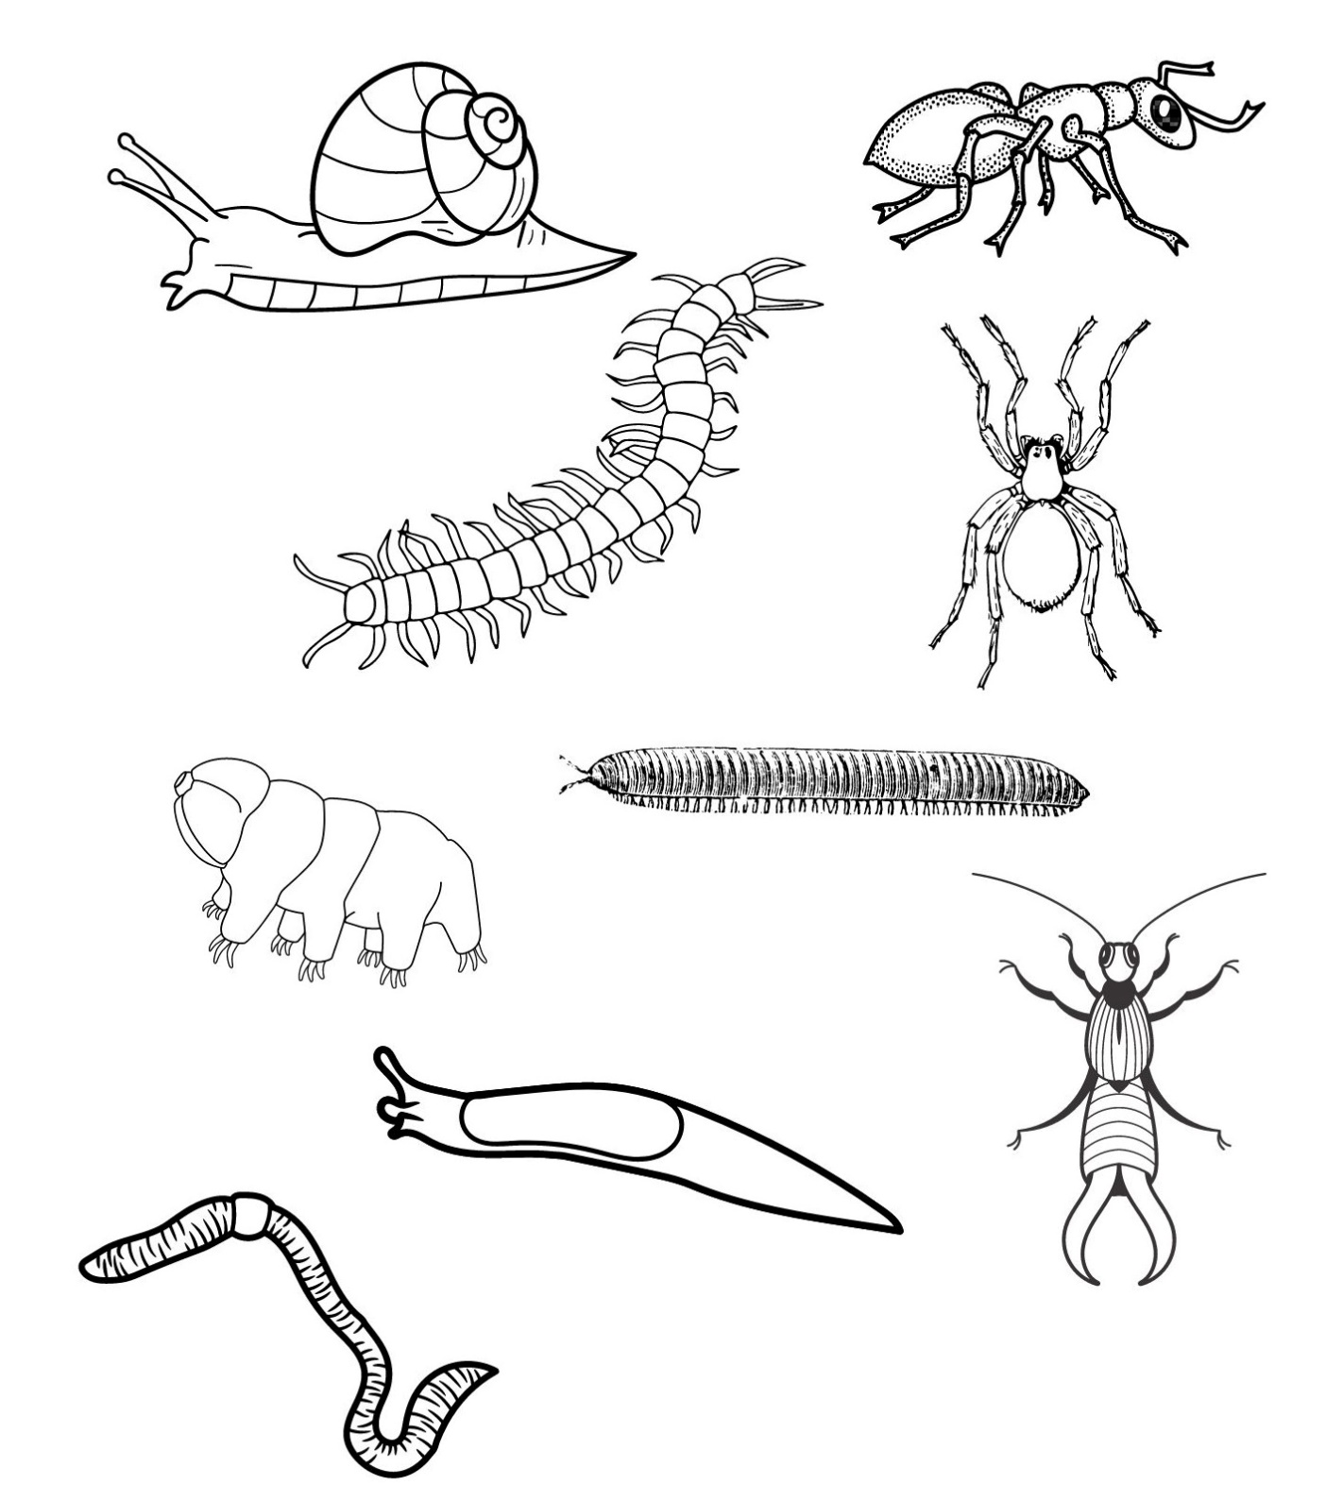
Can you label and colour in these minibeasts you can find in compost? Which is the odd one out?

Earwig
Slug
Worm
Spider
Snail
Centipede
Tardigrade
Millipede
Ant

