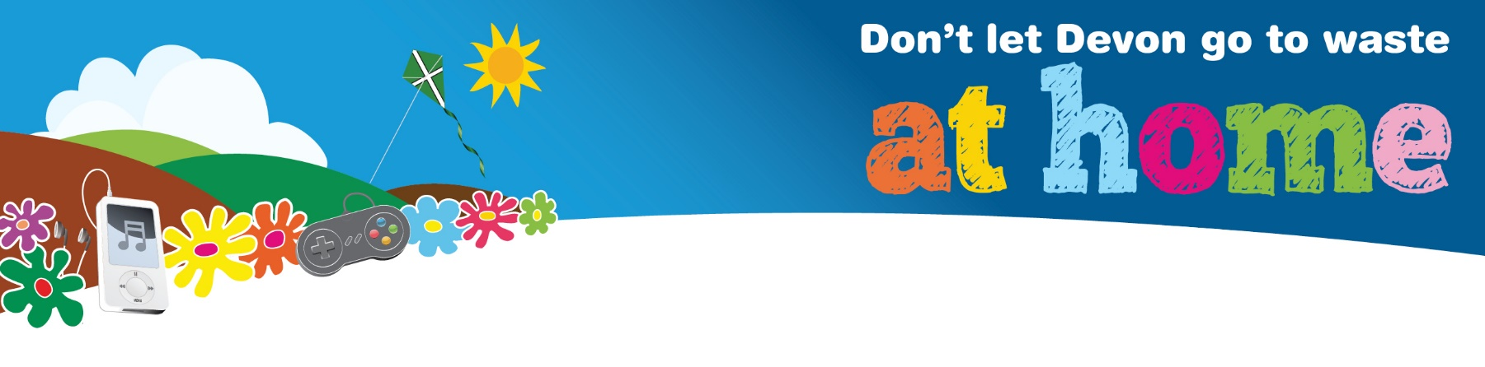

Packaging Symbol Sudoku #1

Fill in the grid so that every row, every column and every 2x2 box contains one of each of the packaging symbols shown below. Remember not to guess; it is a game of logic. Top tip: draw the symbols in pencil so you can rub them out if you make a mistake!
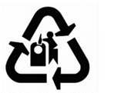 |  |  | 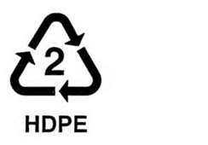
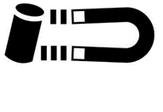

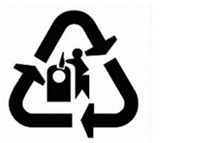 | Glass  This symbol asks that you recycle the glass container. Please dispose of glass bottles and jars in a bottle bank or use your glass household recycling collection if you have one.
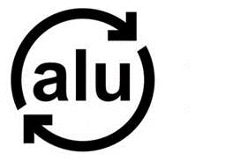 | Recyclable aluminium  This symbol is used to indicate aluminium packaging that is fully recyclable (including foil, drink cans etc.) All local authorities collect aluminium cans for recycling and some collect foil. Aluminium items can be taken to your Household Waste Recycling Centre.
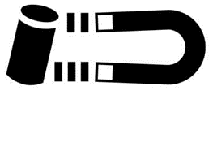 | Recyclable steel  This symbol means that the product/packaging is made of steel.  All local authorities collect steel cans for recycling. Other steel or metal items can be taken to your Household Waste Recycling Centre.
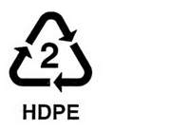 | Plastic resin codes  This identifies the type of plastic used to make the item by providing a 'Resin Identification Code'. It is represented with a 'chasing arrows' symbol surrounding a number between 1 and 7.

Can you find these symbols on some packaging in your home?
You can find out more about packaging symbols at this website
Find out more about what and where you can recycle in your area by visiting www.recycledevon.org

