Recycling Symbol Sudoku #2

Fill in the grid so that every row, every column and every 9x9 box contains one of each of the packaging symbols shown below. Remember not to guess; it is a game of logic. Top tip: draw the symbols in pencil so you can rub them out if you make a mistake.

 |  | 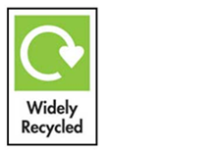 |  |  |  | 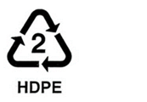
 | 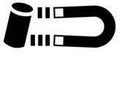 | 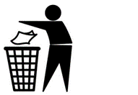 |  |  |  |  |  | 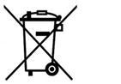
 |  |  |  |  | 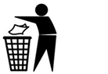

Mobius Loop
This indicates that an object is capable of being recycled, not that the object has been recycled or will be accepted in all recycling collection systems. Sometimes this symbol is used with a percentage figure in the middle to explain that the packaging contains x% of recycled material.

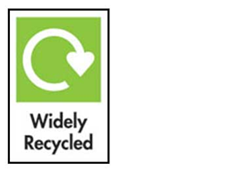 | Widely Recycled  This label is applied to packaging that is collected by 75% or more of local authorities across the UK, for example plastic bottles.
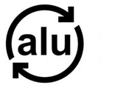 | Recyclable aluminium  This symbol is used to indicate aluminium packaging that is fully recyclable (including foil, drink cans etc.)
Paper, card and wood
The Forest Stewardship Council (FSC) logo identifies wood-based products from well managed forests independently certified in accordance with the rules of the FSC.
More about how to recycle wood, paper or cardboard

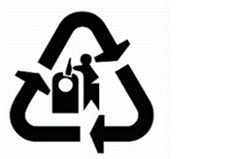 | Glass  This symbol asks that you recycle the glass container. Please dispose of glass bottles and jars in a bottle bank or use your glass household recycling collection if you have one.
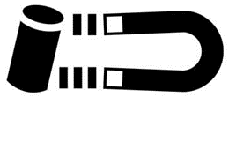 | Recyclable steel  This symbol means that the product/packaging is made of steel.  All local authorities collect steel cans for recycling. Other steel or metal items can be taken to your household recycling centre.
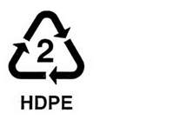 | Plastic resin codes  This identifies the type of plastic resin used to make the item by providing a 'Resin Identification Code'. It is represented with a 'chasing arrows' symbol surrounding a number between 1 and 7 that defines the resin used.
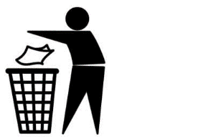 | Tidy man  This symbol from Keep Britain Tidy asks you not to litter. It doesn't relate to recycling but is a reminder to be a good citizen, disposing of the item in the most appropriate manner.
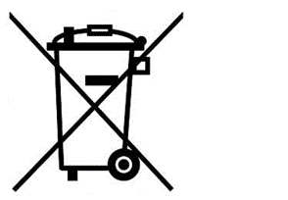 | Waste electricals  This symbol explains that you should not place the electrical item in the general waste. Electrical items can be recycled through a number of channels.  Find out how to recycle electrical items

Can you find these symbols on some packaging in your home?
You can find out more about packaging symbols at this website
Find out more about what and where you can recycle in your area by visiting www.recycledevon.org

