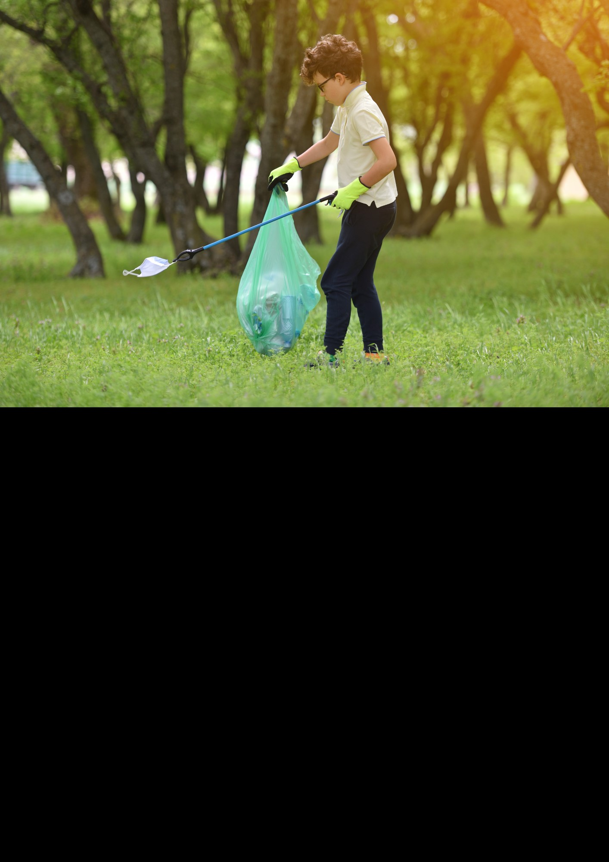

Devon County Council

Short story competition 2024

Teaching pack

This document is to help teachers and educators with ideas on how to relate lessons to a short story about waste.

­­

TABLE OF CONTENTS

Introduction 3

DCC Short Story Competition Terms and Conditons 3

Ideas to inspire writing 7

KS2 lesson plan 9

KS3 lesson plan 10

Story: Bonster the Hungry Monster 11

Story: Operation Green Shift 16

Extras 18

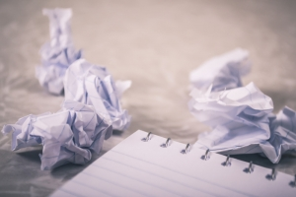

# 

# INTRODUCTION

Devon County Council is running a short story competition of up to 500 words for young people starting from January 2024. Entries will be accepted from any child aged between 7 and 14 who is resident in Devon County (i.e. not Torbay or Plymouth). Stories should be written about the subject of rubbish and waste, such as reducing waste, composting, reusing, or recycling.

The competition will be open for entries from January 24th up to the closing date of 28th March. There will be two categories (KS2 and KS3). Stories can be submitted either by post to the Waste Education Officer at Devon County Council or emailed to [recycle@devon.gov.uk](mailto:recycle@devon.gov.uk).

The winners will be decided by a panel of expert judges in April-May 2024. The top prize will be a £50 book token, promotion on social media (such as an animation of the winning story), a Recycle Devon goody bag and the possibility of having the story read out at a Devon library. Runners up prizes will be a £10 book token and a Recycle Devon goody bag.

# DCC Short Story Competition: Terms and Conditions

1. By entering the competition, the entrant’s parents/guardians are deemed to have read, accepted, and agreed to be bound by, these Terms and Conditions.
2. Entry to the competition is open to all young people aged 7-14 resident in Devon (excluding those from the Unitary authorities of Plymouth and Torbay and those excluded under 22) below)).
3. The closing date for entries is midnight on **Saturday 24th March 2024.**
4. Entrants must write an original short story, at school or at home, on a waste related theme, for example, reducing waste, rubbish, 3Rs (Reduce, Reuse, Recycle), a compost theme, ocean plastics or an extension on ‘Bonster the Hungry Monster’.
5. Entries will be judged on several factors such as: Is the story related to a waste related theme? Is it creative and original? Has the author used the English language well? Is there a focus on sustainability?
6. The short story must be **submitted in A4 format in portrait in 12pt or 14pt Times New Roman, Arial or Calibri font**.
7. Short stories have a word limit of up to 500 words.
8. Schools may submit multiple entries, but only **one entry per pupil** will be accepted.
9. For the purposes of judging, entries will be divided into two categories:
   1. KS2 (years 3, 4, 5 & 6; 7–10-year-olds)
   2. KS3 (years 7-11; 11–14-year-olds)
10. Entries can be **submitted** using any of the following methods:
    1. By email to [recycle@devon.gov.uk](mailto:demelza.annison@resourcefutures.co.uk)
    2. By post to:

Oliver Prato,

Waste Management Team,

County Hall,

Topsham Road,

Exeter

EX2 4QD

1. Entries sent electronically should be in **Word or PDF format**. If submitted from a school, file names should include the school’s name, pupil name and the year group of the pupils (e.g., Silverton_HartleyJ_Y5). Otherwise, the file name should include the young persons’ name and age: e.g., HartleyJ_10.
2. Entries are allowed to be submitted via dictation software to ensure accessibility.
3. The use of artificial intelligence software (AI) to write the story will mean disqualification.
4. One winning entry and two runner-up entries will be selected for each of the age categories detailed above.
5. In case of a high number of entries submissions may be shortlisted by an impartial panel prior to judging, at the discretion of Devon County Council.
6. The winning young person in each category will win **£50 of book tokens** and a reusable bag of Recycle Devon merchandise. They also win the opportunity to read out their short story and have it recorded so it can be broadcast across our social media channels, including Twitter, Facebook, Instagram and YouTube.
7. The runners up will be awarded **£10 of book tokens** and a reusable bag of recycled goodies.
8. The winners and runners up will each receive a framed certificate.
9. There are no cash alternatives for any of the prizes.
10. The winners will be announced in April 2024.
11. Devon County Council accepts no responsibility for late, lost, incomplete, incorrectly submitted, delayed or misdirected entries.
12. Entries will not be accepted from any children of the judges, DCC Waste Management Team or Suez.
13. Devon County Council will appoint a fair and impartial judging panel to judge the entries and select winners. The winners will be selected from all valid entries. In the event of either poor quality or no valid entries being received from pupils in a particular age category, the judging panel reserves the right not to award all prizes.
14. Schools, young people (with parent/guardian permissions), and parents/ guardians must be willing to participate in publicity surrounding the winning of the prize and consent to Devon County Council and partner organisations using the submitted short stories for publicity purposes. Winning entries may be used to promote the 3Rs and composting through events, exhibitions, websites and publications for both commercial and non-commercial usage.
15. The copyright of the short story belongs to the author/s but by entering the competition you are deemed to agree to grant a royalty-free perpetual licence to Devon County Council and partner organisations for the promotional purposes set out in para 24 above.
16. Devon County Council will not be liable for any loss (including, without limitation, indirect, special or consequential loss or loss of profits), expense or damage which is suffered or sustained (whether or not arising from any person’s negligence) in connection with this competition or accepting or using the prize, except for any liability which cannot be excluded by law (including personal injury, death and fraud).
17. The judges’ decision is final, and no correspondence will be entered into other than to notify the winning entrants.
18. If any winning entry is deemed not to comply with these Terms and Conditions, the entry will be discarded, and an alternative winner of the prize will be determined by the judges.
19. These Terms and Conditions are governed by English Law and shall be subject to the exclusive jurisdiction of the English Courts.

Any queries relating to this competition should be directed to: Oliver Prato, Waste Management Support Officer Email: Oliver.Prato@devon.gov.uk

# Ideas to inspire writing

Micheal Morpurgo and ‘Andy’ from Usborne Publishing give advice on how to write good short stories.

One aspect both speakers advise is that writers will ‘make mistakes’ especially in their first draft. It’s important to ‘just get started’.

Michael Morpurgo suggests imagining yourself in the story and ‘talk the story’, thinking of ideas that bring emotion to you, perhaps something you are passionate about.

[Michael Morpurgo: How to write great stories | BBC Teach (youtube.com)](https://www.youtube.com/watch?v=QzAJ3oxYdy4)

[Creative writing tips for kids (youtube.com)](https://www.youtube.com/watch?v=KcVixTq06bA)

Here are some ideas for triggers for writing that links to Bonster the Monster (KS3) and ‘Operation Green Shift’ a story written to help with inspiration. This can help students to ‘just start writing.’

*Using The Bonster the Monster book is below on page 11:*

Using a character: Imagine yourself as Bonster the Hungry Monster. You are trying to build a rocket. However, all the resources on your planet have run out. Are you going to go to Lemonade Land; find lemon aid bottles to reuse and build a rocket? Or are you going to go to Foodie Ville and buy a food waste burger made with rotten apples as you’re hungry?

Creating a new character: Bonster the Hungry Monster is in trouble. His family have come to visit but they’ve crashed on the moon! However, they’re in luck, a hero is here. Captain Creator! The hero that creates life through the fallen leaves of Autumn or the natural waste of the Earth. What will Captain Creator create to help Bonster’s family get down to Earth?

*Using an A.I story: Operation Green Shift: A Tale of Youthful Eco-Enthusiasm.*

Using a character: Imagine you are Dr. Dumptron. You have been defeated by the Eco Guardian. You lay in your lonely flat reflecting and thinking. You decide to turn a new leaf. You want to be admired just like Eco Guardian. So, you decide to show the world how Dr. Dumptron can be an Eco Warrior redeemed!

Creating a character: Imagine you are Eco Guardian’s sidekick Eco Spectacular. Eco Guardian is facing off Dr. Dumptron. However, the Dr has minions of waste. They like to make sure everyone uses the not very compostable cups. Are you going to let that happen or are you going to get your Reuse Cup belt and take the fight to them?

*Extra resources*

The British council have a story creator game linked on their website. It is not related to waste but it’s a fun way to inspire the children. [Story Maker 1 | LearnEnglish Kids (britishcouncil.org)](https://learnenglishkids.britishcouncil.org/fun-games/games/story-maker-1)

## KS2 lesson plan

|  |  |  |  |
| --- | --- | --- | --- |
|  | Subject: English | | Year: 3/4/5/6 |
| **Topic: Short stories about waste** | | | Links to National Curriculum: Writing composition by creating a narrative. |
| Learning objectives: Draft a story board about waste | | | |
| Lesson structure | | Teacher notes | |
| Starter: Read through the first part of Bonster the Hungry Monster (Page 11) or show pictures of waste like plastic on Turtles. | | Introduction (5 minutes): Show the children pictures of waste on the internet. Ask them how they feel, does it make them angry or sad?  Discuss with your partner (5 minutes): Discuss all the different moments in your day or week when you come across rubbish and recycling. How does it make you feel when waste is on the streets?  Thinking activity (5 minutes): Imagine you are a superhero with a monster for a sidekick. Your mission is to solve waste? What powers would they have? What planet do they come from?  Explain (5 minutes): With any story it needs a beginning middle and an end. A beginning needs to introduce the story and characters. The middle needs to show the main character dealing with a problem, a problem that might seem hopeless. The end should be how the main character solves the problem. Is it a happy conclusion?  Story board (10 minutes): Using these ideas, make a story board with pictures and writing.  Activity (15 minutes): Start writing, write as if you’re the main character talking about your life in the imaginary world. It does not matter if you make mistakes, those mistakes can be amended. | |
| Main Activity:  Create a story board by drawing and writing | |
| Plenary:  Share the ideas. | |
| Extension:  Write a short story of **up to** 500 words and submit to Recycle Devon’s short story competition | |

## KS3 lesson plan

|  |  |  |  |
| --- | --- | --- | --- |
|  | Subject: English | | Year: 7/8/9 |
| **Topic: Short stories about waste** | | | Links to National Curriculum: Writing for a wide range of purposes and audiences |
| Learning objectives: Draft a short story about waste | | | |
| Lesson structure | | Teacher notes | |
| Starter: Read through the story 'Operation Green Shift’ (Page 16) | | Introduction (5 minutes): We often see waste but do not often write about it. The journey of waste is a story, it starts at the bin but ends in not always the place you would think. For example, where does food waste go? Many think it is composting but it is actually anaerobic digestion. Check this video on our YouTube for that story.  <https://www.youtube.com/channel/UC5GLQ89DvLENuvYXHkx41vQ/>  Group activity (5 minutes): In groups, discuss all the different moments in your day or week when you come across rubbish and recycling. Where does your rubbish go? Is there anything that you feel particularly strong about like waste on the streets?  Thinking activity (5 minutes): Then on your own think of ways you could create stories around those experiences, maybe it involves a superhero who solves something you feel strongly about. For help with ideas refer to idea triggers (Page 7).  Instructions (10 minutes): A story needs a narrative or plot. This has a beginning middle and end. So, think of where it will be set, is it a real or imaginary? Who is your main character? What is their conflict? Is there a villain? Or is it something with which they are struggling internally with? What will be the climatic event? How will this be solved? Is it a happy conclusion? What will be the moral of the story, is there a message you would like to get across to your audience?  Activity (20 minutes): Using your ideas. On your own create a 5 minute story board. Then start drafting the story in first person. Use descriptive language such as adjectives, adverbs, and verbs, especially when setting the scene to hook the reader.  These are all tips from the TES story creation lesson [Story Elements and Writing a Short Story | Teaching Resources (tes.com)](https://www.tes.com/teaching-resource/story-elements-and-writing-a-short-story-11989005) | |
| Main Activity:  Create a story board. | |
| Plenary:  Share the ideas. | |
| Extension:  Write a short story of up to 500 words and submit to Recycle Devon’s short story competition | |

# Story: Bonster the Hungry Monster

Devised and Written by Carol Arthur, Joanna O’Callaghan, Alex Mack & Demelza Annison. Illustrations by Andy Council, his website is linked here [Home | Andy Council](http://www.andycouncil.co.uk/). Design by Sally Scholefield.

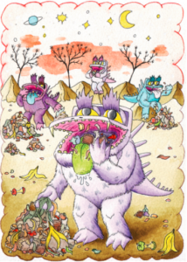

Bonster was bored and HUNGRY, he was  
sitting with his friends on a planet called  
LeftOverLand, with nothing to do and  
nothing to eat

LeftOverLand used to be a wonderful place  
to live. The monsters living there were never  
hungry – they could snack on old teabags,  
scoff chunks of stale old bread and wolf  
down potato peelings and gobble up coffee  
grounds.

But things had changed, leftovers were  
running out and sometimes they had to eat  
horrible ordinary food like cake and biscuits.  
They had no choice – one of the monsters  
had to go in search of a planet with more  
wasted food and Bonster was chosen

Bonster was going to travel in a space rocket,  
which looked a bit like an old tin can.

He only had a few days’ supply of food –  
some lettuce leaves, apple cores and mouldy  
cheese. He climbed nervously on board.  
As the rocket took off, he closed his yellow  
eyes and hoped for the best…  
WhOOOOSH  
went the rocket, up and up until Bonster  
could no longer see LeftOverLand.  
After a long and bumpy ride the rocket  
began to go slower and slower until…  
BANG!  
His rocket crashed into something and  
stopped.  
SPLUTTER!  
It was so dark, where was he?

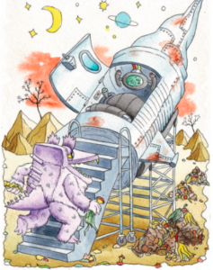

Luckily Bonster’s landing had been soft  
and he wasn’t hurt. He squeezed out of  
the rocket and could feel squishy stuff  
underneath him.  
Bonster reached above him and he could feel  
something solid which he pushed against. It  
opened and his eyes were nearly blinded by  
the sunlight.  
He peeped out – oohh it was beautiful – he  
saw green trees and an amazing blue sea in  
the distance. They only had sludgy brown  
seas in LeftOverLand and spiky black trees.  
Then he realised he had landed inside a  
black wheelie bin! He jumped down to the  
ground and started to wander up the road.

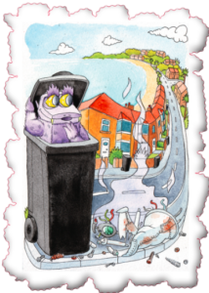

As he wandered along, Bonster saw different  
types of bins and boxes which he peered  
into. Some had shiny black bags inside –  
BORING! Some had glass jars and plastic  
bottles and newspapers inside – BORING!  
Then he spotted a smaller bin which, to his  
delight, had his FAVOURITE food inside.  
He couldn’t believe it! There were eggshells,  
fish skins, carrot peelings, and stale bread  
crusts. He ate them ALL up – yum yum yum!  
BUT, afterwards he was still hungry.

“Wouldn’t you prefer nice fresh food  
to eat?” Olivia asked. “NOOOOO“ growled  
Bonster, “I don’t want any of that new stuff,  
I want mouldy old food please.”  
He turned and saw a girl and boy looking at  
him in surprise. “Hello, my name’s Bonster,”  
he called out. “Have you got any old food  
to eat? I’m super hungry.” The girl stepped  
forward, ”Hello. My name’s Olivia and this  
is Noah,” she said.

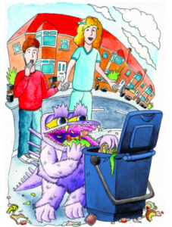

“Come with us!” said Noah. They went to  
their house to look for some Bonster food.  
Dad was in the kitchen, “This is Bonster. He  
likes to eat old food waste.” Said Olivia.  
“He’s super hungry, please can he stay?”  
“I’ll be very helpful,” said Bonster “I’ll eat up  
black rubbish bags.  
all of your old food waste, so it doesn’t go in  
the I don’t take up much  
space!”  
“Ok then,“ sighed dad “BUT you two need to  
look after him and make sure that he gets  
fed.” “Yessss!” cried the children and they  
helped Bonster to sit on the worktop near to  
the sink.

The children fed him every day with old  
eggshells, tea bags, bread crusts and  
vegetable peelings. He was very happy  
sitting there helping his new friends look  
after their beautiful planet

# A cartoon of a child and a child wearing clothing Description automatically generatedStory: Operation Green Shift: A Tale of Youthful Eco-Enthusiasm.

A story written for inspiration

In the vibrant city of Greentopia, where skyscrapers touched the clouds and busy streets buzzed with energy, there lived an incredible superhero named EcoGuardian. With a suit made of recycled materials and a mission to fight against a unique villain—waste—EcoGuardian was the ultimate defender of the environment.

EcoGuardian, secretly known as Alex Greene, was not just an ordinary superhero. By day, he was an environmental scientist, and by night, he transformed into Greentopia's eco-hero. His goal? To teach everyone about the importance of reducing waste and inspire kids and grown-ups alike to make eco-friendly choices.

One evening, as the sun set, casting a warm glow over Greentopia, EcoGuardian received an urgent message. The city's waste disposal system was in trouble, and a nasty villain named Dr. Dumptron was causing chaos. Dr. Dumptron had a machine that was making too much waste, and the city was in danger.

With a burst of green light, EcoGuardian zoomed into action. Using his eco-sensors, he found Dr. Dumptron causing trouble, and a showdown between the superhero and the villain began. Dr. Dumptron, with his crazy machine, was throwing waste everywhere, but EcoGuardian was ready.

EcoGuardian dodged and deflected waste with his eco-shield, showing off his amazing skills. Meanwhile, the citizens of Greentopia watched, a mix of fear and excitement on their faces. But EcoGuardian knew this battle wasn't just about defeating Dr. Dumptron—it was about teaching everyone to be a hero for the planet.

In the middle of the action, EcoGuardian used his special eco-amplifier to speak to the whole city. "Citizens of Greentopia! We can beat waste and make our city cleaner and greener. Let's work together—reduce, reuse, and recycle! It's time for us to take care of our planet!"

Inspired by EcoGuardian's call, kids and adults alike jumped into action. They formed teams to clean up the mess, picking up and sorting waste to protect their city. The sounds of teamwork echoed through the streets as everyone pitched in.

While the citizens worked together, EcoGuardian managed to stop Dr. Dumptron's machine with a clever move from his eco-staff. The villain was caught, and the city cheered for their superhero. With Dr. Dumptron behind bars, Greentopia was safe again.

But EcoGuardian knew that the battle against waste wasn't over. So, he started the "Green Revolution," a big plan to make Greentopia the greenest city ever. Kids and adults joined in, learning about composting, reducing waste, and using renewable energy.

As Greentopia transformed into a super eco-city, EcoGuardian became a hero for everyone. He showed that even kids could make a big difference for the planet. So, as EcoGuardian soared through the city, he knew that with everyone working together, Greentopia would always be a shining example of how to care for our environment.

# Thank you for reading, check out the rest of our Zone website for literacy lessons and a book list linked below.

# A white flower with a yellow center Description automatically generatedA blue rectangle with white text Description automatically generated[Literacy Lessons - Zone (recycledevon.org)](https://zone.recycledevon.org/literacy-lessons/)